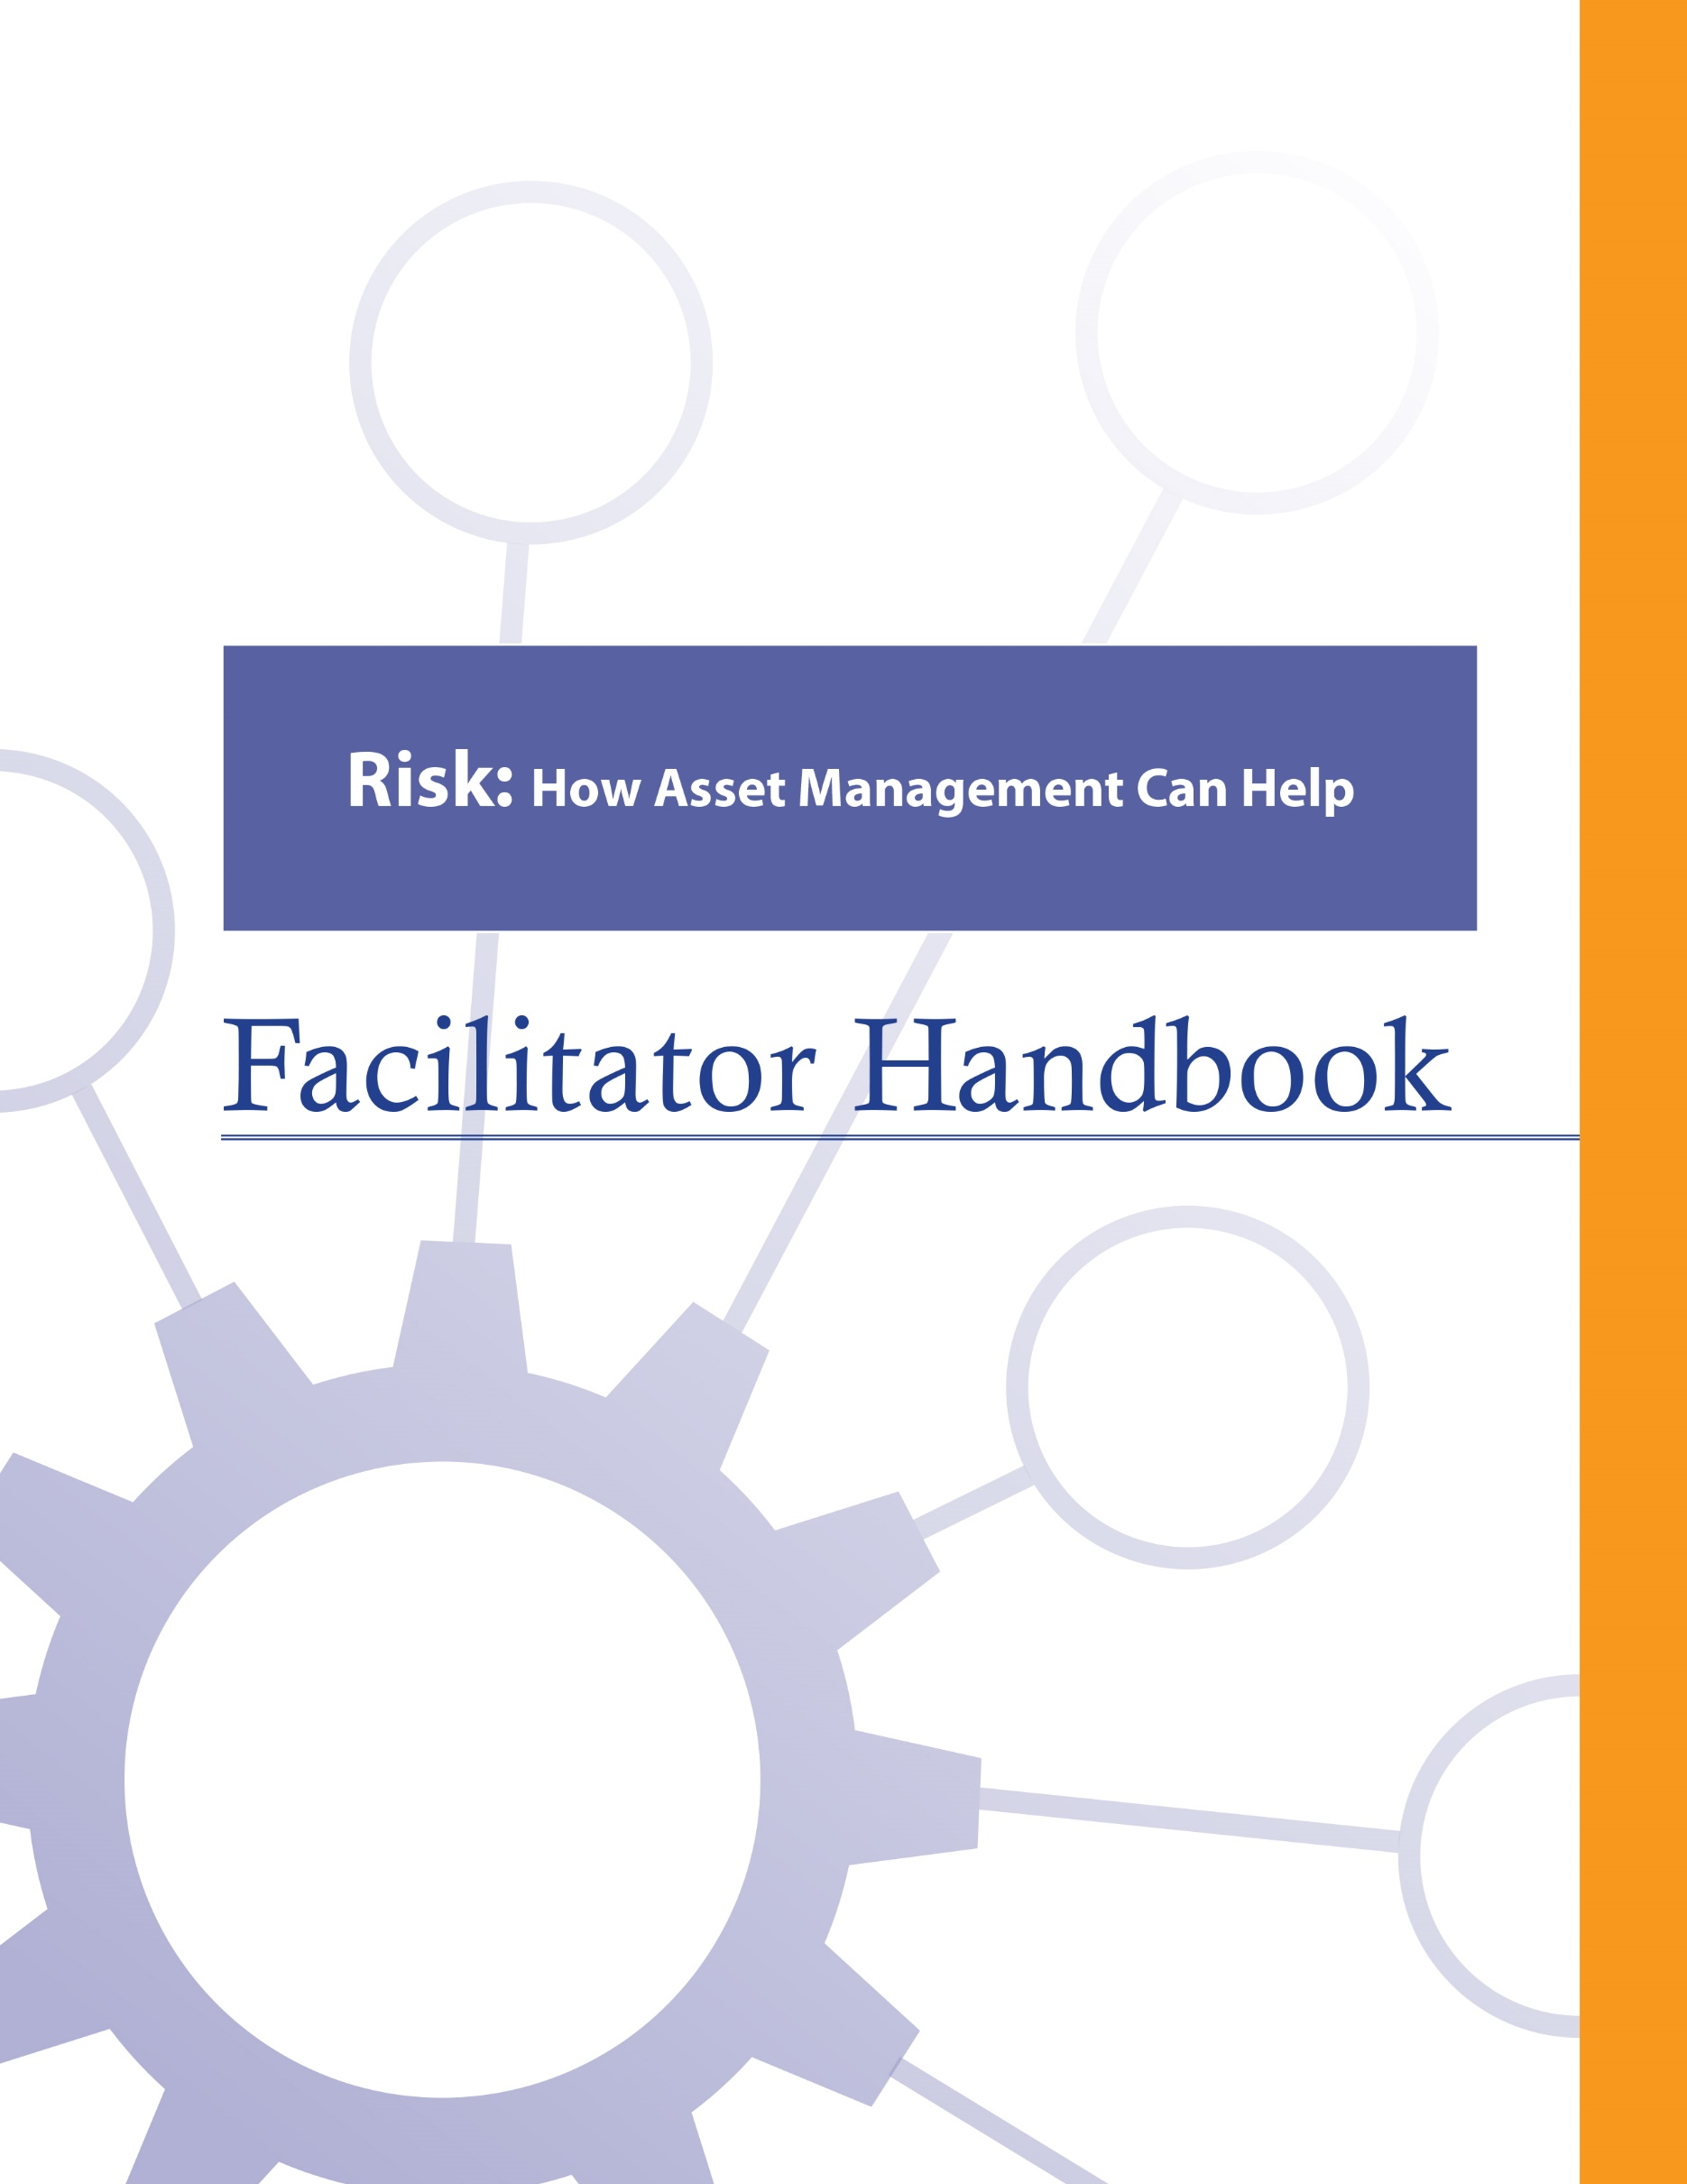

About the FCM
The Federation of Canadian Municipalities (FCM) has been the national voice of municipal government in Canada since 1901, advocating for the needs of municipalities and their citizens. FCM’s membership includes large cities, small urban and rural communities, and 20 provincial and territorial municipal organizations.

About RMA
Formerly known as AAMDC, Rural Municipalities of Alberta (RMA) is an independent association representing Alberta’s 69 counties and municipal districts. Since 1909, the RMA has helped rural municipalities achieve strong, effective local government.

About AUMA
Founded in 1905, the AUMA represents 269 urban municipalities including cities, towns, villages, summer villages, and specialized municipalities. AUMA works with federal and provincial governments and business and community stakeholders on a broad range of issues to strengthen the economic, social, cultural, and environmental vitality of its member municipalities.

This initiative is offered through the Municipal Asset Management Program, which is delivered by the Federation of Canadian Municipalities and funded by the Government of Canada.
fcm.ca/assetmanagementprogram

TABLE OF CONTENTS

How to Use this Facilitator Handbook 1
Characteristics of Adult Learners 2
Agenda 6
Introductory Remarks 7
Learning Goal: Asset Management Refresh 10
Module 1—Identify Risks in a Municipality 14
Learning Goal: Define Risk 14
Learning Goal: Identify Municipal Risks to Service Delivery 18
Module 2 – Identify How Asset Management Supports Municipal Risk Management 21
Learning Goal: Describe the Basic Process for Risk Management 21
Learning Goal: Identify How Asset Management Supports Risk Management 24
Learning Goal: Identify Asset Management Tools that Support Risk Management 26
Learning Goal: Describe Council’s Role in the Risk Management Process 28
Learning Goal: Concluding Remarks 29

How to Use this Facilitator Handbook
This Facilitator Handbook was created to be a resource for the professionals who will be instructing the course on behalf of the AAMDC and AUMA. The Facilitator Handbook is intended to help instructors to provide consistency, and to facilitate the course effectively, within the instructional time available.

How to read the guide:
- The facilitator script and instructions are provided in the right column.
- Thumbnails of the slides corresponding to the script are in the left column.
- The facilitator’s script appears in normal type.
- Additional notes to facilitators appear in bold print.
- Sample responses, discussion points and answers for participant activities appear in italics.

Characteristics of Adult Learners
While we may act like it sometimes, adults are not just big kids. And, we don’t want to be taught like children. As adults, we learn in a very different way than our shorter, younger (maybe even thinner) selves. When we think about a typical learning environment, many of us recall past school days. During those times, our very identity revolved around being a student.
For most of us, the model we have for instructing comes from the teachers who taught us back in the day. However, the teaching techniques that worked for our grade eight English teacher may not be as appropriate for those of us now instructing adults – adults who are also our colleagues and peers. It is important for facilitators of adult education to understand how adults learn and to incorporate teaching principles and strategies that will meet the unique needs of adults and foster the most positive, engaging and productive learning environment possible for them.
What is so different about adults and how can we, as training professionals, incorporate instructional techniques that respect those differences? Below are some generally accepted insights that you may find helpful.

Adults want to have control over their learning
We adults tend to be self-directed. We have work, family and community responsibilities that require us to exercise some level of competence and control. In fact, we can get downright resentful when others take away our right to make choices around our own affairs. This is true when it comes to our learning experiences -- we typically need to exercise some control here, too. In fact, take away our sense of control over how and when we engage in formal learning and you will likely meet some resistance.

What’s a facilitator to do?
- Include adult learners in the planning of their learning (engage them in needs assessments and encourage their input on course objectives & content wherever possible).
- Encourage self-assessment and self-evaluation (rather than instructor-based evaluation).
- Establish a peer relationship with learners rather than the traditional hierarchical one.
- Make yourself available to adult learners outside of the formal learning environment if possible.

Adults, more so than youth, draw upon their experiences as a resource in learning
Been there, done that. Adults have a wealth of past experiences simply because we’ve lived longer than youth. As learners, our past experiences are important resources that we draw on. Adults tend to link new learning to prior learning (much of which is rooted in life experience). Learning is all about accepting and applying new ideas and concepts. For adults, that process often happens within the context of how the idea or concept “fits” with what we’ve already experienced.

What’s a facilitator to do?
- Take time to get to know the experiences of your adult learners and be intentional about helping them link new concepts and ideas with prior learning or experiences.
- Encourage open discussion on how new concepts and ideas being presented fit with the experience of learners.
- Encourage learners to share their experience for the purpose of teaching others. Ask versus tell. Using questions can draw out the information you want to focus on and is an effective way to encourage adult learners to apply their own skills and experience to facilitate their learning.

Adults tend to be more motivated in learning situations than youth
When adults find themselves in a formal learning environment, most times it’s because they want to be there. Adults are not typically motivated by gold stars or good report cards. Instead, they want a learning outcome that can be put to use immediately in concrete, practical and self-benefiting ways.

What’s a facilitator to do?
- Don’t spend a great deal of effort trying to motivate adult learners. Rather, see your role as facilitating the learning they are ready to experience.
- Ensure teaching is relevant to what learners want to learn and what they will be able to use back on the job.
- Accept that people will learn at different rates and in different ways. Some will learn by being told, others will learn by doing. Still others will need to be shown. Use a diversity of teaching methods to ensure your learners stay motivated to learn.

We’re generally more pragmatic in learning than youth
Adults are typically more interested in problem solving than information gathering. Learning “theory,” which must be stored away for future use, can be frustrating and seem irrelevant for many adult learners. Especially for adults, learning becomes complete when we put into practice what we are attempting to learn.

What’s a facilitator to do?
- Using job-related case studies and hands-on exercises and activities will help learners to immediately use what they’re learning in a problem-solving situation. The more often we use what we have learned, the better we can perform or understand it.

Some adults lack confidence in their learning
Some adults who have been away from a formal learning environment for some time may consider the learning “glory days” over. These perceptions can influence how confident they feel during learning situations. Interestingly, research shows that the attention span of the average adult is between 8 and 20 minutes.

What’s a facilitator to do?
- Provide opportunities for learners to receive constructive feedback on how they’re doing (either through guided self-evaluation, constructive input from other participants, or the facilitator’s own observations).
- Present information in a manner that permits mastery in “bite size chunks” with opportunity for hands-on application.

Many adults are more resistant to change than youth
Learning often involves change of some kind. Youth tend to be more idealistic and are often open to change just for the sake of change. However, over the course of being an adult, our experiences around change have not always been good and can lead us to be somewhat resistant to it.

What’s a facilitator to do?
- Encourage learners to explore the “why” of change, not just the “how.”
- Link new concepts to older, understood and accepted concepts.

A group of adult learners will typically be more diverse than a group of youths
A group of adults, more so than a group of youths, will vary a great deal in terms of age, experiences, and backgrounds. Differences can be a powerful resource for learning as adults collaborate together on tasks.

What’s a facilitator to do?
- Allow time for interaction between learners and create opportunities for them to work together in groups to collaborate and share perspectives and experiences.
- Present material in a variety of ways to accommodate a diversity of learning styles.

Agenda
Time | Topic | Facilitator’s Name
10 minutes | Introductory Remarks
20 minutes | - Asset Management Refresh
15 minutes | - Define Risk
45 minutes | - Identify Municipal Risks to Service Delivery
30 minutes | - Describe the Basic Process for Risk Management
15 minutes | Refreshment Break
45 minutes | - Describe How Asset Management Supports Risk Management
30 minutes | - Identify Asset Management Tools that Support Risk Management
20 minutes | - Describe Council’s Role in the Risk Management Process
10 minutes | Concluding Remarks

Introductory Remarks

10 minutes |
Slides | Script
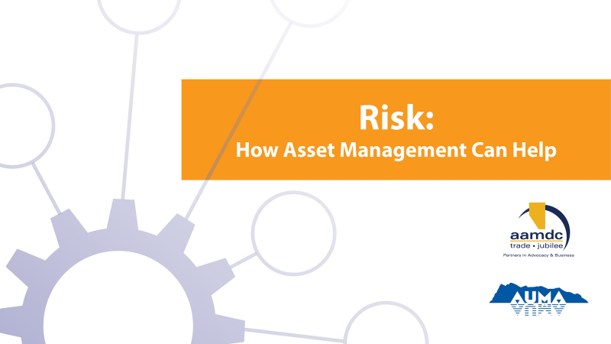
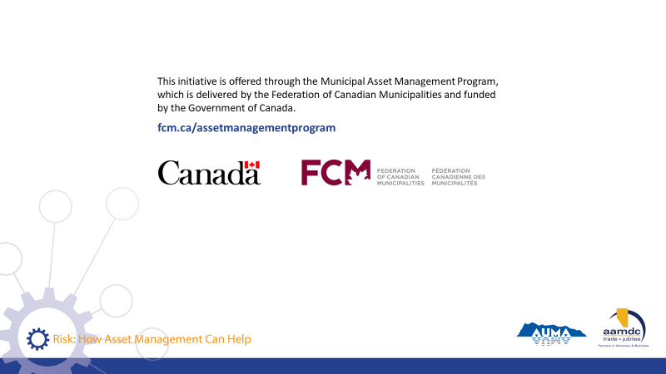
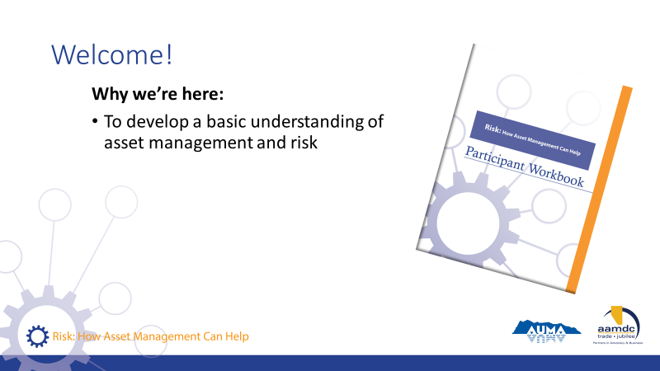 | State:  - Welcome everyone! We are all here as part of the course titled “Risk: How Asset Management Can Help”.  - Read Slide
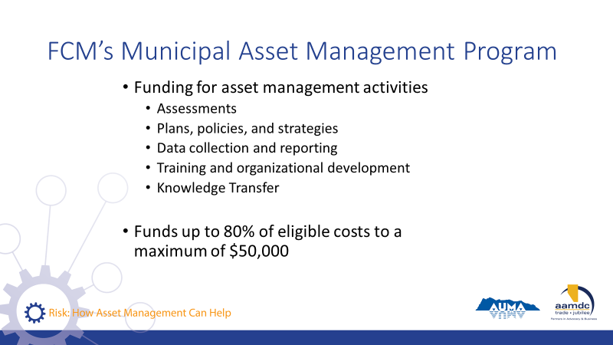 | State:  - Before we get started, we also want to mention that there is funding out there to do asset management.  - So as you’re learning today, if you’re identifying things you’d like to bring back to your community, know that this grant program is available.  Read slide.
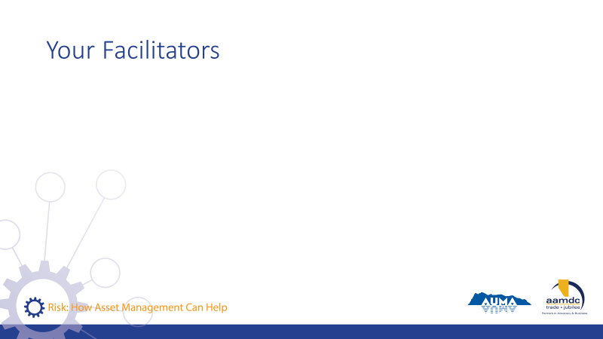 | Facilitator(s) introduce themselves.  Have participants introduce themselves.  Consider the use of icebreaker questions about where participants are at with asset management and what they’d like to know about risk management.
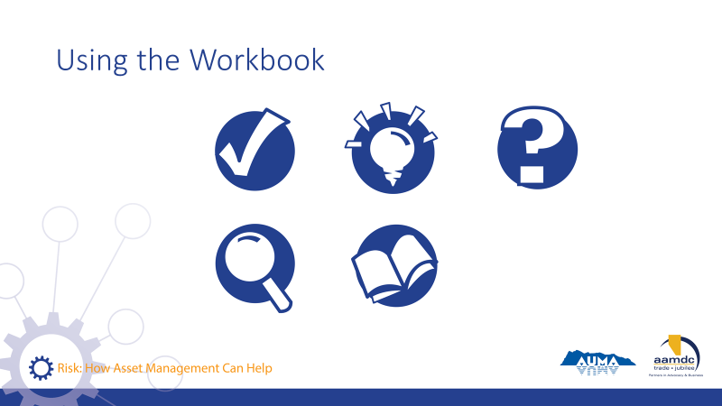 | Review how to use the learner workbook.  State:  Everything we will be covering in the course is contained in your participant workbook. However, we won’t necessarily be talking about all of the content in the workbook. I would encourage you, at some point, to read it over from start to finish.  We have also included a number of recurring icons intended to help you find relevant information in your workbook easily.  As icons appear (with click) on slide, review what each means and how to use it.  State:  The course is based on achieving specific learning goals. This icon identifies the learning goals, so you can be thinking about whether you are achieving them  This icon lets you know we’ve added an interesting fact or additional information related to the course material that we may not specifically cover in our discussion.  When you see this icon, it means we have included a reference to additional information on the topic that you can review at a later date.  Throughout the course, we will provide opportunities for you to apply your knowledge and share your expertise with a partner through various activities related to what you are learning.  In discussing municipal governance, there are a number of terms that may not be familiar to everyone. We’ve highlighted a few in these Glossary boxes and provided definitions. If you spot a term you aren’t familiar with and we haven’t provided a definition, please let us know by filling out the evaluation form and we will not only address it in this course but will add it to future participant workbooks.  Throughout the course, we want you to be continually thinking about how what you are learning in the course will apply to your role as elected official. For this reason, we’ve created space for you to reflect and record your thoughts on what the course content may mean in your world.
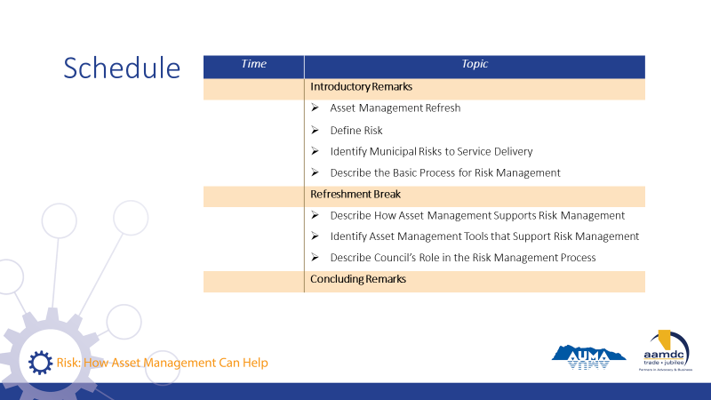 | Review course outline schedule.  State:  As you can see, we will be covering a lot of content today.  Review schedule on slide.

Learning Goal: Asset Management Refresh

20 minutes |
Slides | Script
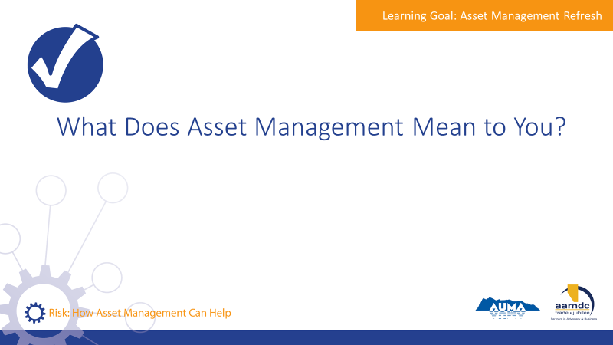 | State:  Let me ask you, when you hear the term asset management, what comes to mind?  Encourage participants to share their thoughts with the large group.
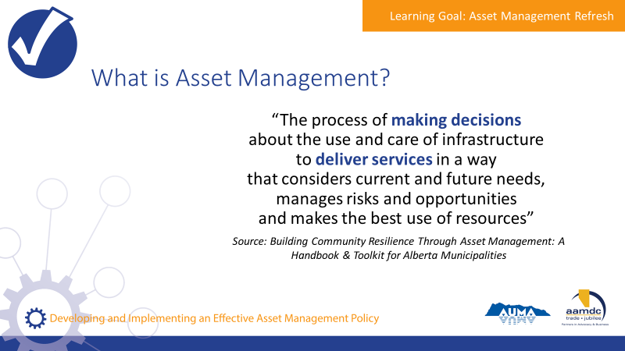 | State:  - Municipalities in Alberta are empowered to provide a range of services to their communities through provincial legislation, specifically the Municipal Government Act (MGA).  - A major component of service provision is taking care of the assets that make those services possible.  - An asset, also known as a tangible capital asset (TCA), is a physical component of a system that enables a service, or services, to be provided.  For example, pipes are the assets that deliver water service to homes, roads and traffic lights are the assets that make transportation possible, and recreation centres are assets that allow recreation services to be provided to the community.  - Municipalities have been managing assets for a long time. However, asset management is more than just managing assets or developing inventories of the assets a municipality owns.  - Here’s one definition of asset management that we think captures the essence of what it really is. We took this from the Alberta Handbook and Toolkit.  Review definition from slide.  State:  - They key terms here are “making decisions” and “deliver services”.  - Asset management is about using systems and processes to balance cost, risk, and LOS to make informed decisions that make sense for your community in the long run.  Assets don’t exist for the sake of having assets, they exist to deliver services. Service delivery is the starting point for all asset management.  Ask:  - What is the role of council in asset management?  - What is the role of the CAO and administration?
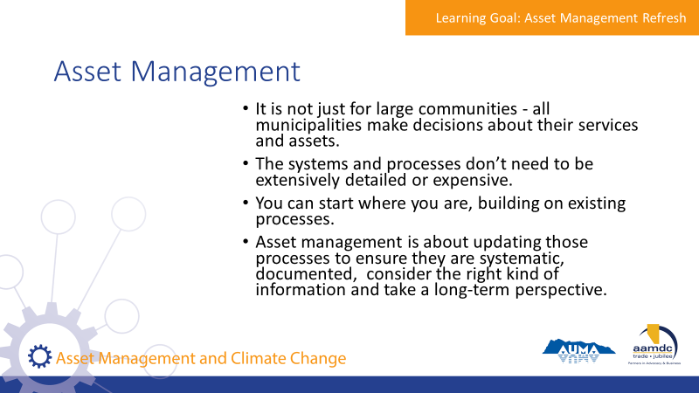 | State:  - It is not just for large communities. All municipalities make decisions about their services and assets.  - The systems and processes don’t need to be extensively detailed or expensive.  - You can start where you are. Your municipality probably already uses processes for things like planning and budgeting.  Asset management is about updating those processes to ensure they are systematic, documented, consider the right kind of information and take a long-term perspective.
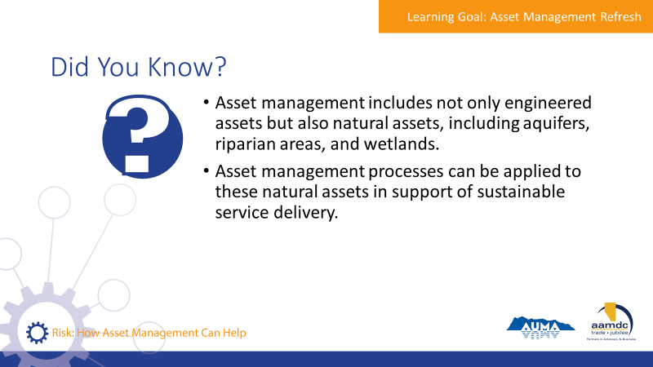 | State:  - Here are a few facts we thought you would find interesting. [Read facts on slide].  - Natural assets are critical to service delivery, and it’s useful to think through how these assets are cared for and invested in, in the same way that infrastructure assets are.  - Does anyone know if their AM programs include consideration of natural assets? Or have you had any discussions about natural assets?
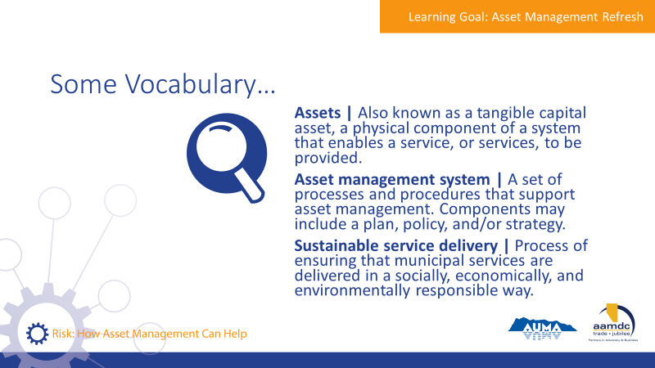 | State:  - There are a couple of terms we will be using as we discuss asset management, so we want to make sure we have a common understanding of them before we get into our discussion of asset management.  Review terms on slide.
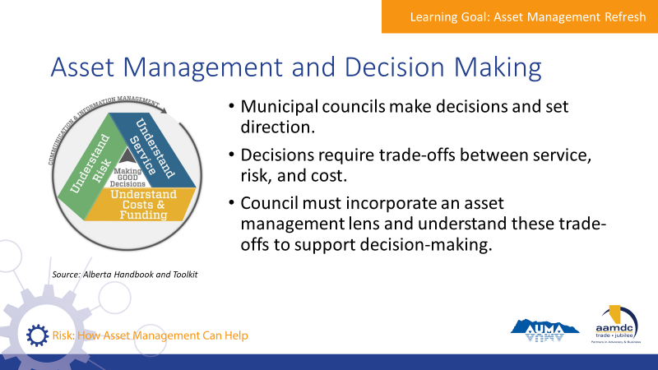 | State:  - Council’s role is to make decisions and set directions.  - Decisions require thinking about trade-offs between service, risk, and cost.  - Council should incorporate an asset management lens on decision making processes and request information from staff to understand these trade offs.
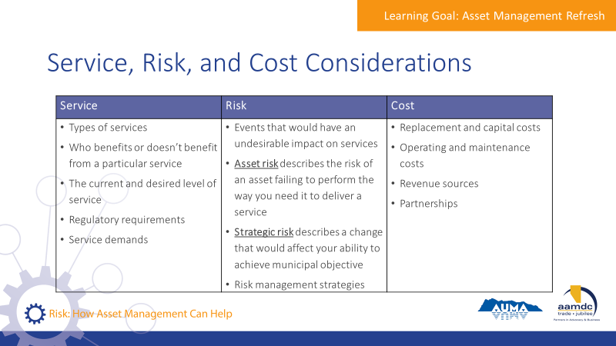 | State:  - This chart shows a summary of what should be considered for service, risk, and cost when evaluating trade-offs  - Risk will be covered in more depth in this course, and how risk connects to levels of service and cost.  Review considerations on slide.
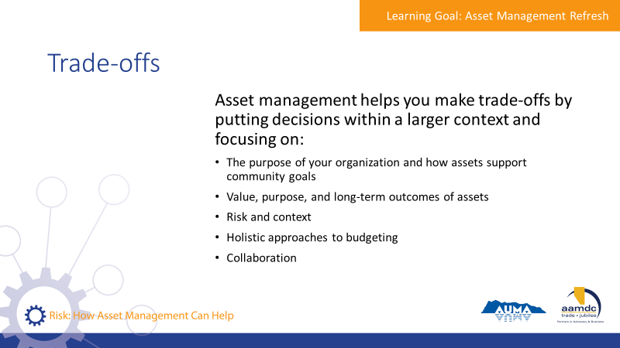 | State:  - Asset management helps you make trade-offs by putting decisions within a larger context.  - It helps you focus on things like:  - The purpose of your organization and how asset support community goals  - Value, purpose, and long-term outcomes of assets  - Risk and context  - Holistic approaches to budgeting  - Collaboration
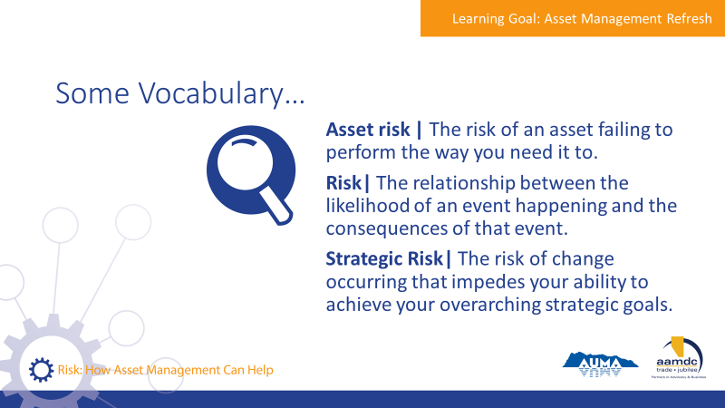 | State:  - Asset management uses many words that we day-to-day, but they mean specific things.  - To make sure we’re all on the page when we talk about risk, let’s review what risk means in an asset management context.  - Risk is the relationship between the likelihood of an event happening and the consequences of that event, with respect to your objectives.  - Asset risk refers to the specific risk of an asset failing to perform the way you need it to.  - Strategic risk refers to the risk of a change occurring that impedes your ability to achieve your overarching strategic goals.
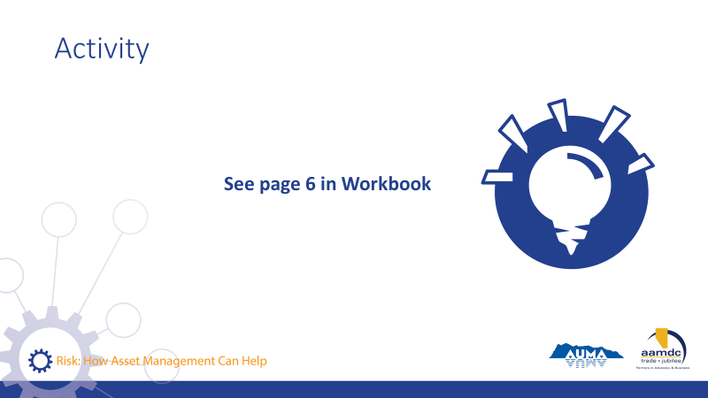 | Activity – page 6 (5-8 minutes)  - Let’s turn to page 6 in your workbook.  - What are some examples of trade-offs between service, risk, and cost that we see in our everyday lives?  - You can think of examples from your municipality, but also from other contexts, like sports or family or other things.  Discuss as a group.

Module 1—Identify Risks in a Municipality

Learning Goal: Define Risk

15 minutes |
Slides | Script
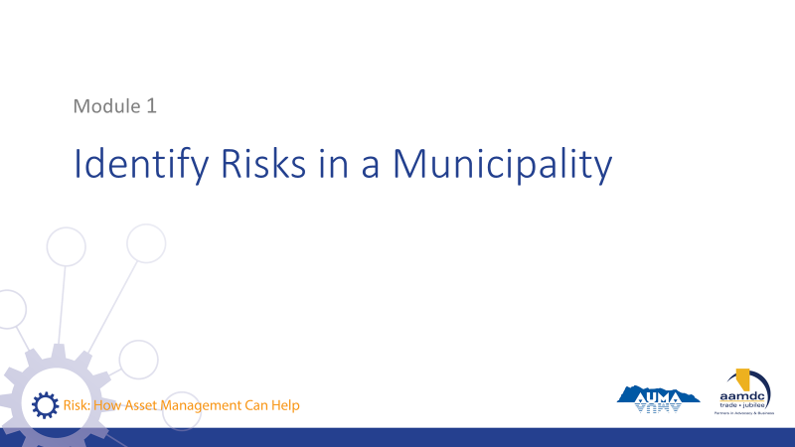 | State:  - Our first module will take us through identifying risks in a municipality.
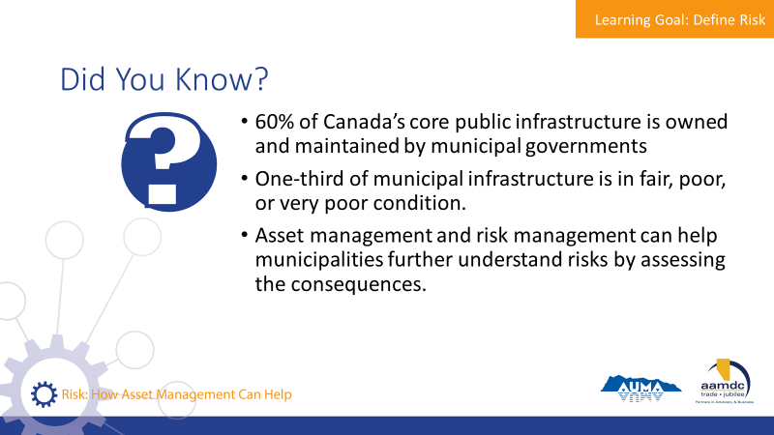 | State:  - To get us started thinking about risk, consider this from the Canadian Infrastructure Report Card:  Read slide.
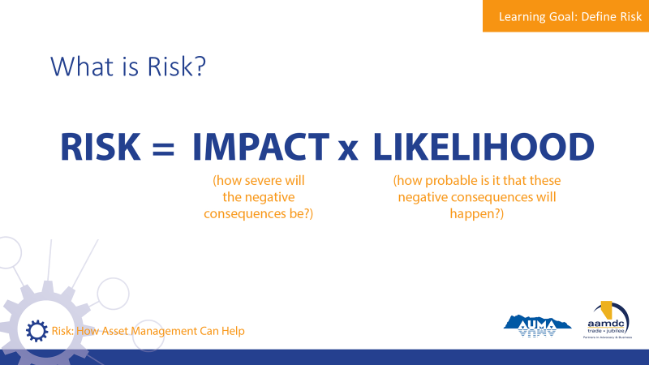 | State:  Risk can be expressed in a simple calculation that sounds something like this:  Risk equals the impact (how severe will the negative consequences be) times likelihood (how probably is it that these negative consequences will happen).
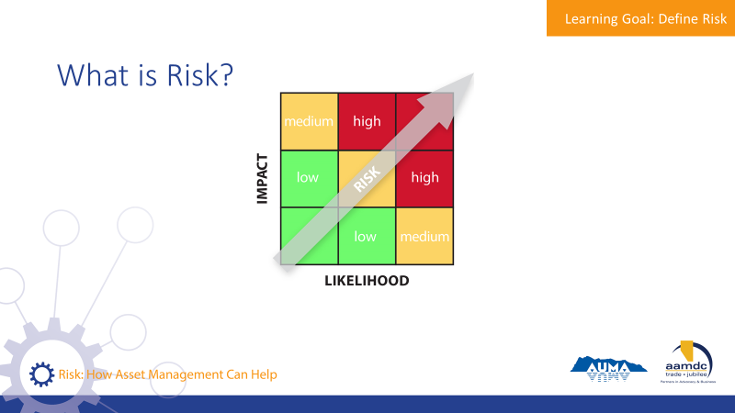 | State:  - This matrix is used to plot the level of risk that might be associated with a particular action or event.  - Who has seen, or used, a similar matrix like this to understand and assess risks?  - Here’s how it works:  Ask participants for a verbal example of a risk. Inquire about the consequence, the likelihood, and show where the risk will fall on the matrix.
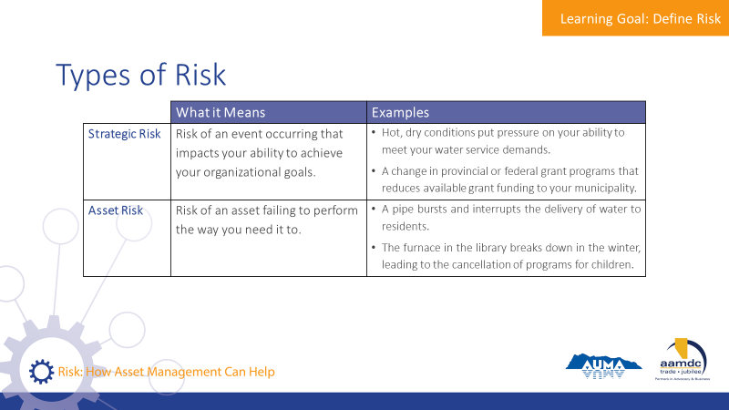 | State:  - Earlier, we introduced a few definitions of risk.  - Let’s review some examples of strategic and asset risks.  - Asset risk describes the risk of an asset failing to perform the way you need it to deliver a service. For example, a pipe bursting, roadway washing out, or lagoon reaching capacity all describe types of asset risks.  - Strategic risk describes a change that would affect your ability to achieve municipal objectives. For example, the Public Works manager retiring without a transition plan in place, a declining revenue base, or changing regulations are strategic risks.  - Climate change is an example of both asset and strategic risk.  - It is an asset risk because changes to temperature and weather patterns may impact the ability of your infrastructure to perform as it was intended to. For example, increased rainfall may overwhelm your stormwater system because it was built for a different capacity and range of events.  - Climate change is also a strategic risk because it changes the assumptions under which services are delivered, which may force your community to draw resources away from some goals towards others. For example, if your community’s water source is becoming compromised by hotter, drier conditions, resources may need to be shifted to find another water source or better secure the existing one.
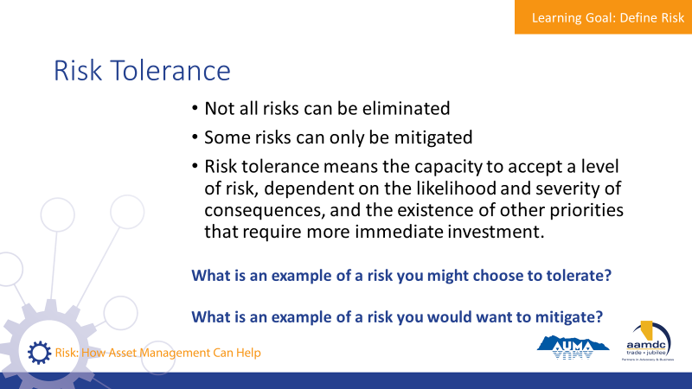 | State:  - Managing risk is not always as straightforward as eliminating risk, and every community and asset has a different level of risk tolerance.  - In some cases, a community can mitigate risks but not eliminate them altogether. For example, a community that faces drought conditions each summer can enact water conservation measures and educate the public but may not be able to prevent the need to enforce water restrictions.  - In other cases, the level of risk may be manageable, but a municipality may choose to tolerate the risk because other priorities are more urgent. For example, a side road in poor condition may be a nuisance for the small portion of the population that uses it, however, investment in repairing the road may be delayed to pay for the cost of repairing a burst pipe.  - Asset management involves the consideration of a community’s risk tolerance.  - Risk tolerance means the capacity to accept a level of risk, dependent on the likelihood and severity of consequences, and the existence of other priorities that require more immediate investment.  - As individual people, our risk tolerance often varies a fair bit. Walk through an example of when one person’s risk tolerance is different than another’s.  - It is important that municipalities talk openly about risk tolerance because different members of staff, council, and the public may have different opinions on what can be tolerated and what should not. It is important to aim for clarity of your municipality’s risk tolerance.  Ask the group:  - What is an example of a risk you might choose to tolerate?  - What is an example of a risk you would want to mitigate?
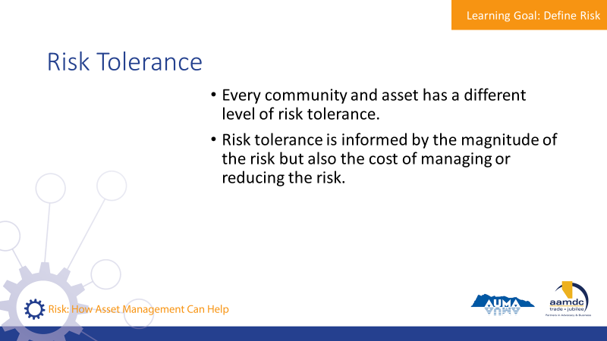 | State:  - Every community has a different level of risk tolerance.  - Attempting to reduce risk as much as possible is prohibitively expensive, and unnecessary.  - Your risk tolerance will be informed not just by the magnitude of the risk (the consequence it will have and the likelihood that it will happen) but also the cost of managing or reducing the risk. This is an example of a trade-off between risk and cost.  - Municipalities and their constituents understand that things aren’t going to be perfect 100% of the time – but the important things need to be pretty good most of the time.  - How do you know if your risk tolerance, as a council and administration, is clear and aligned?
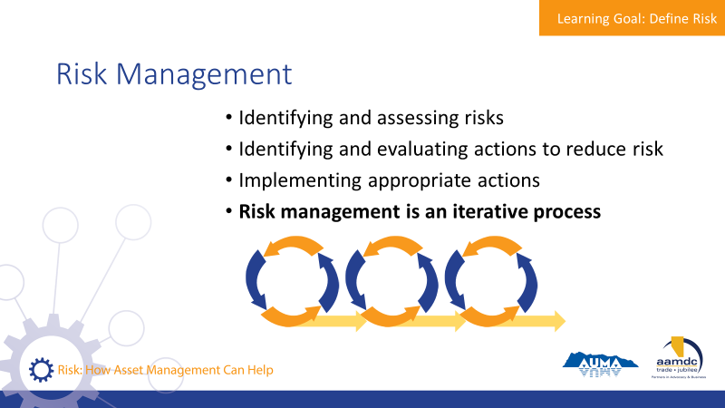 | State:  - Risk management refers to the process of identifying and assessing risks, identifying and evaluating actions that can be taken to reduce risk, and implementing the appropriate actions.  - You then need to start the cycle again, checking if your mitigating actions are effective or not, and responding accordingly.  - Risk management is an iterative process, meaning that the desired result is achieved through repeated efforts, rather than through a single action.
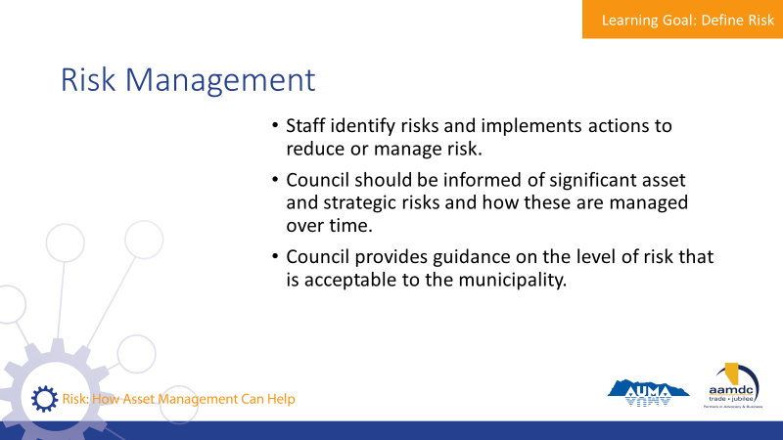 | State:  - Municipal staff identify risks and implement actions to reduce or manage risks.  - Council should be informed of significant asset and strategic risks and how these are managed over time.  - Council provides guidance on the level of risk that is acceptable to the municipality.  - Page 9 of your workbook identifies some additional resources you can turn to if you want to learn more.
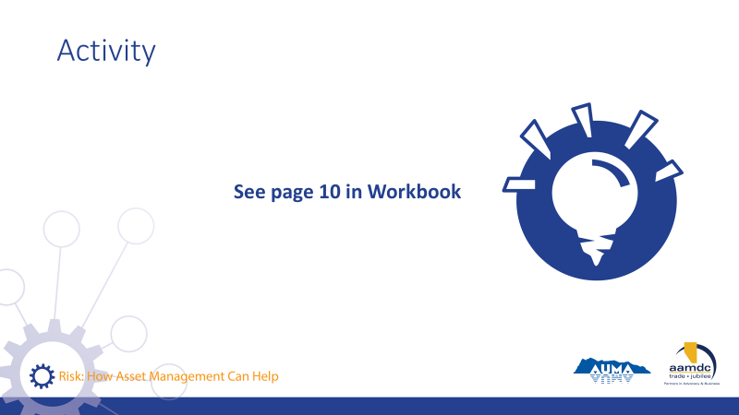 | Activity – page 10 (15 to 20 minutes)  State:  - Let’s turn to page 10 and 11 of the workbook to do an activity on strategic and asset risks.  - In your table groups, read through the questions in your workbook and brainstorm your answers.  - We’ll regroup and discuss together.  Debrief as a larger group.

Learning Goal: Identify Municipal Risks to Service Delivery

45 minutes |
Slides | Script
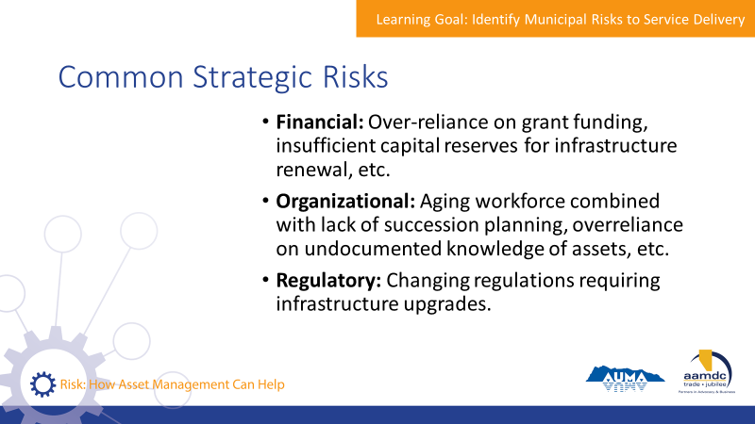 | State:  - Many communities in Canada are facing challenges related to aging infrastructure and delayed investment in asset maintenance and renewal, usually due to lack of budget and other priorities.  - Because of this, many communities are facing similar strategic risks.  - Some common strategic risks are:  Read through slide.
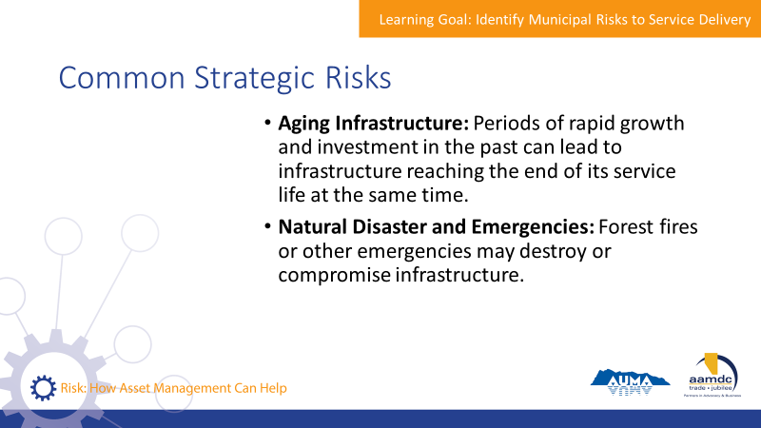 | Read through slide.
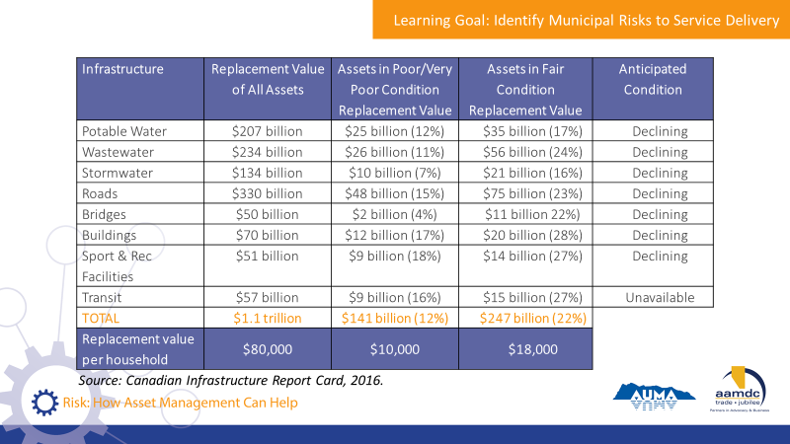 | State:  - Take a look at the table on the slide.  - It shows some information on assets for all of Canada.  - The second column is the replacement value of all assets.  - The third column is the replacement value of assets in very poor or poor condition, while the fourth is for assets in fair condition.  - The last column shows anticipated condition of the assets based on reported reinvestment levels.  Ask the group:  - What are your initial reactions to seeing this information?
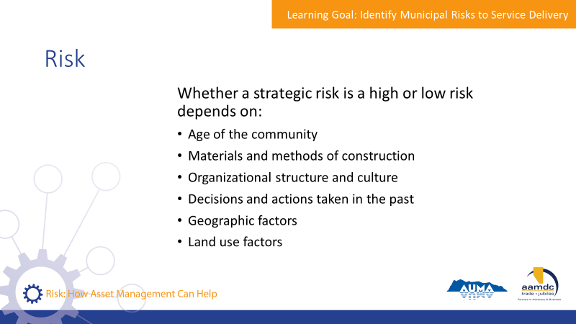 | State:  - While there may be similar strategic risks across communities, what is a high risk in one community may be a low risk in another. This depends on unique factors such as:  - The age of the community  - The materials and methods of construction – some may be well-designed while others may be made of low quality materials or were built for older standards.  - Organizational structure and culture – some organizations are good at sharing information across departments and use systematic approaches to decisions, while others don’t.  - Decisions and actions taken in the past – such past decisions on how to maintain infrastructure, or how much money to set aside for renewal.  - Geographical factors – for example, some communities rely on gravity for drainage and have fewer mechanical assets that can fail.  - Land use factors – for example, lower density communities may have higher per capita costs for maintenance and replacement of infrastructure.  - Climate change is also introducing new risks to infrastructure and municipal service delivery.  - For example, droughts can mean that existing sources of water may not be as reliable in the future, or existing drainage infrastructure may be inundated by increasingly intense storms.
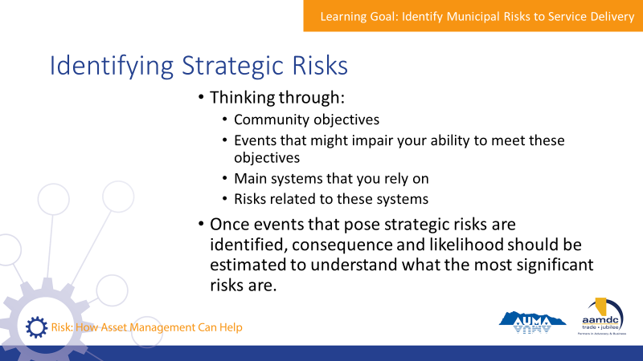 | State:  - Identifying strategic risks in your community means thinking through:  - Community objectives – such as delivery of core services, sustainable services, meeting regulations, growth and development, attracting new businesses, etc.  - Events that might impair your ability to meet these objectives  - The mains systems you rely on to meet your objectives  - Any risks related to these systems
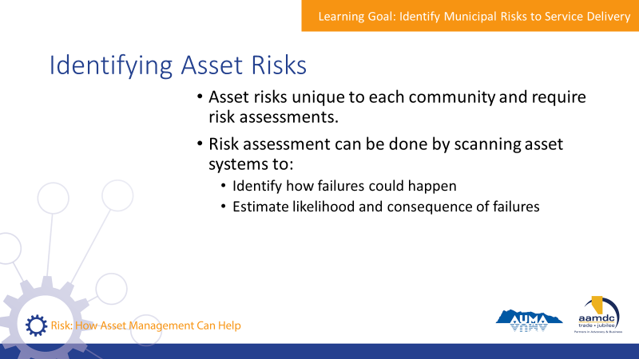 | State:  - Asset risks are related to specific assets and are unique to each community.  - Identifying asset risks requires risk assessments.  - These can be done by scanning asset systems, such as the water system or recreation assets, to identify:  - How failures could happen  - The likelihood and consequence of these failures  Emphases:  - In the case of both strategic and asset risks, once you know what your risks are, they can be ranked and prioritized. Then you can plan for managing the risks as you need to.
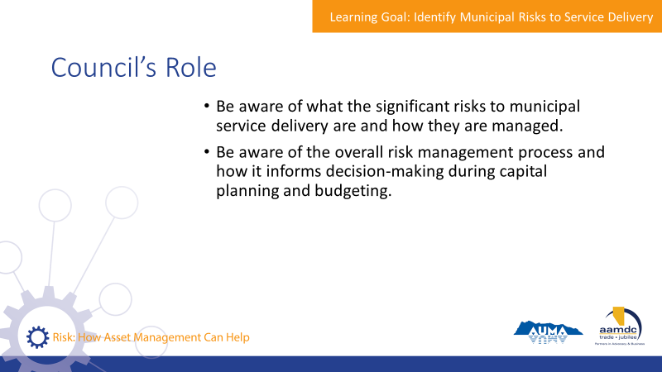 | State:  - It is the responsibility of staff, not council, to conduct risk assessments for both strategic and asset risks.  - Council is responsible for being aware of what the significant risks are to municipal service delivery, and how they are managed.  - Council should be aware of strategic risks, and how these are being managed. If an asset risk is high enough, council should also be aware of these risks.  - Council should also be aware of the overall risk management process, and how it informs decision-making during capital planning and budgeting.
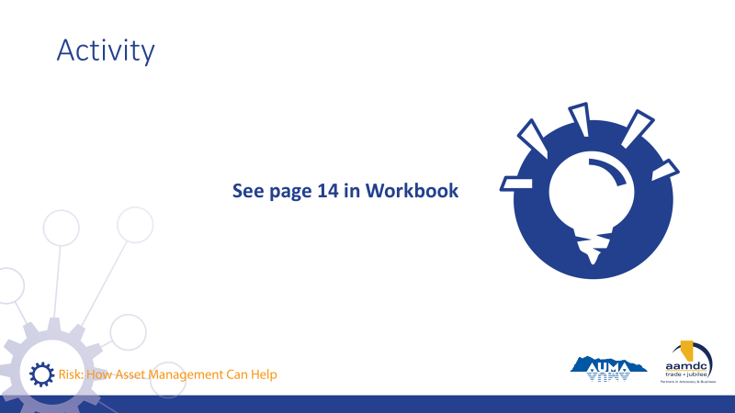 | Activity – page 14 (15 minutes)  State:  - Let’s turn to page 14 in your workbook and do some brainstorming about risk.  Go through each question as a group.

Module 2 – Identify How Asset Management Supports Municipal Risk Management

Learning Goal: Describe the Basic Process for Risk Management

30 minutes |
Slides | Script
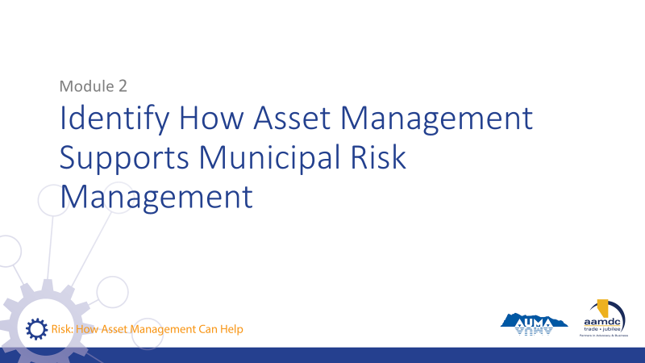 | State:  - As we move on to the next module, we’re going to go into how asset management supports municipal risk management.
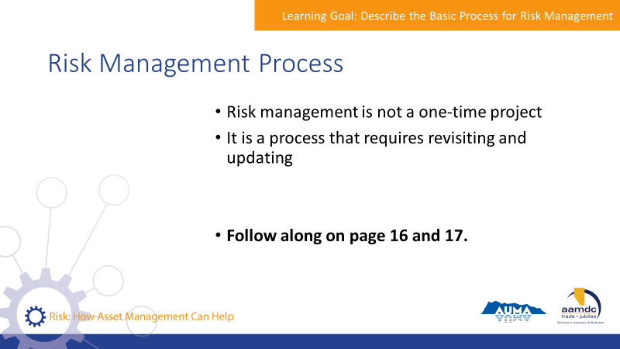 | State:  - Risk management is not a one-time project that has a date of completion.  It is a process and requires revisiting and updating.  - Keep your workbooks open to page 16 and 17. There’s an opportunity for you to jot down notes as we go and you think about risks in your own community.  - As we go through the risk management process, think through risks to service delivery in your community.
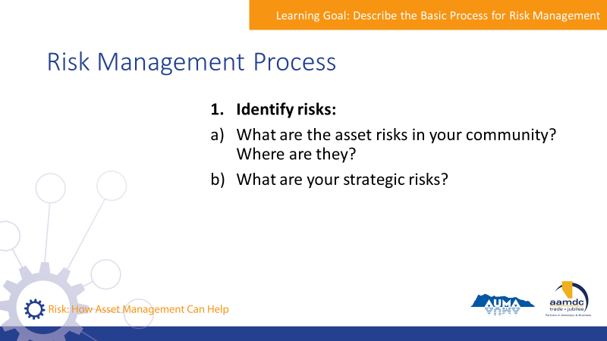 | State:  - The first step in a risk management process is identifying risks.  Ask the group:  - What are some of the asset risks in your community?  - Do you know where they are?  - What are some strategic risks?  Discuss together.
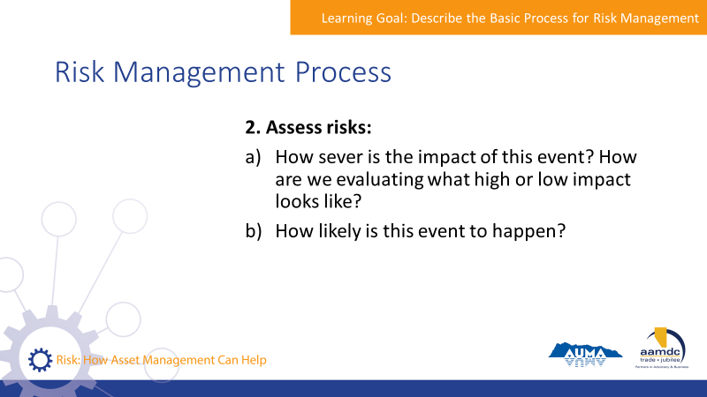 | State:  - The next step in the process is assessing your risks.  Ask the group:  - When thinking about risks in your community, how severe is the impact of the events you identified in step 1?  - How does your community evaluate what high or low impact looks like?  - How likely is this event to happen?
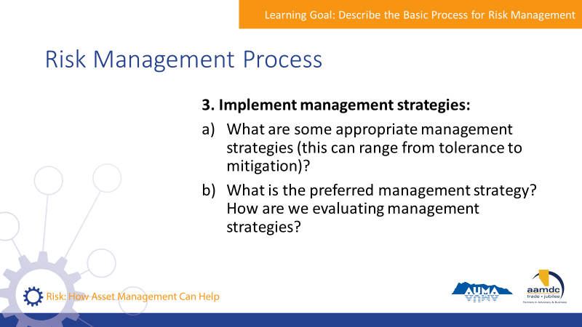 | State:  - When you know your risks and the likelihood and severity of impacts, then you can identify and implement management strategies.  Ask the group:  - What are some appropriate management strategies for the risks you identified?  - What is the preferred management strategy?  - How are you evaluating management strategies?
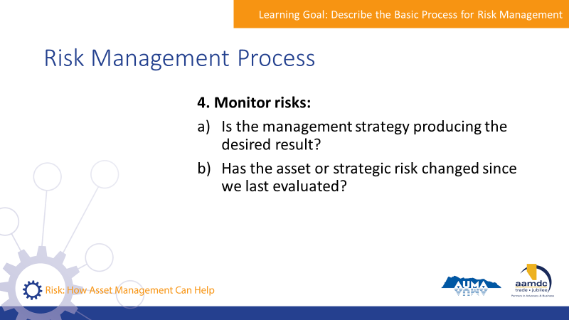 | State:  - Once you’ve implemented risk management strategies, then you can monitor those risks to see how they change over time.  Ask the group:  - Is your community’s management strategy producing the desired result?  - Have the asset or strategic risks changed since you last evaluated the risk?
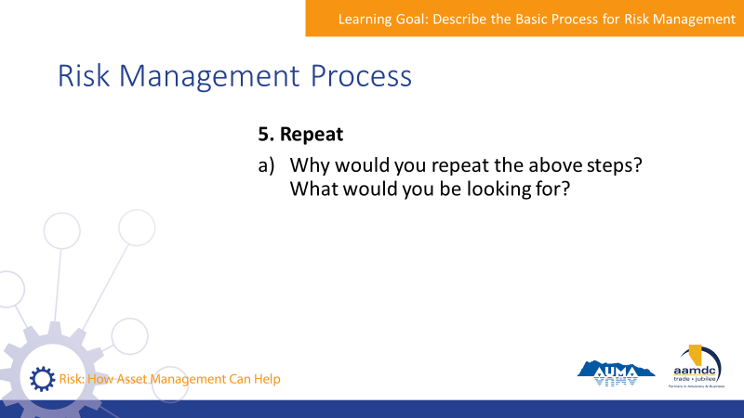 | State:  - As we said at the beginning, risk management is an iterative process. Rinse-repeat.  Ask the group:  - Why would you repeat the above steps?  - What would you be looking for?
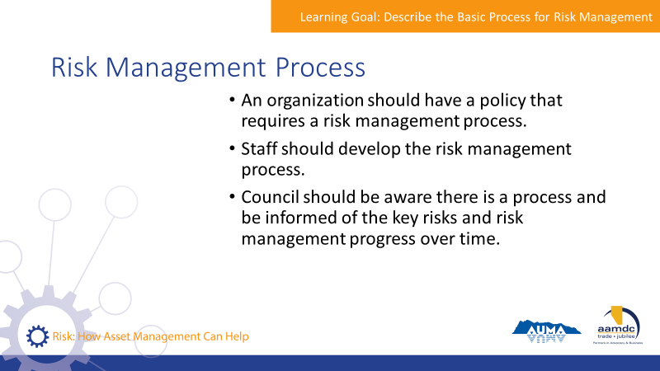 | State:  - An organization should have a policy that indicates the requirement for a risk management process.  - It is up to staff to develop the risk management process.  - Council should be aware that there is a process and be informed of key risks and progress on managing these risks.
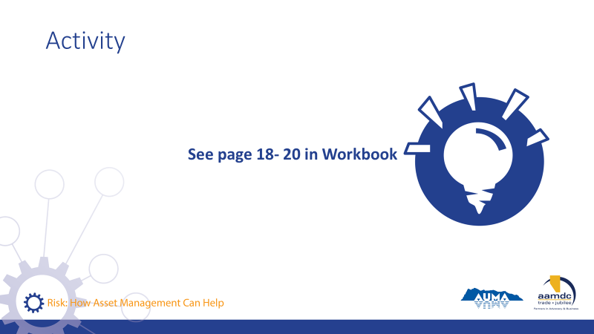 | Activity – pages 18 to 20 (15 minute)  State:  - Turn to page 18 in your workbook.  - In your table groups, read through the three scenarios presented on pages 18 to 21 and choose one (or two, if time) scenarios to complete.  - Discuss together and write your answers in your workbook.  Debrief as a group. Listen for:  - Description of consequence and likelihood  - Asset vs. strategic risk  - Risk tolerance  - A process of identifying a few options for mitigating risk (capital and operational solutions) and assessing these options

Break
15 minutes |

Learning Goal: Identify How Asset Management Supports Risk Management

45 minutes |
Slides | Script
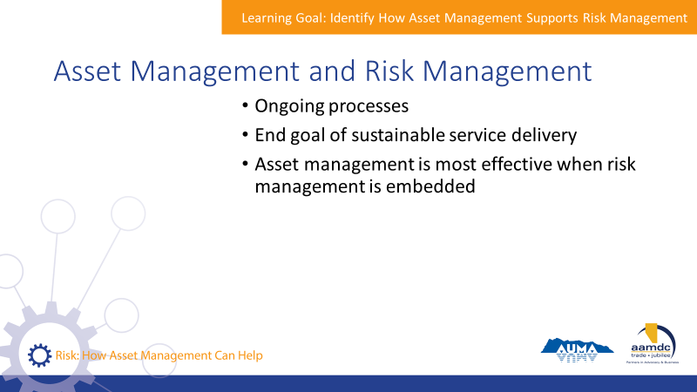 | State:  - There are a lot of parallels between asset management and risk management.  - Both are ongoing processes.  - The end goal of both is sustainable service delivery.  - Asset management is most effective when risk management is embedded into the process.
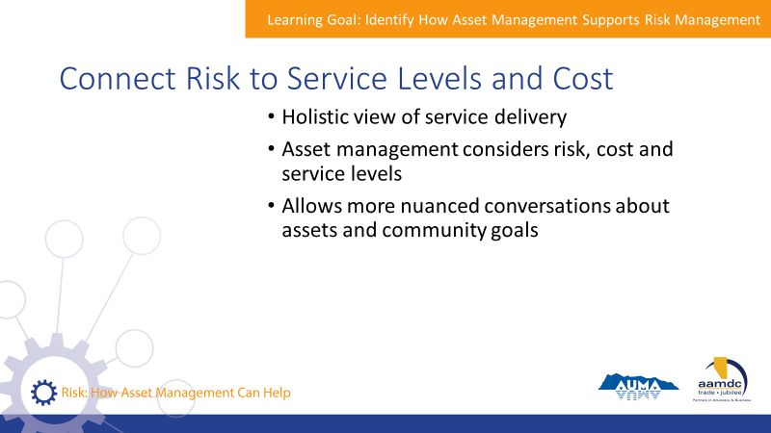 | State:  - Asset management supports risk management in a number of ways.  - It takes a holistic view of service delivery and considers risk alongside cost and service levels.  - By considering these together you can have more nuanced conversations about assets and how they support your community’s long-term goals.
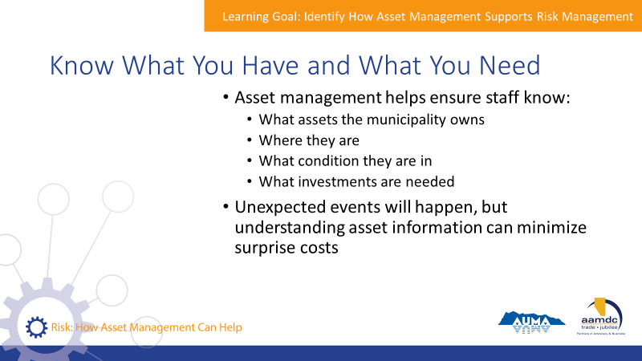 | State:  - Asset management helps staff know what assets the municipality owns, where they are, what condition they are in, and what investments are needed to keep them working.  - There will always be unexpected events, but having good information on your assets helps keep surprise costs to a minimum, and helps your react better when unexpected things happen.  - For example, a community that has compiled their asset information can react quickly and effectively if they experience a water main break.  - That’s because they know where the valves are to isolate the break.  - They also will know the alignment of the water main, the size and material the main is made of.  - This makes repairs easier and faster.
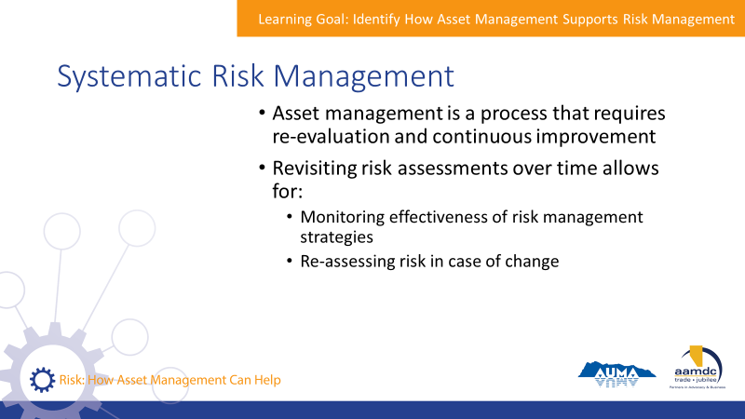 | State:  - Asset management is a process that requires re-evaluation and continuous improvement.  - Revisiting risk assessments over time helps you accomplish a few things:  - Monitor the effectiveness of risk management strategies  - Re-assess risk in case of changes
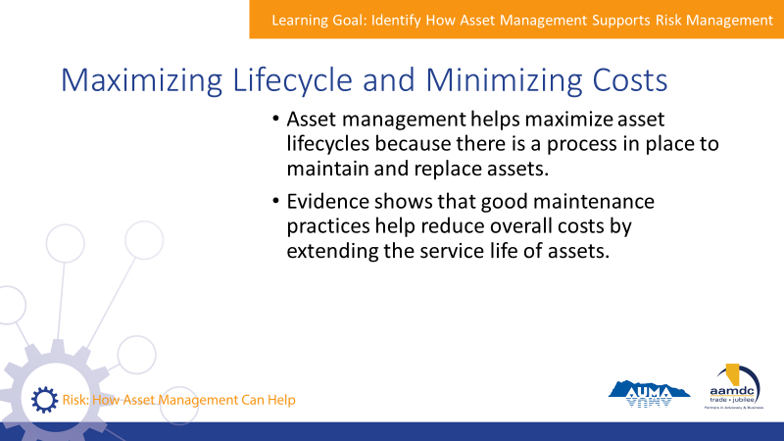 | State:  - Asset management helps maximize asset lifecycles because there is a plan and process in place to maintain and replace assets as need.  - There is significant evidence that good maintenance practices help reduce overall costs by extending the service life of assets.
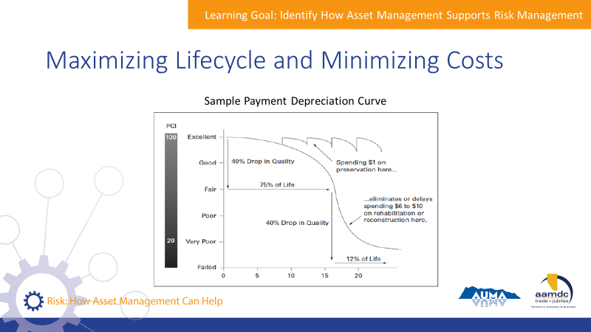 | State:  - This graph illustrates how good maintenance practices help extend the life of roads almost indefinitely.  - Costs of performing road maintenance, things like crack sealing, are several times lower than reconstructing the full roads.  - This is an example for roads, but other types of assets exhibit similar patterns where appropriate investment in maintenance can significantly extend the life of the asset.
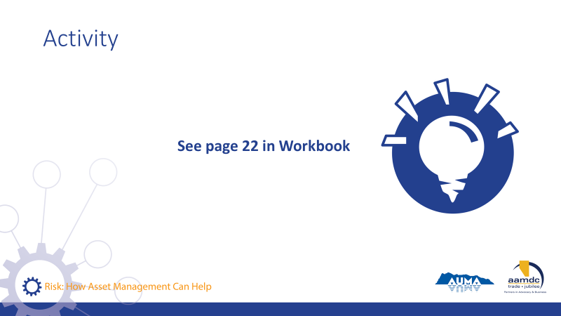 | Activity – page 22 (10 minutes)  State:  - Turn to page 22 in your workbook.  - Take a few minutes to read the scenario presented.  - In your table groups, discuss the questions in your workbook.  - What are the risks (strategic and asset) in this scenario?  - What are the assets?  - What are the trade-offs?  - How should this community go about making a decision in this scenario?  Debrief as a group. Listen for:  - How risks could be assessed and evaluated  - Options for mitigating the risks  - Choosing between the options  - Assessment of asset and strategic risks

Learning Goal: Identify Asset Management Tools that Support Risk Management

30 minutes |
Slides | Script
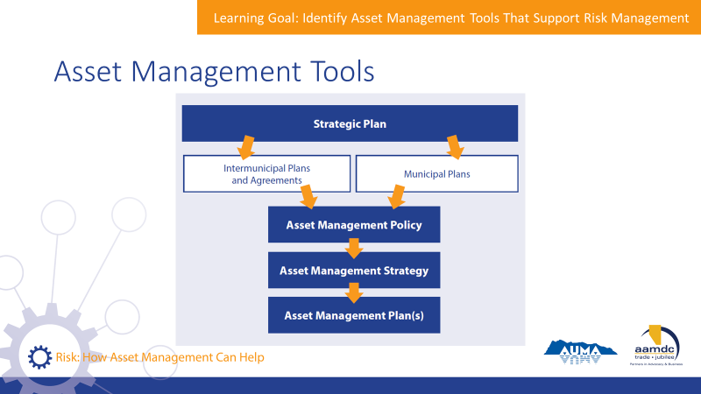 | State:  - There are a number of asset management tools that municipalities can use to support risk management.  - Asset management tools are things like your AM Policy, Strategy, and Plan(s)  - The chart on the slide shows you how these relate to each other.  Review chart.
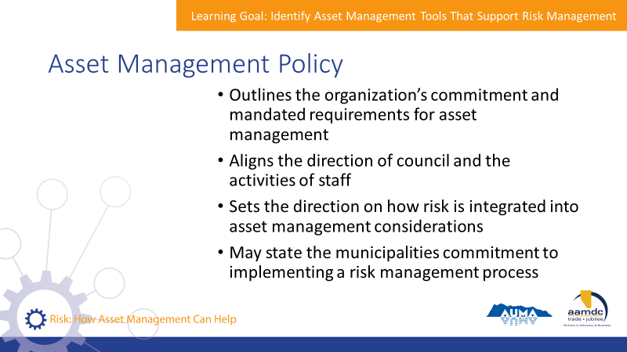 | State:  - The highest-level asset management tool is an asset management policy.  - An asset management policy:  Read slide.
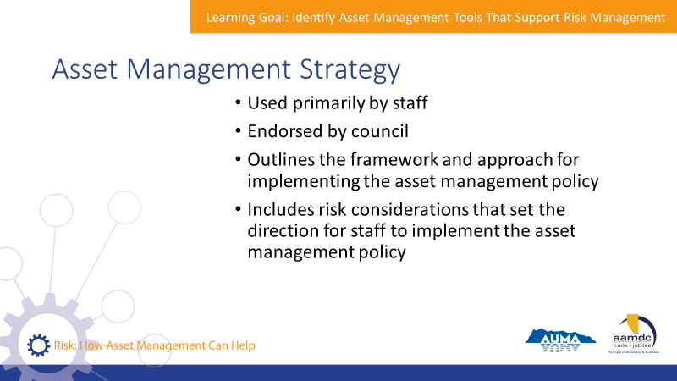 | State:  - While a policy sets the organization’s direction on asset management, including risk management, an asset management strategy provides more direction and is used primarily by staff.  Read slide.
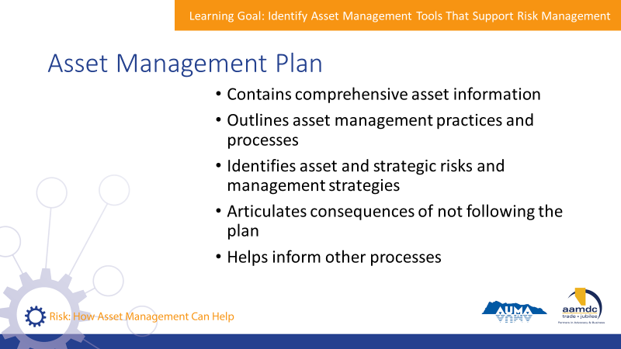 | State:  - An asset management plan is a more detailed document outlining how your community manages specific assets.  Read slide.
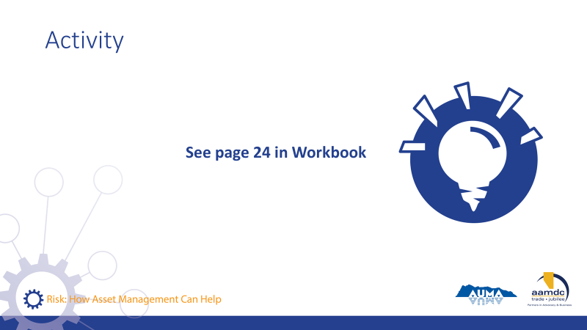 | Activity – page 24 to 25 (10-15 minutes)  State:  - Turn to page 24.  - Let’s think through how the different asset management tools help you manage risks.  - As we’ve discussed, asset management tools support risk management. They also connect to other documents and plans.  - The diagram in your workbook shows how these fit together.  - In table groups, brainstorm and answer the question on page 24 and 25.  - What are some of the ways that risk and risk management would be considered in each of the tools?  Debrief together. Listen for:  - MDP: strategic risks of developing new areas, increasing density, or otherwise changing land use. Risk to LOS of growth or decline of population.  - Strategic Plan: addressing significant strategic risks may be key priority areas in the organizational strategic plan  - Capital plan: capital projects to manage asset and strategic risks. Risk assessment informs what type of capital project should be used to mitigate the risk, when it is necessary, and the consequences of not doing that project.  - Budget: Capital and O&M projects to manage asset and strategic risks.

Learning Goal: Describe Council’s Role in the Risk Management Process

20 minutes |
Slides | Script
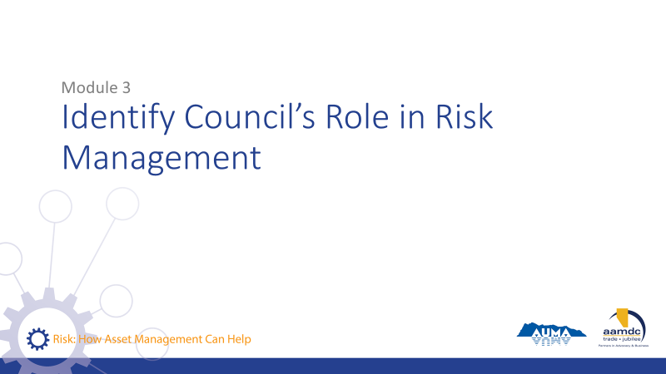 | State:  - We’ve spent a lot of time today going into what risks communities face and how they manage these risks through asset management.  - Let’s spend some time going into the specific role of council in risk management.
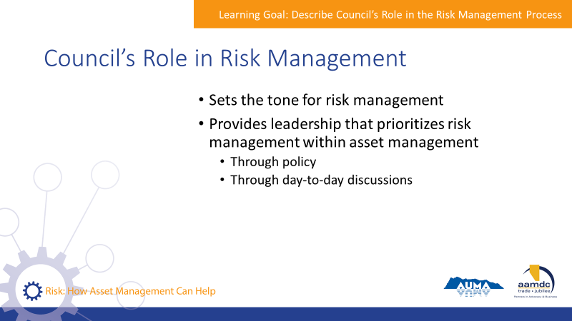 | State:  - Council plays an important role in setting the tone for risk management.  - Council provides leadership to prioritize risk management within asset management.  - They do this through policy, of course, but also through day-to-day conversations by asking for and considering information about risk when making decisions.
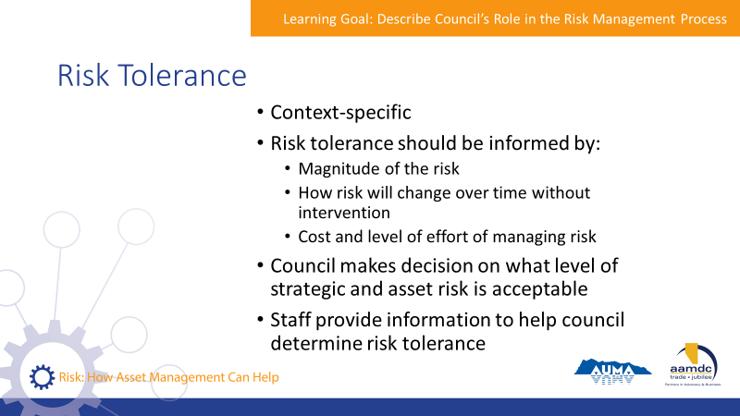 | State:  - We know that risk tolerance is context-specific, unique to each asset and each community.  - Risk tolerance should be informed by:  - The magnitude of the risk  - How the risk will change over time without intervention  - The cost and level of effort of managing the risk  - Council’s primary role is making decision on what level of strategic and asset risk is acceptable.  - Staff provides council with information to help council determine risk tolerance.
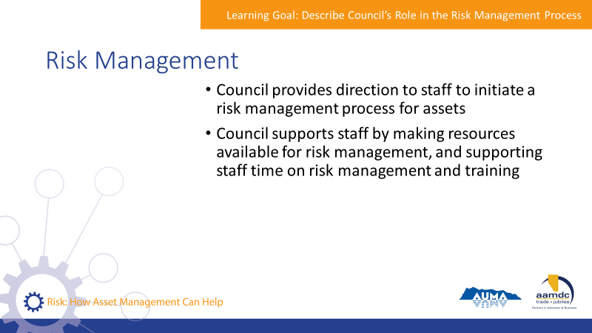 | State:  - When it comes to risk management, council provides direction to staff to initiate a risk management process for assets, if one doesn’t already exist.  - Council supports staff by making resources available for risk management.  - Or by supporting staff spending time on risk management and training.
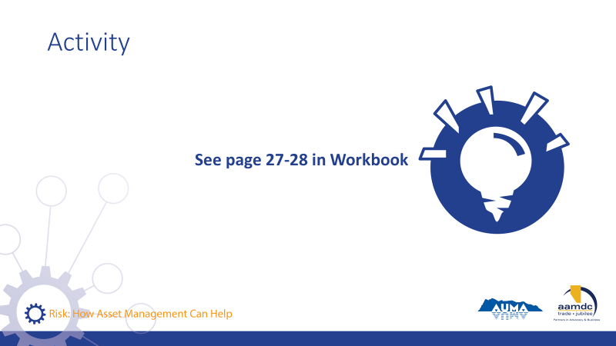 | Activity – page 27 (20 minutes)  State:  - Turn to page 27 in your workbook.  - Working in your table groups, brainstorm answers to the questions on page 27 and 28. Think about the application to your own community.  - We’ll go through some answers together.  Debrief as a group.

Learning Goal: Concluding Remarks

10 minutes |
Slides | Script
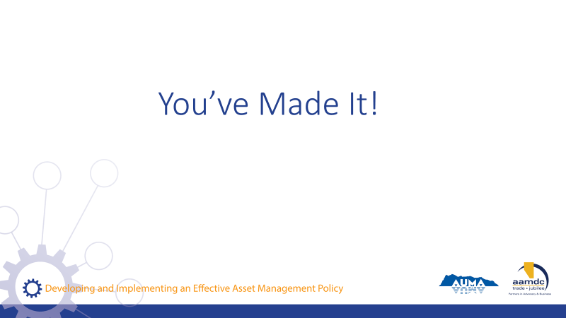 | State:  - Well, you’ve made it!  - Here we are at the end of the course.  - I hope you found today full of learning, good conversation, and shared insight. I want to thank you for joining us.  - Remember, today is just a start.  - Together, we’ve laid the foundation, but we hope that you’ll continue to learn, ask questions, and participate in other opportunities to expand your knowledge of risk and asset management.  - Throughout the workbook, and at the back, you can find the glossary and a list of resources if you ever need to reference something you learned in this course.
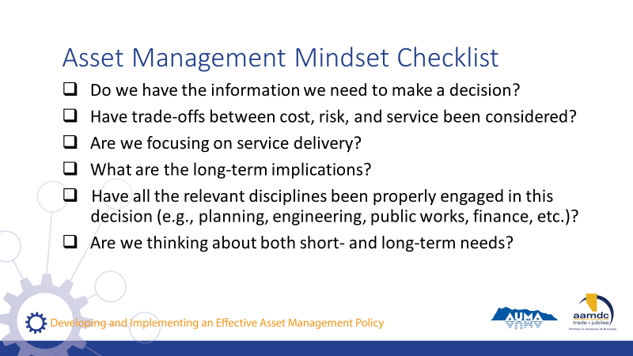 | State:  - If you got anything out of today, we hope that it was an understanding of how an asset management mindset can support you in your role as an elected official and steward of community well-being.  - If you’re ever stuck, start by asking yourself some questions:  Read questions on slide.  State:  - All of these questions apply to the integration of climate change and asset management.
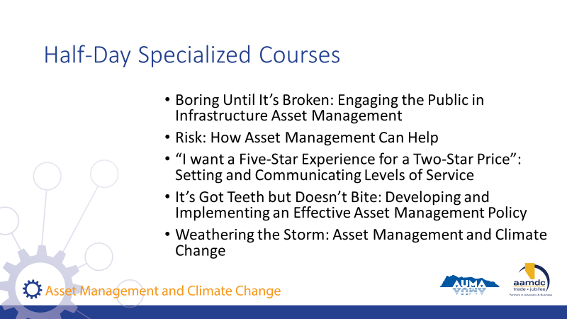 | State:  - AUMA and RMA offer five half-day courses as part of these series on specific topics related to asset management.  Read courses on slide.  - If you want to find out more, talk to us after class.
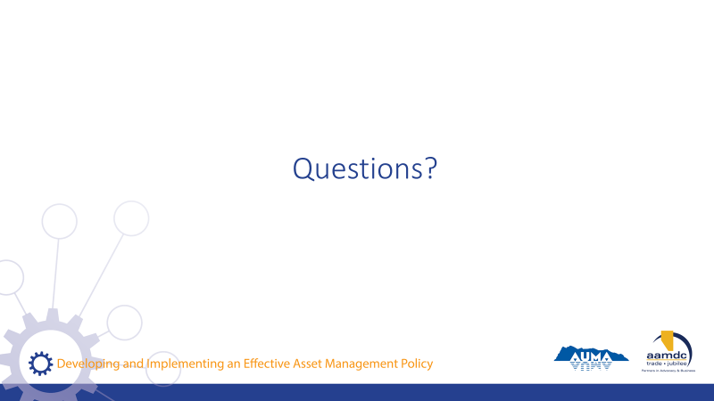 | State:  - Before we leave for the day, does anyone have any remaining questions about anything we covered?
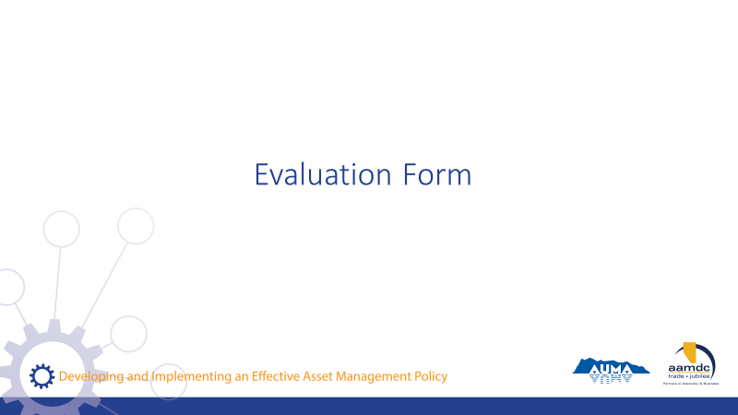 | State:  - Before you leave today, we would really value getting your input on this course.  - Your input will help us to understand how the course helped you (what worked for you) and where we can be making improvements.  - Thanks for taking about 10 minutes to provide your feedback. Once completed, you can leave your forms on (pick a central location for all forms so they remain anonymous).

NOTES

