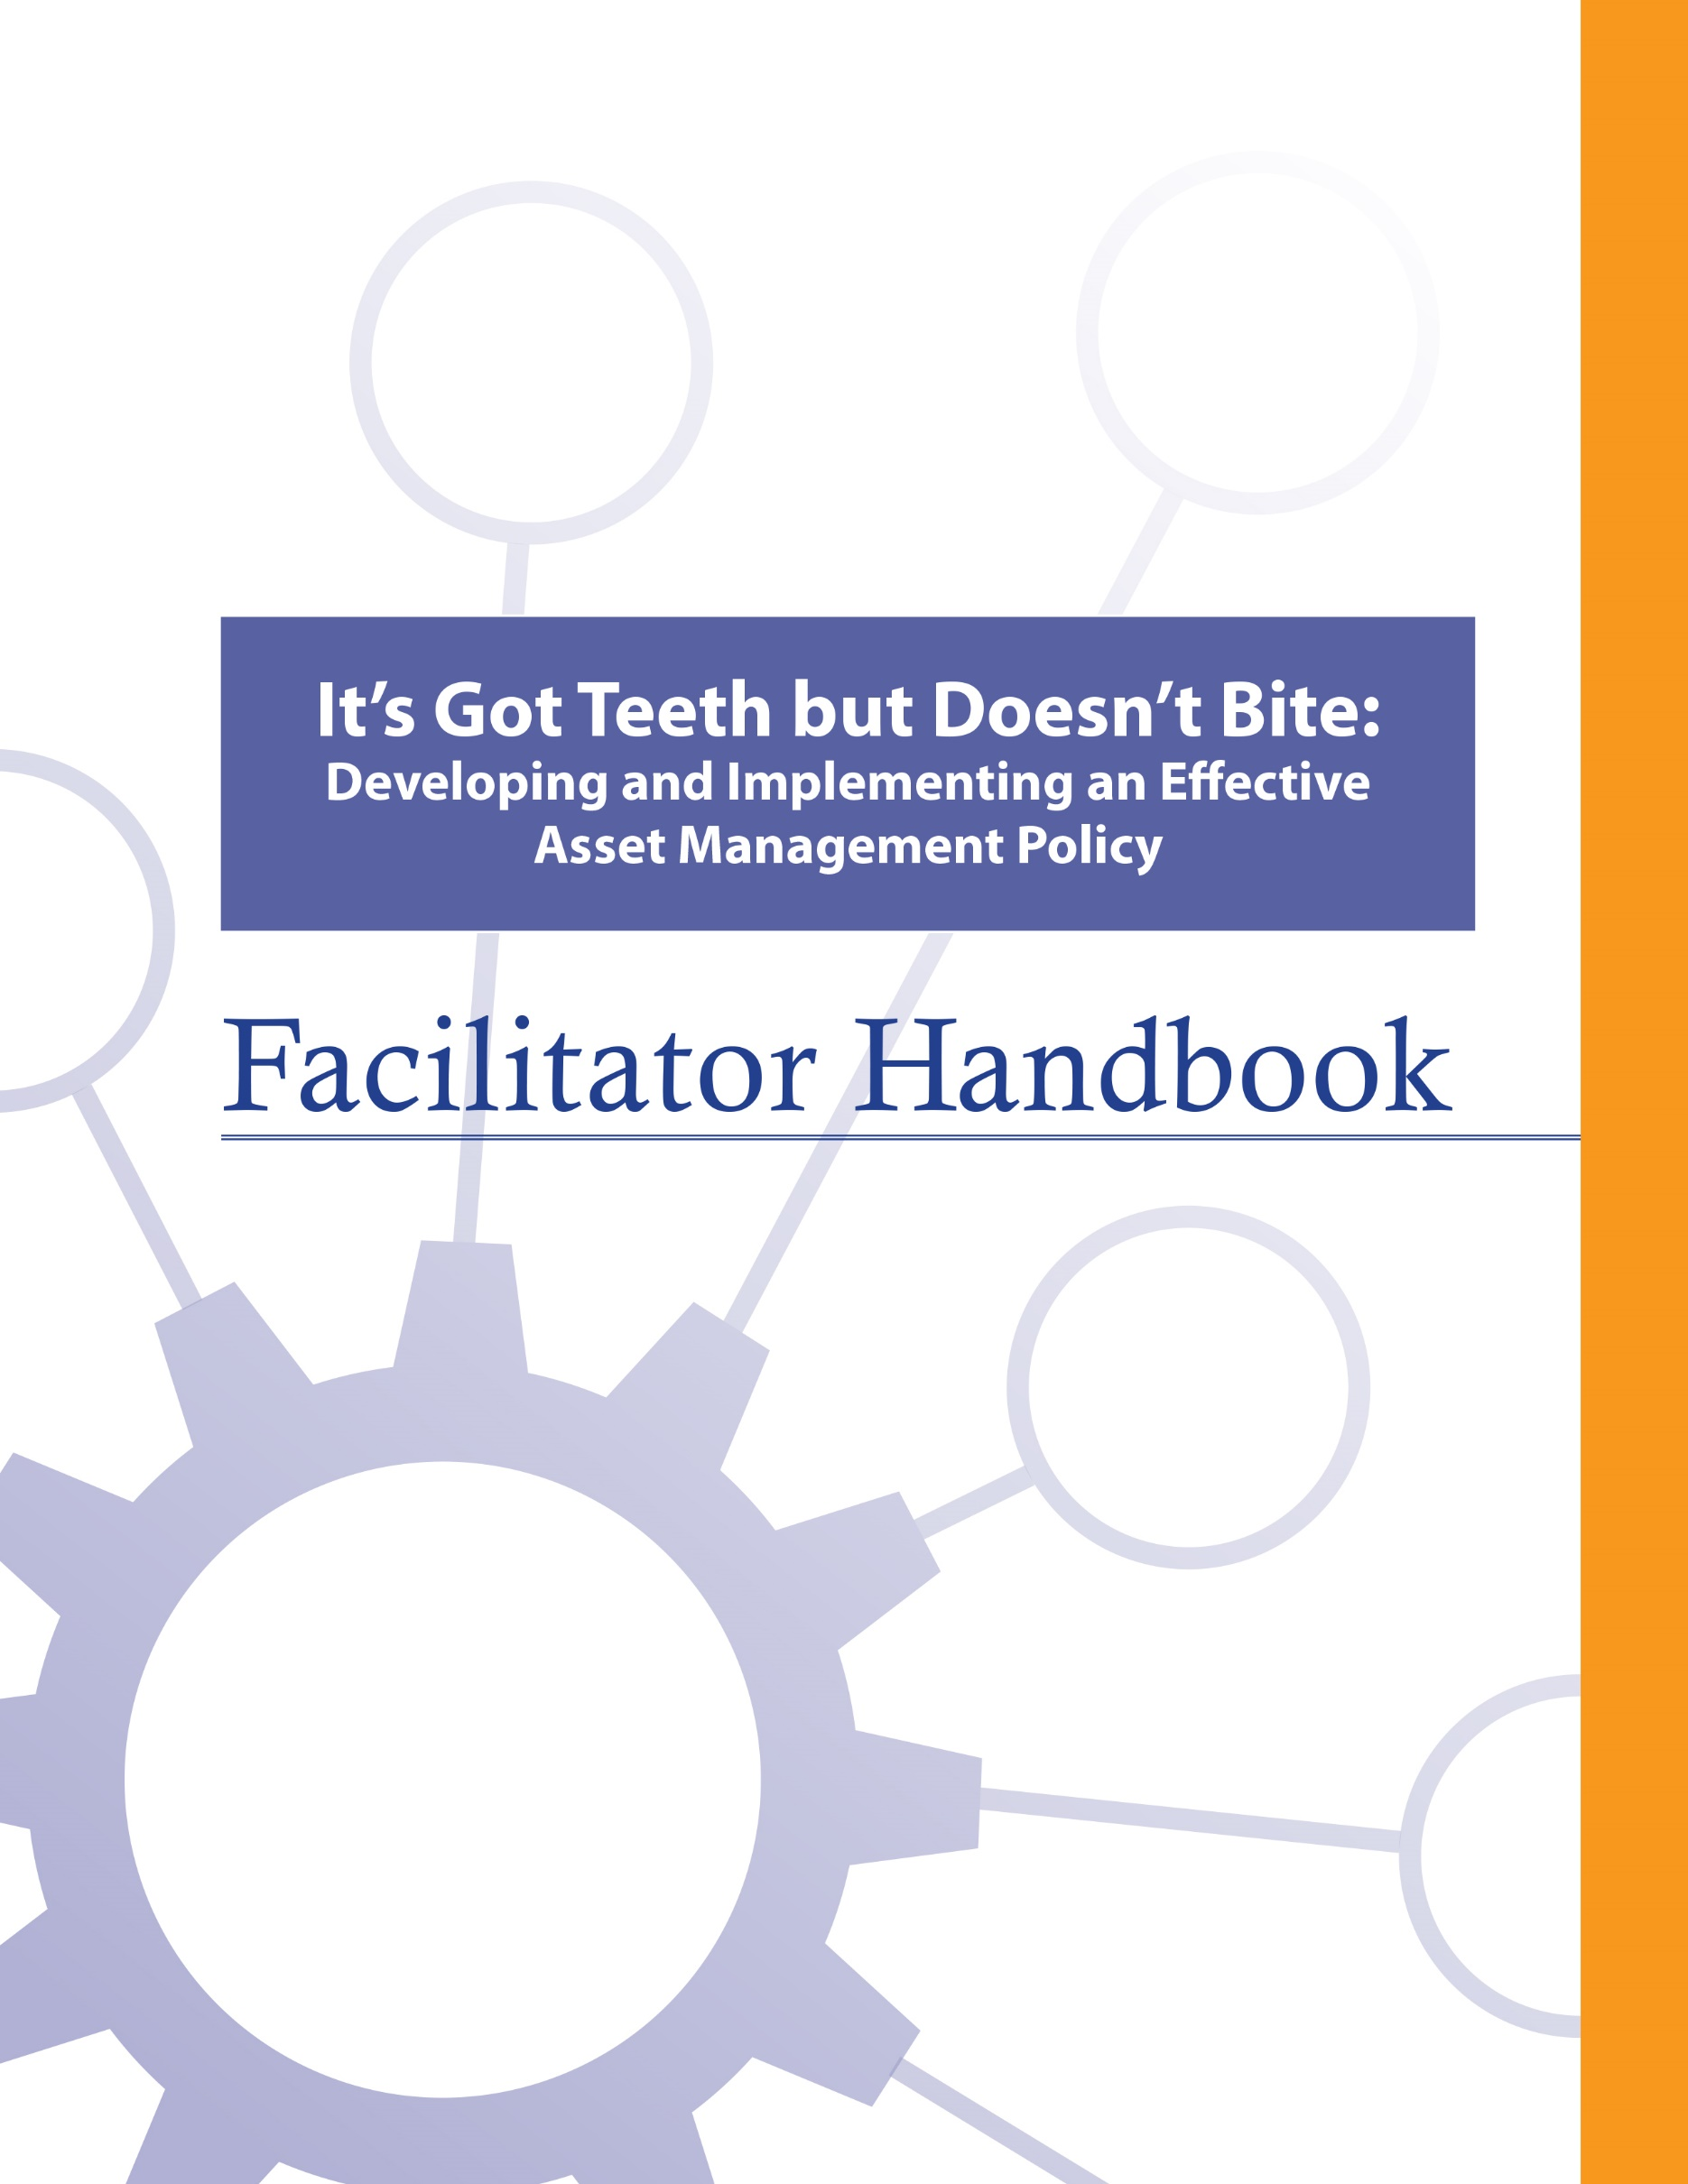

About the FCM
The Federation of Canadian Municipalities (FCM) has been the national voice of municipal government in Canada since 1901, advocating for the needs of municipalities and their citizens. FCM’s membership includes large cities, small urban and rural communities, and 20 provincial and territorial municipal organizations.

About RMA
Formerly known as AAMDC, Rural Municipalities of Alberta (RMA) is an independent association representing Alberta’s 69 counties and municipal districts. Since 1909, the RMA has helped rural municipalities achieve strong, effective local government.

About AUMA
Founded in 1905, the AUMA represents 269 urban municipalities including cities, towns, villages, summer villages, and specialized municipalities. AUMA works with federal and provincial governments and business and community stakeholders on a broad range of issues to strengthen the economic, social, cultural, and environmental vitality of its member municipalities.

This initiative is offered through the Municipal Asset Management Program, which is delivered by the Federation of Canadian Municipalities and funded by the Government of Canada.

TABLE OF CONTENTS

How to Use this Facilitator Handbook 1
Characteristics of Adult Learners 2
Agenda 6
Introductory Remarks 7
Learning Goal: Asset Management Refresh 10
Module 1—Identify the Role of Policy in Asset Management 13
Learning Goal: Identify the Role of Policy in Municipal Governance 13
Learning Goal: Identify the Role of Policy in Asset Management 16
Module 2 – Evaluate Asset Management Policy Statements 19
Learning Goal: Outline an Organization’s Commitment to Asset Management and the Objectives and Mandated Requirements for Asset Management 19
Learning Goal: Connect Asset Management to the Organization’s Strategic Objectives, Values, Priorities, and Community Objectives 21
Learning Goal: Outline Principles to Guide Decision-Making About Assets and the Approach to Managing Costs and Funding 22
Learning Goal: Concluding Remarks 24

How to Use this Facilitator Handbook
This Facilitator Handbook was created to be a resource for the professionals who will be instructing the course on behalf of the RMA and AUMA. The Facilitator Handbook is intended to help instructors to provide consistency, and to facilitate the course effectively, within the instructional time available.

How to read the guide:
- The facilitator script and instructions are provided in the right column.
- Thumbnails of the slides corresponding to the script are in the left column.
- The facilitator’s script appears in normal type.
- Additional notes to facilitators appear in bold print.
- Sample responses, discussion points and answers for participant activities appear in italics.

Characteristics of Adult Learners
While we may act like it sometimes, adults are not just big kids. And, we don’t want to be taught like children. As adults, we learn in a very different way than our shorter, younger (maybe even thinner) selves. When we think about a typical learning environment, many of us recall past school days. During those times, our very identity revolved around being a student.
For most of us, the model we have for instructing comes from the teachers who taught us back in the day. However, the teaching techniques that worked for our grade eight English teacher may not be as appropriate for those of us now instructing adults – adults who are also our colleagues and peers. It is important for facilitators of adult education to understand how adults learn and to incorporate teaching principles and strategies that will meet the unique needs of adults and foster the most positive, engaging and productive learning environment possible for them.
What is so different about adults and how can we, as training professionals, incorporate instructional techniques that respect those differences? Below are some generally accepted insights that you may find helpful.

Adults want to have control over their learning
We adults tend to be self-directed. We have work, family and community responsibilities that require us to exercise some level of competence and control. In fact, we can get downright resentful when others take away our right to make choices around our own affairs. This is true when it comes to our learning experiences -- we typically need to exercise some control here, too. In fact, take away our sense of control over how and when we engage in formal learning and you will likely meet some resistance.

What’s a facilitator to do?
- Include adult learners in the planning of their learning (engage them in needs assessments and encourage their input on course objectives & content wherever possible).
- Encourage self-assessment and self-evaluation (rather than instructor-based evaluation).
- Establish a peer relationship with learners rather than the traditional hierarchical one.
- Make yourself available to adult learners outside of the formal learning environment if possible.

Adults, more so than youth, draw upon their experiences as a resource in learning
Been there, done that. Adults have a wealth of past experiences simply because we’ve lived longer than youth. As learners, our past experiences are important resources that we draw on. Adults tend to link new learning to prior learning (much of which is rooted in life experience). Learning is all about accepting and applying new ideas and concepts. For adults, that process often happens within the context of how the idea or concept “fits” with what we’ve already experienced.

What’s a facilitator to do?
- Take time to get to know the experiences of your adult learners and be intentional about helping them link new concepts and ideas with prior learning or experiences.
- Encourage open discussion on how new concepts and ideas being presented fit with the experience of learners.
- Encourage learners to share their experience for the purpose of teaching others. Ask versus tell. Using questions can draw out the information you want to focus on and is an effective way to encourage adult learners to apply their own skills and experience to facilitate their learning.

Adults tend to be more motivated in learning situations than youth
When adults find themselves in a formal learning environment, most times it’s because they want to be there. Adults are not typically motivated by gold stars or good report cards. Instead, they want a learning outcome that can be put to use immediately in concrete, practical and self-benefiting ways.

What’s a facilitator to do?
- Don’t spend a great deal of effort trying to motivate adult learners. Rather, see your role as facilitating the learning they are ready to experience.
- Ensure teaching is relevant to what learners want to learn and what they will be able to use back on the job.
- Accept that people will learn at different rates and in different ways. Some will learn by being told, others will learn by doing. Still others will need to be shown. Use a diversity of teaching methods to ensure your learners stay motivated to learn.

We’re generally more pragmatic in learning than youth
Adults are typically more interested in problem solving than information gathering. Learning “theory,” which must be stored away for future use, can be frustrating and seem irrelevant for many adult learners. Especially for adults, learning becomes complete when we put into practice what we are attempting to learn.

What’s a facilitator to do?
- Using job-related case studies and hands-on exercises and activities will help learners to immediately use what they’re learning in a problem-solving situation. The more often we use what we have learned, the better we can perform or understand it.

Some adults lack confidence in their learning
Some adults who have been away from a formal learning environment for some time may consider the learning “glory days” over. These perceptions can influence how confident they feel during learning situations. Interestingly, research shows that the attention span of the average adult is between 8 and 20 minutes.

What’s a facilitator to do?
- Provide opportunities for learners to receive constructive feedback on how they’re doing (either through guided self-evaluation, constructive input from other participants, or the facilitator’s own observations).
- Present information in a manner that permits mastery in “bite size chunks” with opportunity for hands-on application.

Many adults are more resistant to change than youth
Learning often involves change of some kind. Youth tend to be more idealistic and are often open to change just for the sake of change. However, over the course of being an adult, our experiences around change have not always been good and can lead us to be somewhat resistant to it.

What’s a facilitator to do?
- Encourage learners to explore the “why” of change, not just the “how.”
- Link new concepts to older, understood and accepted concepts.

A group of adult learners will typically be more diverse than a group of youths
A group of adults, more so than a group of youths, will vary a great deal in terms of age, experiences, and backgrounds. Differences can be a powerful resource for learning as adults collaborate together on tasks.

What’s a facilitator to do?
- Allow time for interaction between learners and create opportunities for them to work together in groups to collaborate and share perspectives and experiences.
- Present material in a variety of ways to accommodate a diversity of learning styles.

Agenda
Time | Topic | Facilitator’s Name
20 minutes | Introductory Remarks
30 minutes | - Asset Management Refresh
20 minutes | - Identify the Role of Policy in Municipal Governance
35 minutes | - Identify the Role of Policy in Asset Management
15 minutes | Refreshment Break
45 minutes | - Outline an Organization’s Commitment to Asset Management and the Objectives and Mandated Requirements for Asset Management
15 minutes | - Connect Asset Management to the Organization’s Strategic Objectives, Values, Priorities, and Community Objectives
45 minutes | - Outline Principles to Guide Decision-Making About Assets and the Approach to Managing Costs and Funding
15 minutes | Concluding Remarks

Introductory Remarks

20 minutes |
Slides | Script
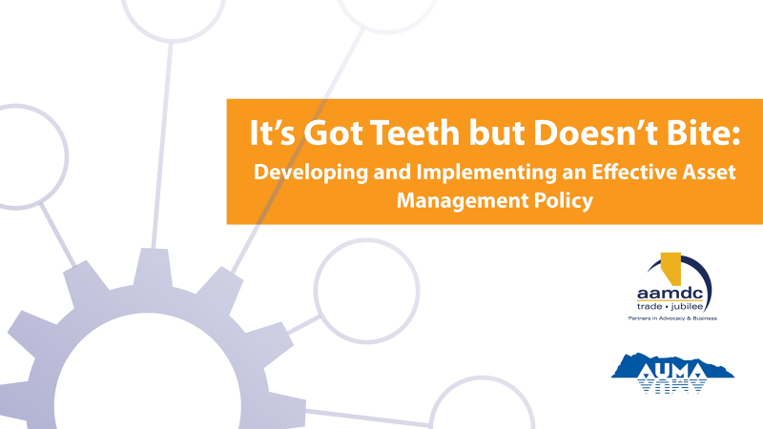
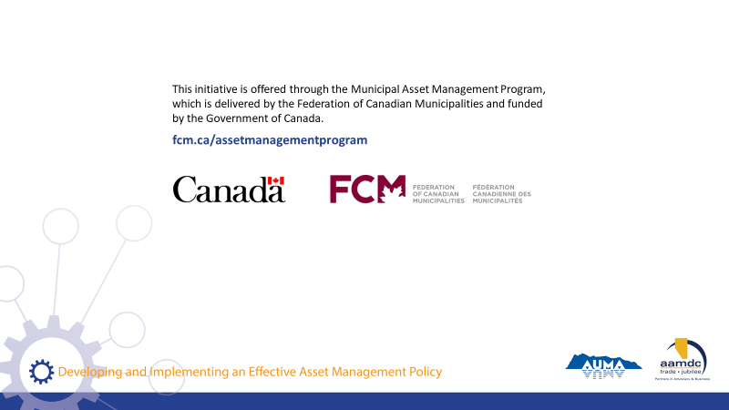
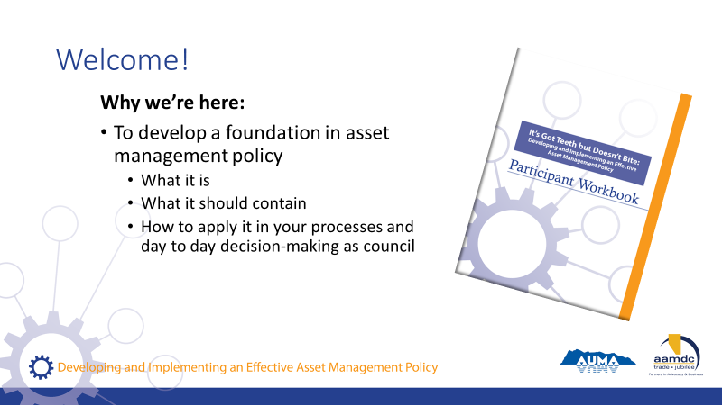 | State:  Welcome to our course on asset management policy.  Key Introduction Points:  - What is an asset management policy?  - What does it contain?  - How to apply it in your processes and decision-making
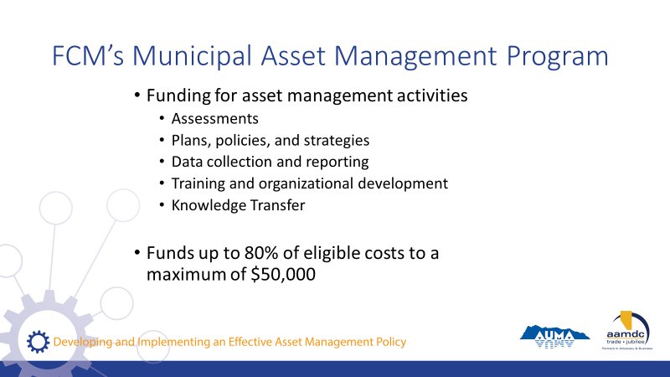 | State:  - Before we get started, we also want to mention that there is funding out there to do asset management.  - So as you’re learning today, if you’re identifying things you’d like to bring back to your community, know that this grant program is available.  Read slide.
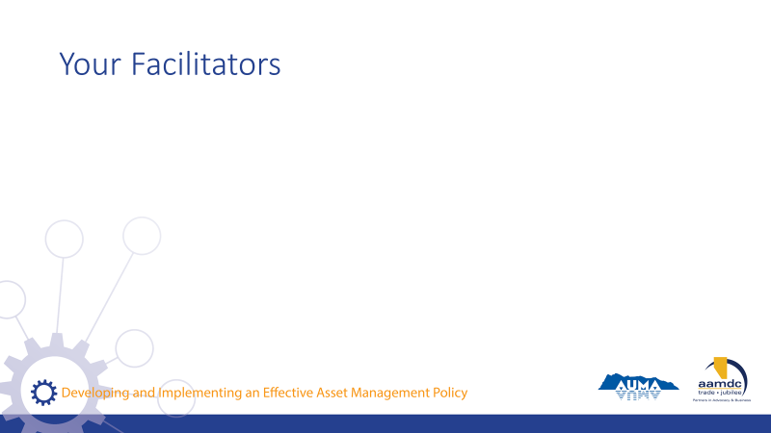 | Facilitator(s) introduce themselves.  Have participants introduce themselves.  Consider the use of icebreaker questions about where participants are at with asset management.
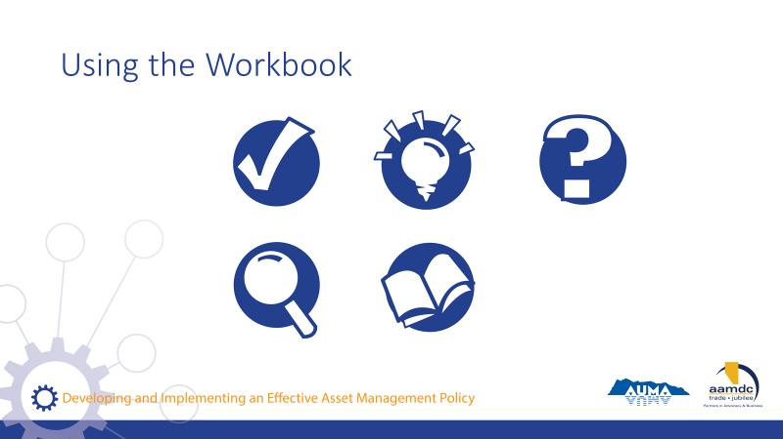 | Review how to use the learner workbook.  Key messages:  - Everything covered today is in your workbook.  - Encourage you to read the workbook from start to finish.  - Recurring icons are used to help you find relevant information easily.  As icons appear (with click) on slide, review what each means and how to use it.  State:  The course is based on achieving specific learning goals. This icon identifies the learning goals, so you can be thinking about whether you are achieving them.  This icon lets you know we’ve added an interesting fact or additional information related to the course material that we may not specifically cover in our discussion.  When you see this icon, it means we have included a reference to additional information on the topic that you can review at a later date.  Throughout the course, we will provide opportunities for you to apply your knowledge and share your expertise with a partner through various activities related to what you are learning.  In discussing municipal governance, there are a number of terms that may not be familiar to everyone. We’ve highlighted a few in these Glossary boxes and provided definitions. If you spot a term you aren’t familiar with and we haven’t provided a definition, please let us know by filling out the evaluation form and we will not only address it in this course but will add it to future participant workbooks.  Throughout the course, we want you to be continually thinking about how what you are learning in the course will apply to your role as elected official. For this reason, we’ve created space for you to reflect and record your thoughts on what the course content may mean in your world.
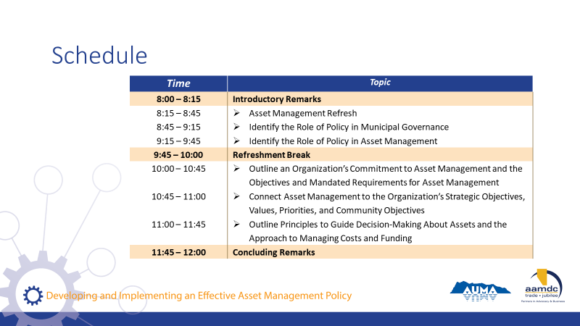 | Review course schedule on slide.  State:  As you can see, we will be covering a lot of content today.

Learning Goal: Asset Management Refresh

30 minutes |
Slides | Script
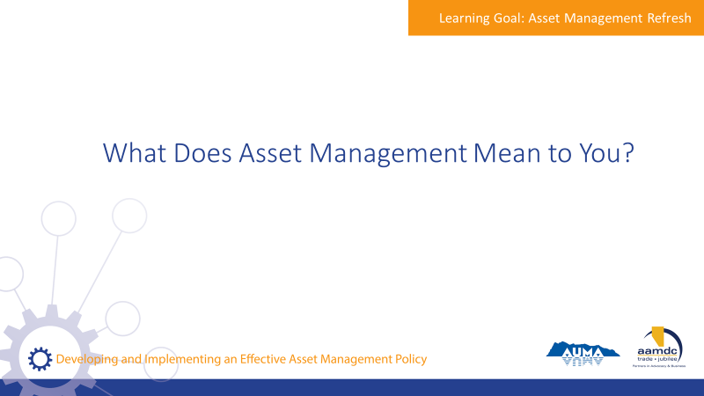 | State:  Let me ask you, when you hear the term asset management, what comes to mind?  Encourage participants to share their thoughts with the large group.
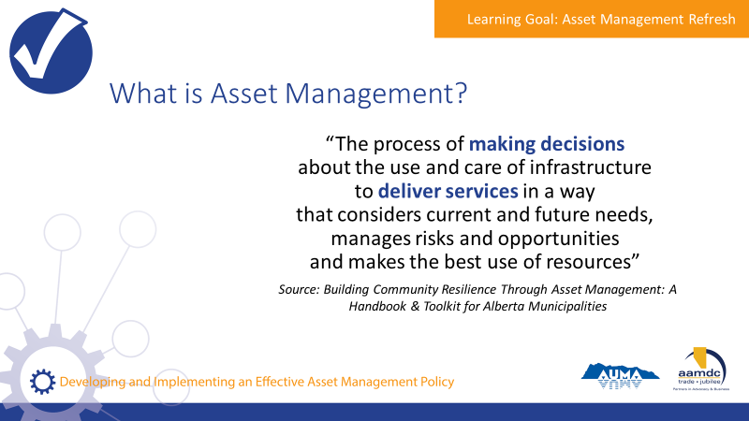 | State:  - Municipalities in Alberta are empowered to provide a range of services to their communities through provincial legislation, specifically the Municipal Government Act (MGA).  - A major component of service provision is taking care of the assets that make those services possible.  - An asset, also known as a tangible capital asset (TCA), is a physical component of a system that enables a service, or services, to be provided.  For example, pipes are the assets that deliver water service to homes, roads and traffic lights are the assets that make transportation possible, and recreation centres are assets that allow recreation services to be provided to the community.  - Municipalities have been managing assets for a long time. However, asset management is more than just managing assets or developing inventories of the assets a municipality owns.  - Here’s one definition of asset management that we think captures the essence of what it really is. We took this from the Alberta Handbook and Toolkit.  Review definition from slide.  State:  - They key terms here are “making decisions” and “deliver services”.  - Asset management is about using systems and processes to balance cost, risk, and LOS to make informed decisions that make sense for your community in the long run.  Assets don’t exist for the sake of having assets, they exist to deliver services. Service delivery is the starting point for all asset management.
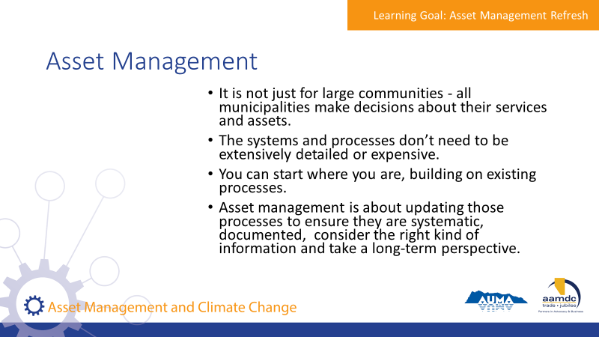 | State:  - It is not just for large communities. All municipalities make decisions about their services and assets.  - The systems and processes don’t need to be extensively detailed or expensive.  - You can start where you are. Your municipality probably already uses processes for things like planning and budgeting.  Asset management is about updating those processes to ensure they are systematic, documented, consider the right kind of information and take a long-term perspective.
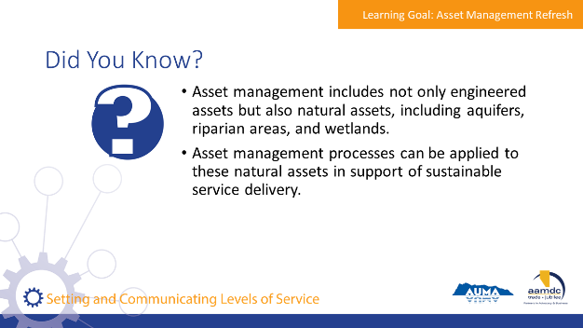 | State:  - Here are a few facts we thought you would find interesting. [Read facts on slide].  - Natural assets are critical to service delivery, and it’s useful to think through how these assets are cared for and invested in, in the same way that infrastructure assets are.  - Does anyone know if their AM programs include consideration of natural assets?
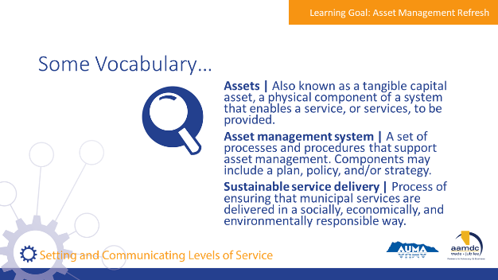 | State:  - There are a couple of terms we will be using as we discuss asset management, so we want to make sure we have a common understanding of them before we get into our discussion of asset management.  Review terms on slide.
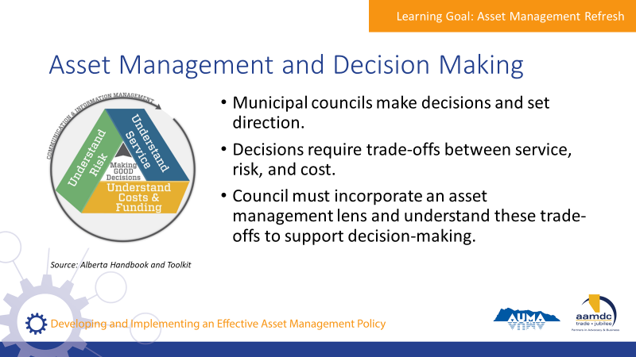 | State:  - Council’s role is to make decisions and set directions.  - Decisions require thinking about trade-offs between service, risk, and cost.  Council should incorporate an asset management lens on decision making processes and request information from staff to understand these trade offs.
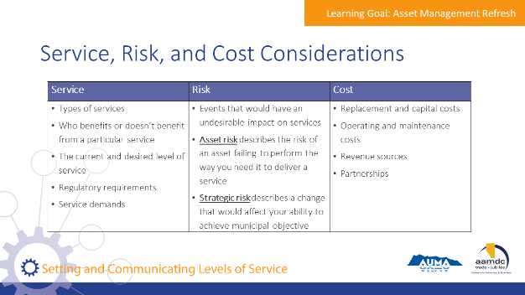 | State:  - This chart shows a summary of what should be considered for service, risk, and cost when evaluating trade-offs  - Levels of service will be covered in more depth in this course, and how levels of service connect to risk and cost.  Review considerations on slide.

Module 1—Identify the Role of Policy in Asset Management

Learning Goal: Identify the Role of Policy in Municipal Governance

20 minutes |
Slides | Script
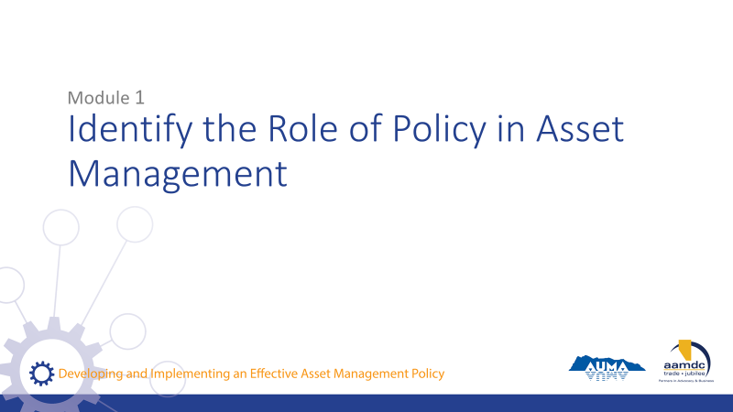 | State:  - This course has been designed with specific learning objectives for each module to state what learners should be able to do after completing a module.  - After Module 1, you should be able to:  - Identify the role of policy in municipal government  - Identify the role of policy in asset management  - If you don’t feel like you are mastering these learning objectives, or if you have questions about any of the content, we want to encourage you to let us know. Ask questions during the course at any time or see us during the break.  - Also, you will get out of the course what you put into it. So please participate fully and if there is anything that may get in the way of your full participation, we want to know that as well.
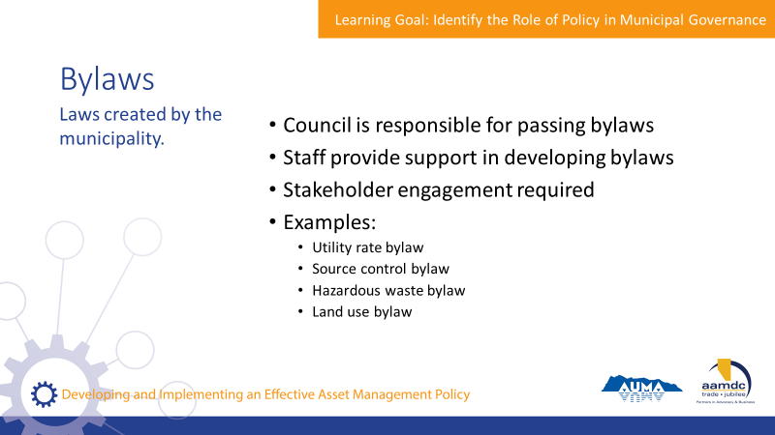 | State:  - Bylaws are laws created by municipalities.  - The power to create bylaws is granted to municipalities by the Municipal Government Act.  - Council is responsible for passing bylaws.  - Staff help develop bylaws.  - Stakeholder engagement is required under s.230 of the MGA  - Some examples of bylaws related to infrastructure and service delivery include:  - Utility rates bylaw  - Source control bylaw  - Hazardous waste bylaw  - Land use bylaw  Ask the group:  - What are some other examples of bylaws related to service delivery?
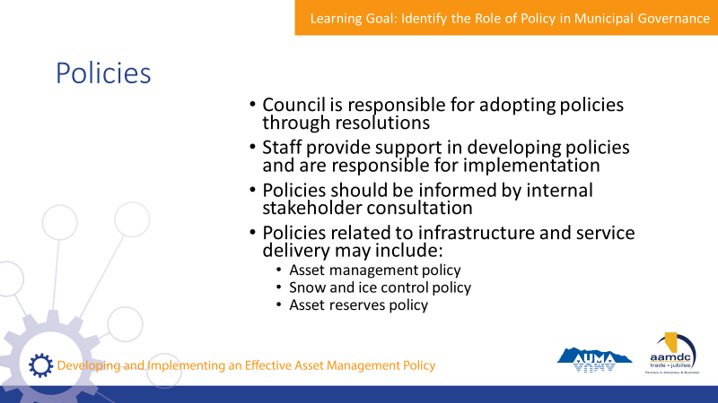 | State:  - Policies are documented principles and statements of intent that guide administration.  - Council adopts policies through resolutions  - Staff provide support in policy development and implement policies  - Policies should be informed by internal stakeholder consultation  - Examples of policies related to infrastructure:  - Asset management policy  - Snow and ice control policy  - Asset reserves policy  What are some other examples of policies related to service delivery?
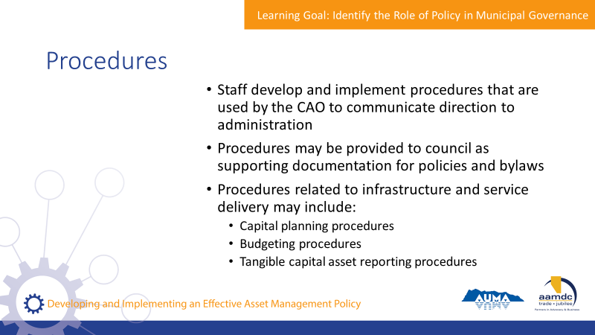 | State:  - Procedures are steps for a process or activity internal to the municipal government.  - Staff develop and implement procedures.  - CAO uses procedures to communicate direction.  - Procedures may be provided to council as information or supporting documentation for policies and bylaws.  - Examples of procedures related to infrastructure:  - Capital planning procedures  - Budgeting procedures  - Tangible capital asset reporting procedures
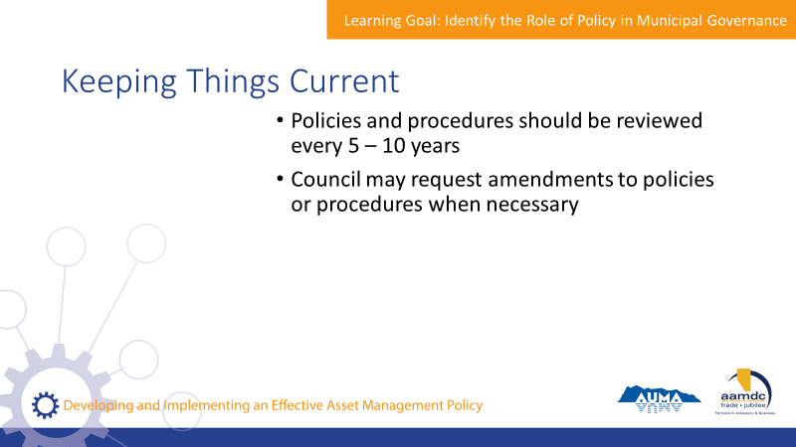 | State:  - Policies and procedures should be reviewed every 5 to 10 years.  - Council may request amendments to policy or procedures when necessary. For example, a new term of councillors may want policies reviewed to ensure they align with incoming mandate.
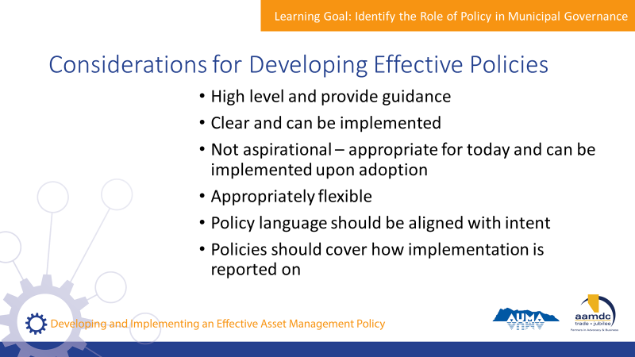 | State:  - Your workbook outlines a number of general considerations for an effective policy.  - The following are some of the key considerations.  Read list on slide.
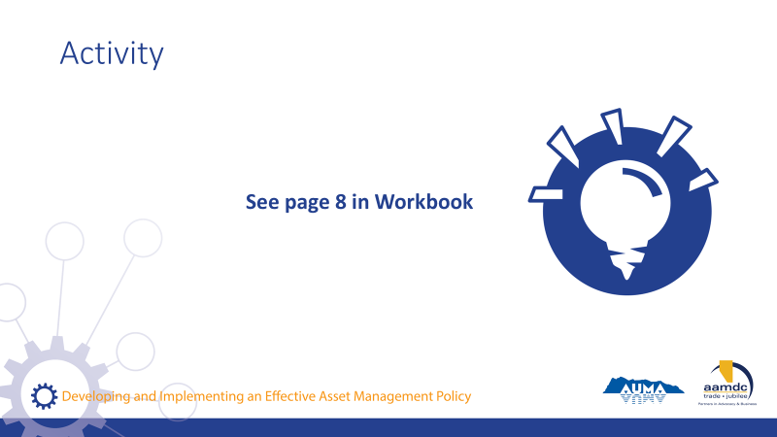 | Activity – page 8 (8 minutes)  State:  - Please turn to page 8 of your workbook.  - At your table, discuss the following question: What are other considerations for developing strong and effective policy?  - It may be helpful to use examples from your municipalities of what policies have been successful and which have not, and think about what were the characteristics of the policies that have been effective.  At the end, ask each table to share with the whole group one consideration as an example. Put additional considerations for developing strong and effective policy on a flip chart on the wall for later reference.

Learning Goal: Identify the Role of Policy in Asset Management

30 minutes |
Slides | Script
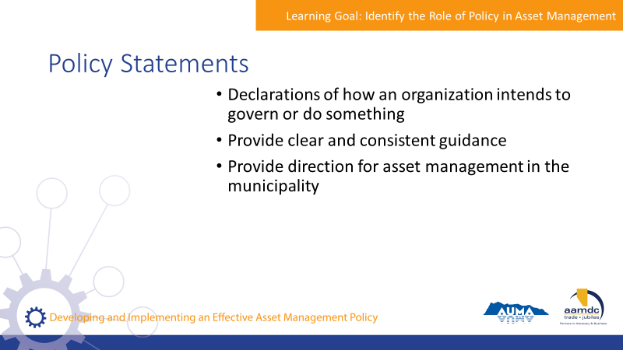 | State:  - Asset management is part of sustainable service delivery. Because of this, asset management policies should use a sustainable service delivery lens.  - Policy statements are a declaration of how an organization intends to govern or do something.  - They provide clear and consistent guidance to CAO and staff.  - They provide direction for asset management in the municipality.
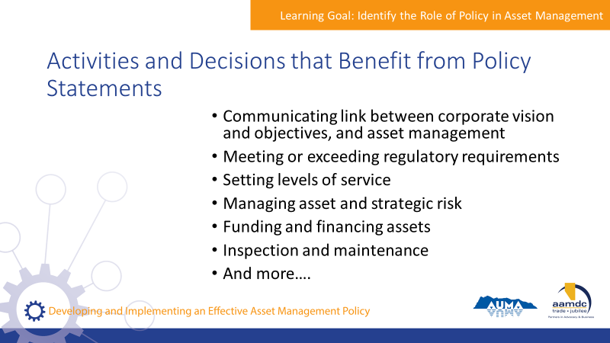 | State:  - Many activities and decisions related to asset management can benefit from policy statements. Pg. 9 of your workbook provides a longer list, but some of the main ones include those on the slide.  Read list on slide.
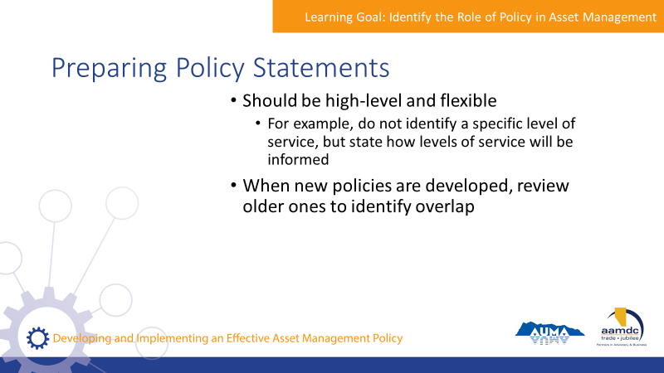 | State:  - When preparing policy statements, remember that they should be high-level and flexible.  - For example, a policy statement doesn’t identify a specific level of service, but it might state how a level of service will be informed through community engagement.
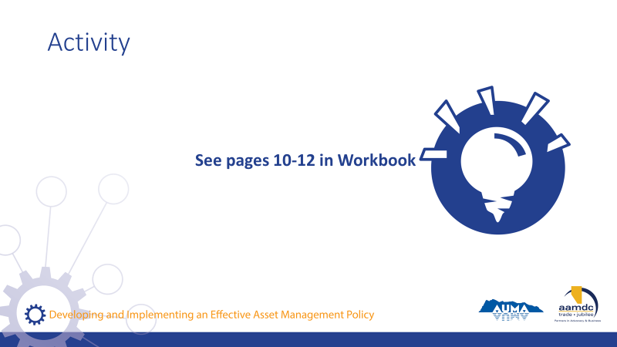 | Activity – page 10 to 12 (20-25 minutes)  State:  - Let’s all turn to page 10 of your workbook. We’ll do a number of exercises together to dig deeper in to asset management policies.  - We asked you to bring in examples of your community’s existing asset management policies. For those of you that were able to bring those, get into small groups of three or four and discuss the questions on page 10.  - If you’re finished early, you can also work through the questions on pages 11 and 12.  Read questions on page 10.  - For those of you who were not able to bring in examples of existing policies – or are not aware of the policies you have related to asset management, please raise your hand and get into small groups of three or four.  - Working with your group, discuss the questions on page 11 to 12.  - Some examples of policy statement concepts include: LOS will be established in consultation with constituents; lifecycle costing will be used to evaluate options; the municipality is committed to exceeding regulatory requirements for asset management, because it is important for the sustainability of the community, etc.  Facilitators should move around and provide guidance to groups as needed.  Large group debrief should focus on:  - Facilitating peer learning and sharing experiences with others  - Key observations from communities that have policies (i.e. how comprehensive are your policies related to AM? Which are well understood and implemented, and which are not?  - Key discussion points from groups that do not have policies (those that worked through the questions on pages 11-12)

Break
15 minutes | 9:45 a.m. to 10:00 a.m.

Module 2 – Evaluate Asset Management Policy Statements

Learning Goal: Outline an Organization’s Commitment to Asset Management and the Objectives and Mandated Requirements for Asset Management

45 minutes |
Slides | Script
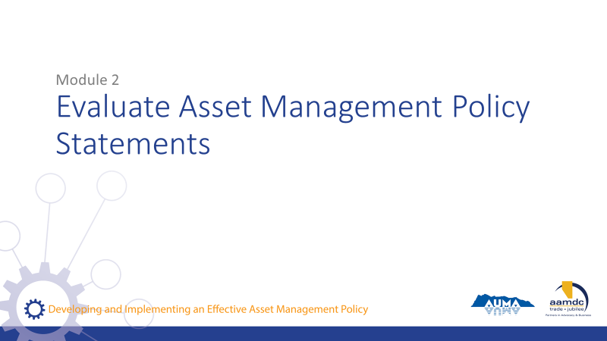 | State:  - Welcome back from your break. We’re going to be moving on to Module 2: Evaluate Asset Management Policy Statements.  - After we complete this module, you should be able to:  - Outline an organization’s commitment to asset management, and the objectives and mandated requirements of asset management  - Connect asset management to the organization’s strategic objectives, values, priorities, and community objectives  - Outline principles to guide decision-making about assets and the approach to management costs and funding  - Let’s get started!
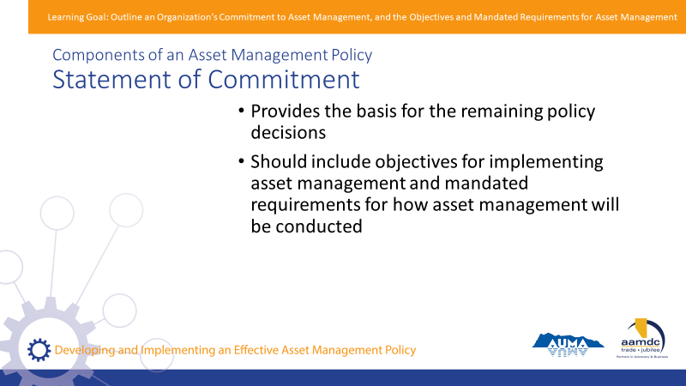 | State:  - One of the things that you may wish to include in your asset management policy is a statement of commitment.  - A statement of commitment provides the basis for the remaining policy directions.  - It should include the organization’s objectives for implementing asset management, as well as any mandated requirements for how asset management will be conducted.
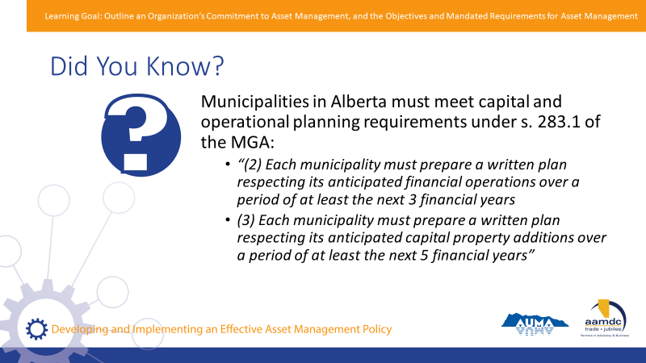 | State:  - Another component of your policy will be information on how your organization is fulfilling legislative requirements for asset management.  - For example, municipalities in Alberta have to meet capital and operating planning requirements under section 283.1 of the Municipal Government Act.  - The MGA states that  - Each municipality must prepare a written plan respecting its anticipated financial operations over a period of at least the next 3 financial years.  - Each municipality must prepare a written plan respecting its anticipated capital property additions over a period of at least the next 5 financial years.  - These requirements can be referenced in your policy.
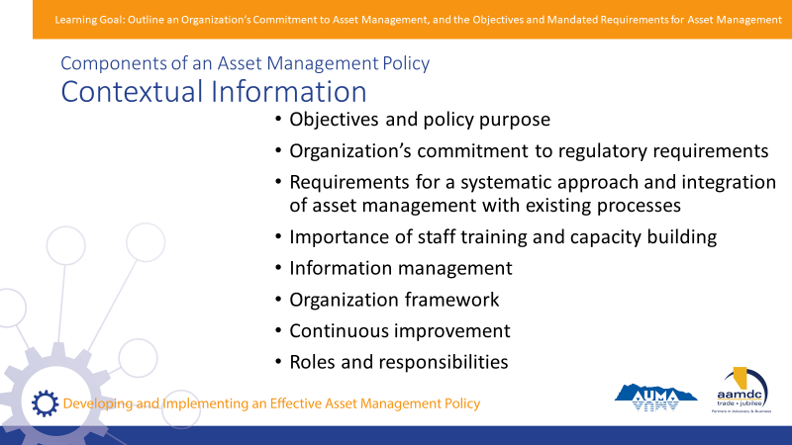 | State:  - Your policy will also provide contextual information to place asset management within broader organization processes.  - Some of the things that may be included as part of this information include (on slide):  - Objectives and policy purpose  - Organization’s commitment to meet or exceed regulatory requirements (i.e. does your municipality aim to meet basic requirements? Or do you aim to exceed them and take a leadership role?)  - Requirements for a systematic approach and integration of asset management with existing processes  - Importance of staff training and capacity building  - Information management – integrating financial and engineering information  - Organizational framework – are strategies or plans required?  - Continuous improvement  - Roles and responsibilities
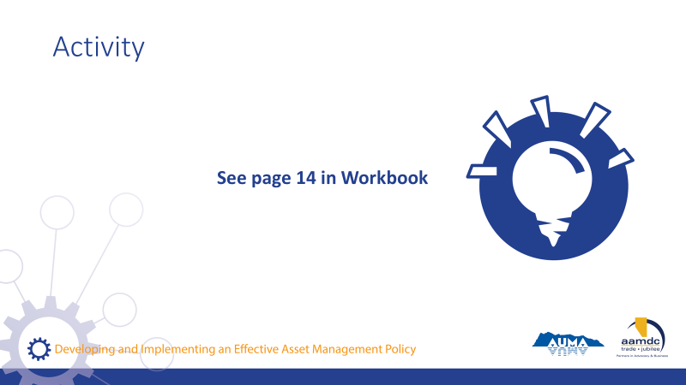 | Activity – page 14 (30 minutes)  State:  - Let’s take a look at some of policies in action. At the back of your workbook, you’ll find examples of real policies. These are from several communities, though the identifying information has been removed.  - We’ll be using these policies to complete the activities on page 14 as a group.  - Let’s take about 5 to 10 minutes to individually read through the policies.  Facilitators lead exercise as a group, going through the questions for each policy. Depending on time, you may only get through one or two policies.

Learning Goal: Connect Asset Management to the Organization’s Strategic Objectives, Values, Priorities, and Community Objectives

15 minutes |
Slides | Script
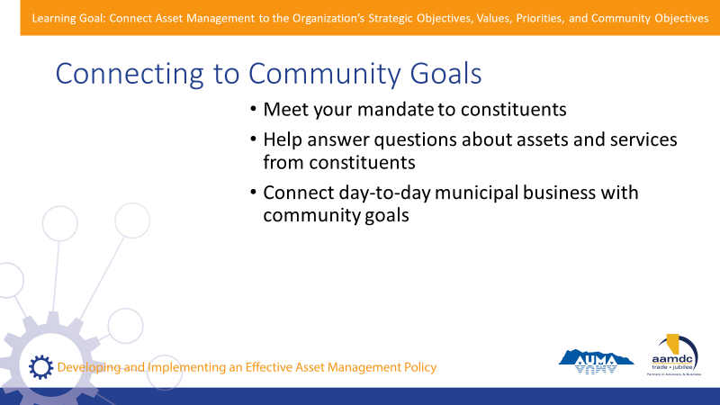 | State:  - A municipality’s values, priorities, and objectives set the direction for asset management policies. Asset management is a means to an end – and that end is defined by the values and priorities of a community.  - Connecting assets and services to broader community goals supports several objectives:  - Helps you meet your mandate to constituents  - Helps answer questions about assets and services to constituents  - Connects day-to-day municipal business with community goals
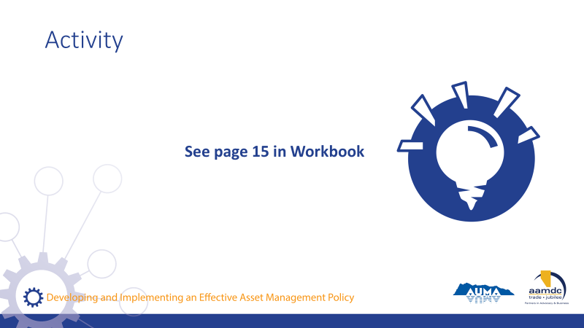 | Activity – page 15 (10 minutes)  - Individually, think about how your community’s values, priorities, and objectives connect to asset management.  - On page 15, you have space to write down your answers.  - Once you have a few examples, let’s discuss as a group.  - People can look at the example policies for ideas if they find it helpful.  As a larger group, ask participants to share examples and discuss.

Learning Goal: Outline Principles to Guide Decision-Making About Assets and the Approach to Managing Costs and Funding

45 minutes |
Slides | Script
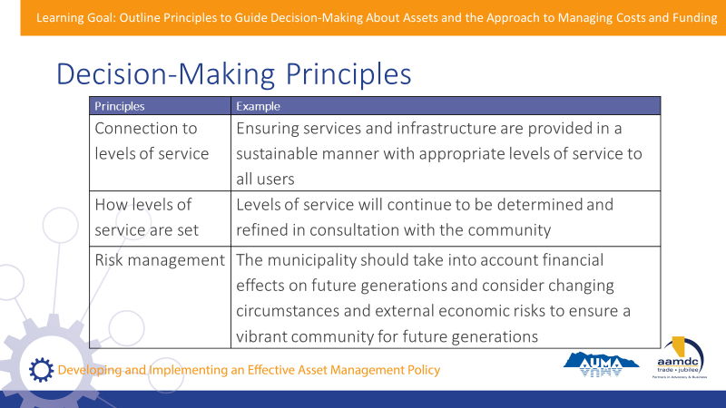 | State:  - Asset management is about making informed decisions that support sustainable service delivery – we can’t say this enough!  - An asset management policy should include some principles to guide decision-making.  - Page 16 of your workbook outlines some decision-making principles for asset management. Let’s review these together.  Go through this slide and the next and introduce the principles and provide examples. Elaborate on each example and engage the group in identifying specific decisions made in a municipality that each of these principles would help to guide.  Ask the question from time to time “why would this type of principle need to be considered in your AM policy statements?”
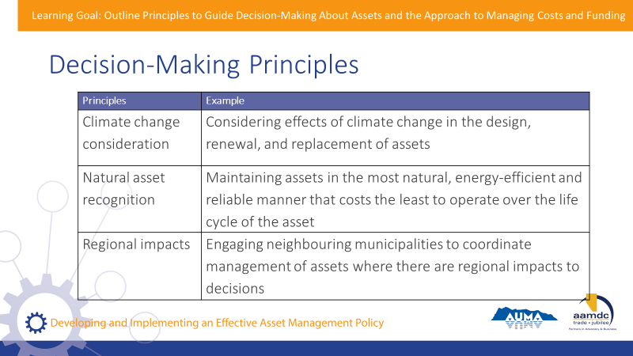
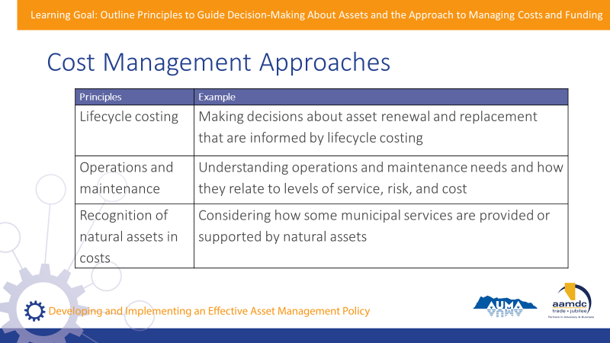 | State:  - An asset management policy should also include some information on cost management approaches.  Go through this slide and the next and introduce the cost management approaches and provide examples.  Elaborate on the examples and engage the group in identifying specific examples of how this would apply in a municipality.  Ask the group “Why do these cost management approaches need to be considered in your policy statements?”
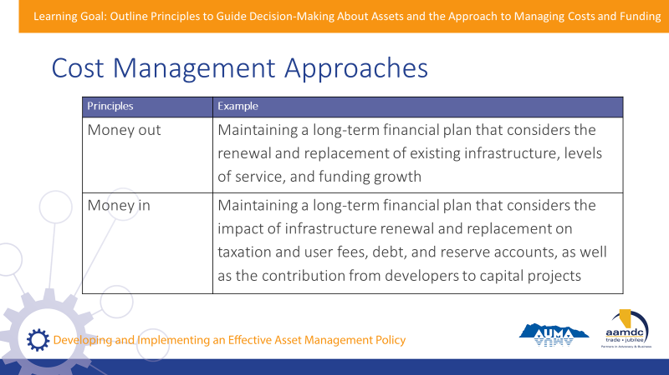
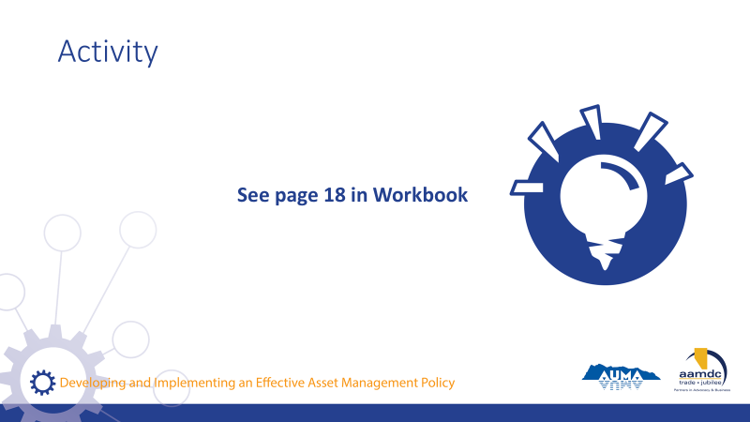 | Activity – page 18 (20-30 minutes)  State:  - Let’s see how these principles and approaches are addressed in real policies.  - For those of you who brought examples from your community, we’ll be using those again. If you didn’t bring an example, you can partner with someone who did or use one of the example policies at the back.  - Take a few minutes to reflect on your own and then go through the questions with your table group.

Learning Goal: Concluding Remarks

15 minutes |
Slides | Script
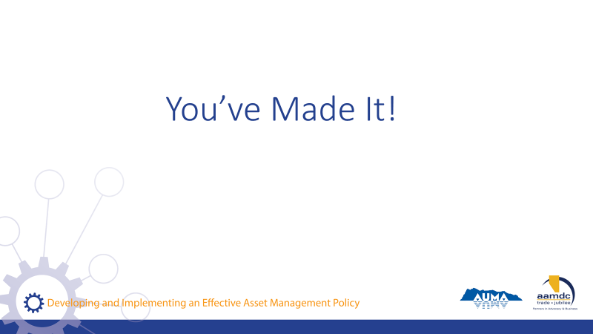 | State:  - Well, you’ve made it!  - Here we are at the end of the course.  - I hope you found today full of learning, good conversation, and shared insight. I want to thank you for joining us.  - Remember, today is just a start.  - Together, we’ve laid the foundation, but we hope that you’ll continue to learn, ask questions, and participate in other opportunities to expand your knowledge of asset management policy.  - Throughout the workbook, and at the back, you can find the glossary and a list of resources if you ever need to reference something you learned in this course.
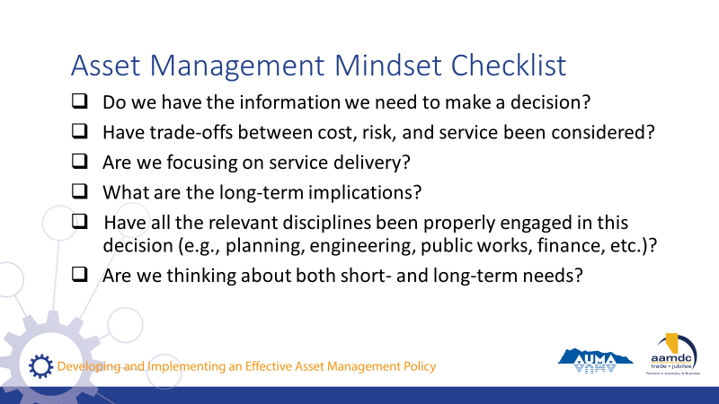 | State:  - If you got anything out of today, we hope that it was an understanding of how an asset management mindset can support you in your role as an elected official and steward of community well-being.  - If you’re ever stuck, start by asking yourself some questions:  Read questions on slide.  State:  - All of these questions apply to the integration of climate change and asset management.
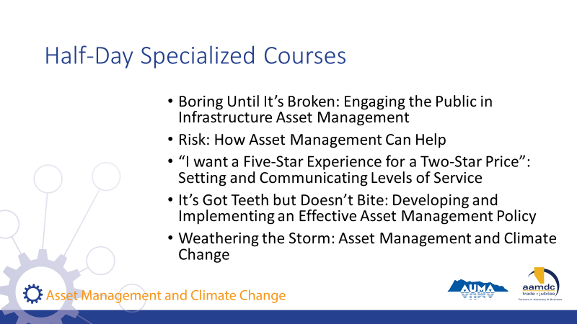 | State:  - AUMA and RMA offer five half-day courses as part of these series on specific topics related to asset management.  Read courses on slide.  If you want to find out more, talk to us after class.
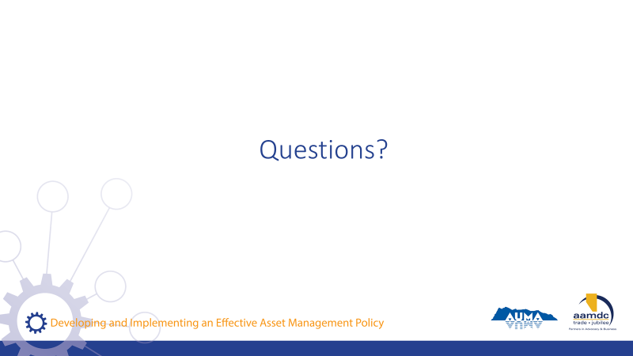 | State:  Before we leave for the day, does anyone have any remaining questions about anything we covered?
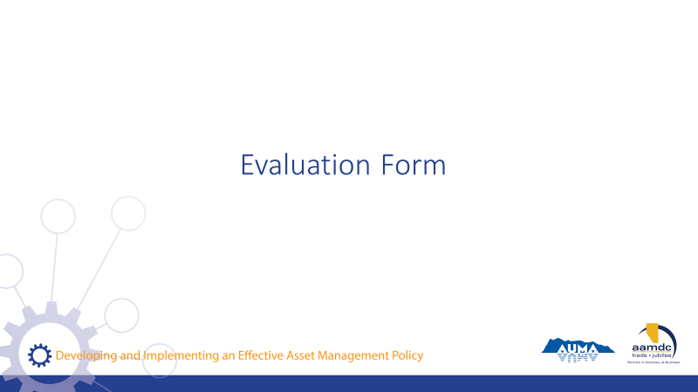 | State:  - Before you leave today, we would really value getting your input on this course.  - Your input will help us to understand how the course helped you (what worked for you) and where we can be making improvements.  - Thanks for taking about 10 minutes to provide your feedback. Once completed, you can leave your forms on (pick a central location for all forms so they remain anonymous).

NOTES

