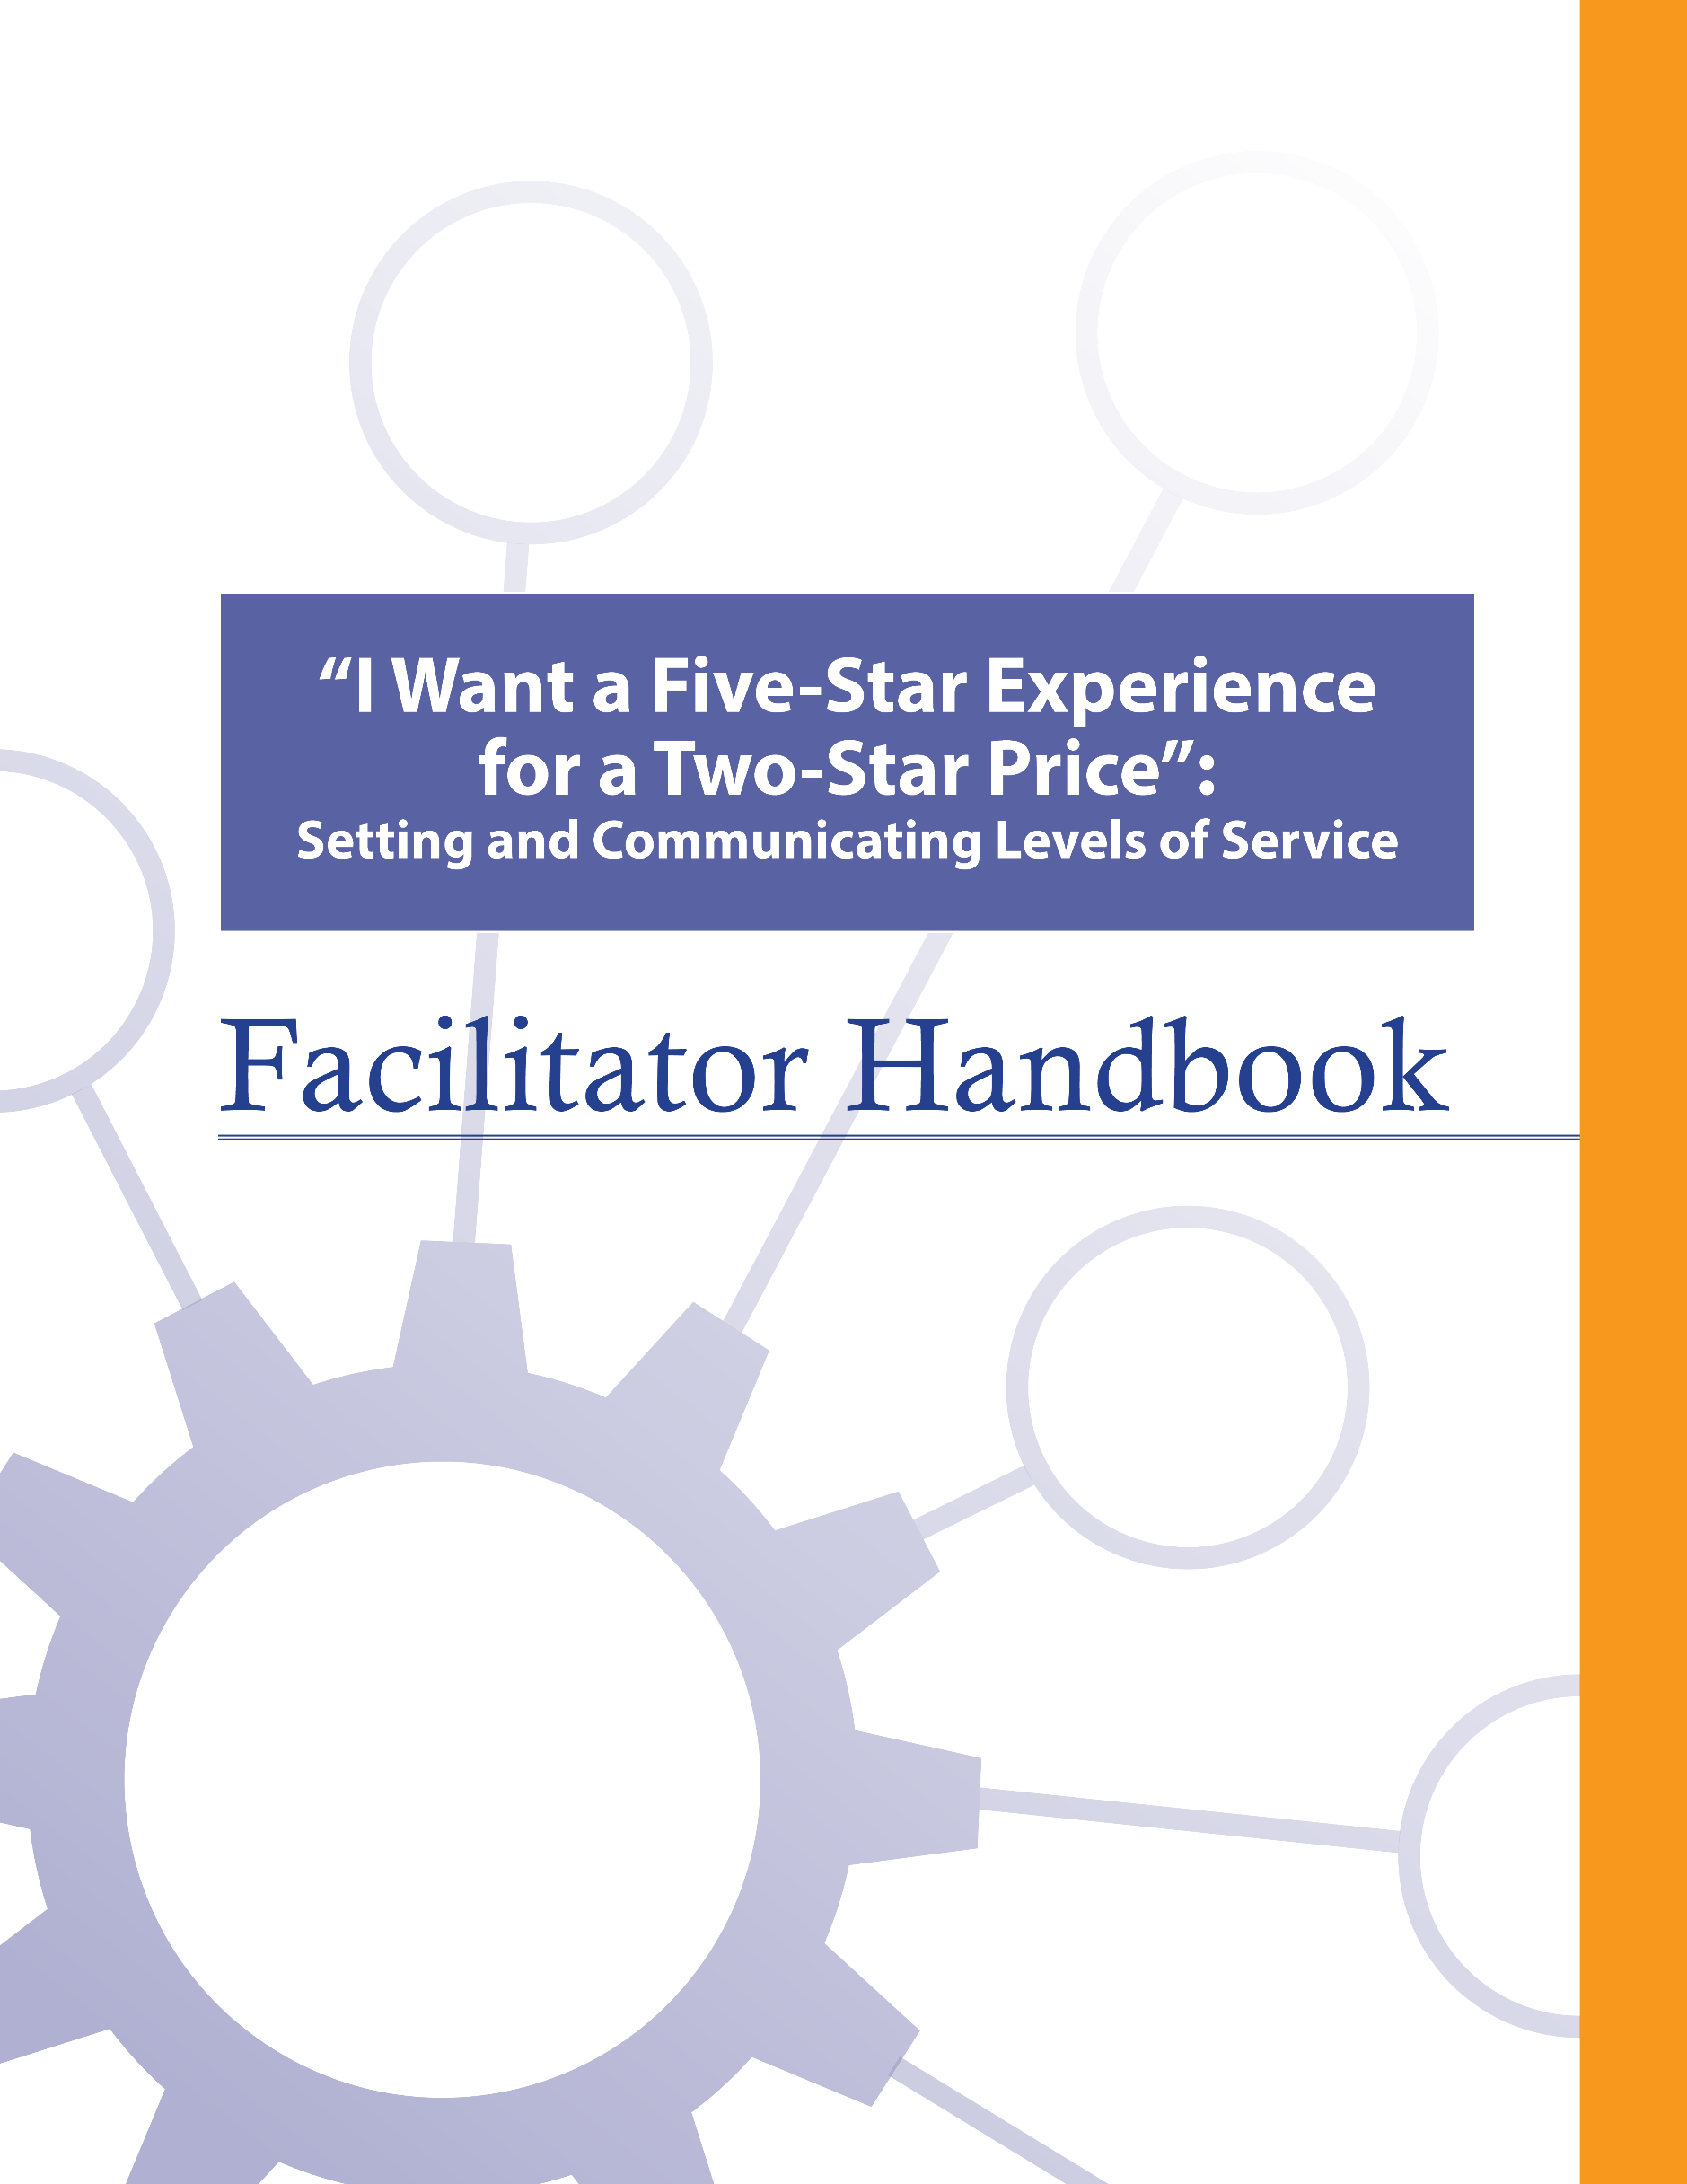

About the FCM
The Federation of Canadian Municipalities (FCM) has been the national voice of municipal government in Canada since 1901, advocating for the needs of municipalities and their citizens. FCM’s membership includes large cities, small urban and rural communities, and 20 provincial and territorial municipal organizations.

About RMA
Formerly known as AAMDC, Rural Municipalities of Alberta (RMA) is an independent association representing Alberta’s 69 counties and municipal districts. Since 1909, the RMA has helped rural municipalities achieve strong, effective local government.

About AUMA
Founded in 1905, the AUMA represents 269 urban municipalities including cities, towns, villages, summer villages, and specialized municipalities. AUMA works with federal and provincial governments and business and community stakeholders on a broad range of issues to strengthen the economic, social, cultural, and environmental vitality of its member municipalities.

This initiative is offered through the Municipal Asset Management Program, which is delivered by the Federation of Canadian Municipalities and funded by the Government of Canada.
fcm.ca/assetmanagementprogram

TABLE OF CONTENTS

How to Use this Facilitator Handbook 1
Characteristics of Adult Learners 2
Agenda 6
Introductory Remarks 7
Learning Goal: Asset Management Refresh 9
Module 1 – Define Levels of Service and the Connection to Asset Management 13
Learning Goal: Identify Levels of Service 13
Learning Goal: Identify Common Challenges Related to Municipal Service Delivery 16
Learning Goal: Identify Why Levels of Service Are Important and the Connection to Asset Management 18
Module 2 – Identify How to Set Levels of Service 23
Learning Goal: Identify Council’s Role in Setting Levels of Service 23
Learning Goal: Identify the Process for Setting Levels of Service 24
Module 3 – Effectively Apply and Communicate Levels of Service 26
Learning Goal: Incorporate Levels of Service into Decision-Making 26
Learning Goal: Communicate Levels of Service with Constituents 28
Learning Goal: Monitor and Revise Levels of Service 29
Concluding Remarks 30

How to Use this Facilitator Handbook
This Facilitator Handbook was created to be a resource for the professionals who will be instructing the course on behalf of the AAMDC and AUMA. The Facilitator Handbook is intended to help instructors to provide consistency, and to facilitate the course effectively, within the instructional time available.

How to read the guide:
- The facilitator script and instructions are provided in the right column.
- Thumbnails of the slides corresponding to the script are in the left column.
- The facilitator’s script appears in normal type.
- Additional notes to facilitators appear in bold print.
- Sample responses, discussion points and answers for participant activities appear in italics.

Characteristics of Adult Learners
While we may act like it sometimes, adults are not just big kids. And, we don’t want to be taught like children. As adults, we learn in a very different way than our shorter, younger (maybe even thinner) selves. When we think about a typical learning environment, many of us recall past school days. During those times, our very identity revolved around being a student.
For most of us, the model we have for instructing comes from the teachers who taught us back in the day. However, the teaching techniques that worked for our grade eight English teacher may not be as appropriate for those of us now instructing adults – adults who are also our colleagues and peers. It is important for facilitators of adult education to understand how adults learn and to incorporate teaching principles and strategies that will meet the unique needs of adults and foster the most positive, engaging and productive learning environment possible for them.
What is so different about adults and how can we, as training professionals, incorporate instructional techniques that respect those differences? Below are some generally accepted insights that you may find helpful.

Adults want to have control over their learning
We adults tend to be self-directed. We have work, family and community responsibilities that require us to exercise some level of competence and control. In fact, we can get downright resentful when others take away our right to make choices around our own affairs. This is true when it comes to our learning experiences -- we typically need to exercise some control here, too. In fact, take away our sense of control over how and when we engage in formal learning and you will likely meet some resistance.

What’s a facilitator to do?
- Include adult learners in the planning of their learning (engage them in needs assessments and encourage their input on course objectives & content wherever possible).
- Encourage self-assessment and self-evaluation (rather than instructor-based evaluation).
- Establish a peer relationship with learners rather than the traditional hierarchical one.
- Make yourself available to adult learners outside of the formal learning environment if possible.

Adults, more so than youth, draw upon their experiences as a resource in learning
Been there, done that. Adults have a wealth of past experiences simply because we’ve lived longer than youth. As learners, our past experiences are important resources that we draw on. Adults tend to link new learning to prior learning (much of which is rooted in life experience). Learning is all about accepting and applying new ideas and concepts. For adults, that process often happens within the context of how the idea or concept “fits” with what we’ve already experienced.

What’s a facilitator to do?
- Take time to get to know the experiences of your adult learners and be intentional about helping them link new concepts and ideas with prior learning or experiences.
- Encourage open discussion on how new concepts and ideas being presented fit with the experience of learners.
- Encourage learners to share their experience for the purpose of teaching others. Ask versus tell. Using questions can draw out the information you want to focus on and is an effective way to encourage adult learners to apply their own skills and experience to facilitate their learning.

Adults tend to be more motivated in learning situations than youth
When adults find themselves in a formal learning environment, most times it’s because they want to be there. Adults are not typically motivated by gold stars or good report cards. Instead, they want a learning outcome that can be put to use immediately in concrete, practical and self-benefiting ways.

What’s a facilitator to do?
- Don’t spend a great deal of effort trying to motivate adult learners. Rather, see your role as facilitating the learning they are ready to experience.
- Ensure teaching is relevant to what learners want to learn and what they will be able to use back on the job.
- Accept that people will learn at different rates and in different ways. Some will learn by being told, others will learn by doing. Still others will need to be shown. Use a diversity of teaching methods to ensure your learners stay motivated to learn.

We’re generally more pragmatic in learning than youth
Adults are typically more interested in problem solving than information gathering. Learning “theory,” which must be stored away for future use, can be frustrating and seem irrelevant for many adult learners. Especially for adults, learning becomes complete when we put into practice what we are attempting to learn.

What’s a facilitator to do?
- Using job-related case studies and hands-on exercises and activities will help learners to immediately use what they’re learning in a problem-solving situation. The more often we use what we have learned, the better we can perform or understand it.

Some adults lack confidence in their learning
Some adults who have been away from a formal learning environment for some time may consider the learning “glory days” over. These perceptions can influence how confident they feel during learning situations. Interestingly, research shows that the attention span of the average adult is between 8 and 20 minutes.

What’s a facilitator to do?
- Provide opportunities for learners to receive constructive feedback on how they’re doing (either through guided self-evaluation, constructive input from other participants, or the facilitator’s own observations).
- Present information in a manner that permits mastery in “bite size chunks” with opportunity for hands-on application.

Many adults are more resistant to change than youth
Learning often involves change of some kind. Youth tend to be more idealistic and are often open to change just for the sake of change. However, over the course of being an adult, our experiences around change have not always been good and can lead us to be somewhat resistant to it.

What’s a facilitator to do?
- Encourage learners to explore the “why” of change, not just the “how.”
- Link new concepts to older, understood and accepted concepts.

A group of adult learners will typically be more diverse than a group of youths
A group of adults, more so than a group of youths, will vary a great deal in terms of age, experiences, and backgrounds. Differences can be a powerful resource for learning as adults collaborate together on tasks.

What’s a facilitator to do?
- Allow time for interaction between learners and create opportunities for them to work together in groups to collaborate and share perspectives and experiences.
- Present material in a variety of ways to accommodate a diversity of learning styles.

Agenda
Time | Topic | Facilitator’s Name
15 minutes | Introductory Remarks
15 minutes | - Asset Management Refresh
25 minutes | - Identify Levels of Service
25 minutes | - Identify Common Challenges Related to Municipal Service Delivery
25 minutes | - Identify Why Levels of Service Are Important and the Connection to Asset Management
15 minutes | - Identify Council’s Role in Setting Levels of Service
15 minutes | Refreshment Break
15 minutes | - Identify the Process for Setting Levels of Service
30 minutes | - Incorporate Levels of Service into Decision-Making
20 minutes | - Communicate Levels of Service with Constituents
30 minutes | - Monitor and Revise Levels of Service
10 minutes | Concluding Remarks

Introductory Remarks

15 minutes |
Slides | Script
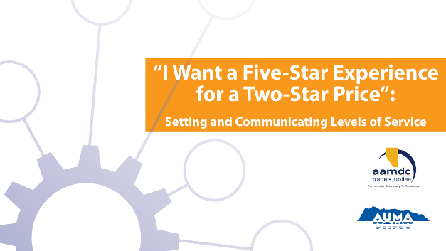
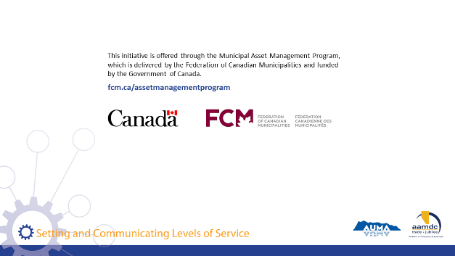
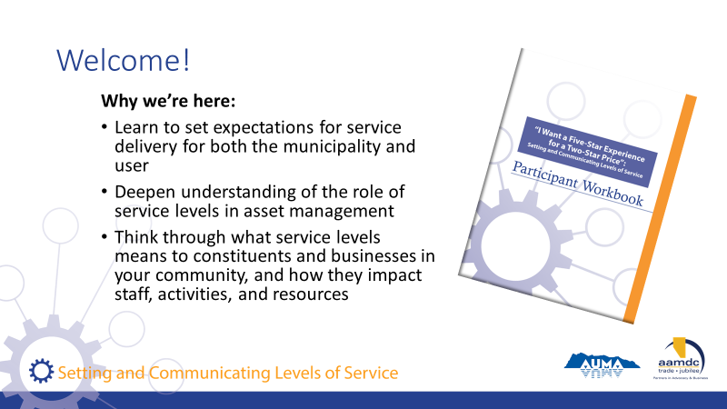 | State:  Welcome to our course on setting and communicating levels of service (LOS).  Key Introduction Points:  - Learn to set expectations for service delivery for both the municipality and service user  - Deepen your understanding of the role of LOS in asset management  - What LOS means to different users and how they impact municipal staff, activities, and resources
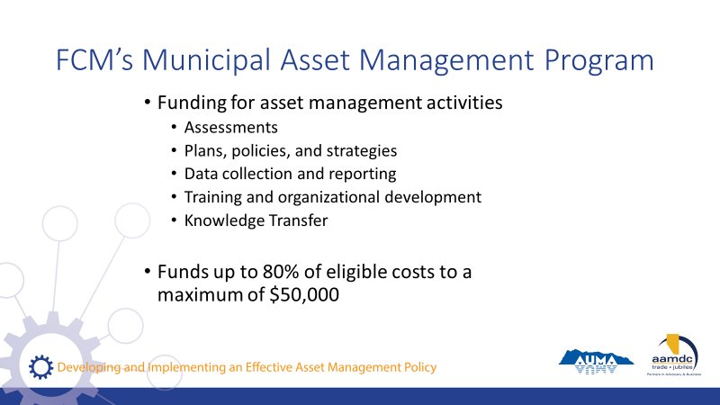 | State:  - Before we get started, we also want to mention that there is funding out there to do asset management.  - So as you’re learning today, if you’re identifying things you’d like to bring back to your community, know that this grant program is available.  Read slide.
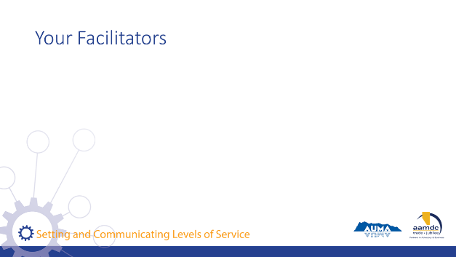 | Facilitator(s) introduce themselves.  Have participants introduce themselves.  Consider the use of icebreaker questions about where participants are at with LOS and asset management.
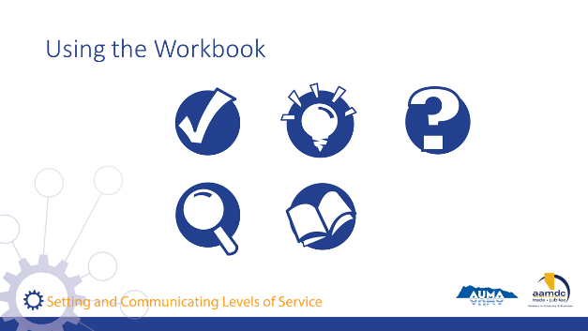 | Review how to use the learner workbook.  Key messages:  - Everything covered today is in your workbook.  - Encourage you to read the workbook from start to finish.  - Recurring icons are used to help you find relevant information easily,  As icons appear (with click) on slide, review what each means and how to use it.  State:  The course is based on achieving specific learning goals. This icon identifies the learning goals, so you can be thinking about whether you are achieving them.  This icon lets you know we’ve added an interesting fact or additional information related to the course material that we may not specifically cover in our discussion.  When you see this icon, it means we have included a reference to additional information on the topic that you can review later.  Throughout the course, we will provide opportunities for you to apply your knowledge and share your expertise in groups through various activities related to what you are learning.  In discussing municipal governance, there are a number of terms that may not be familiar to everyone. We’ve highlighted a few in these Glossary boxes and provided definitions. If you spot a term you aren’t familiar with and we haven’t provided a definition, please let us know by filling out the evaluation form and we will not only address it in this course but will add it to future participant workbooks.
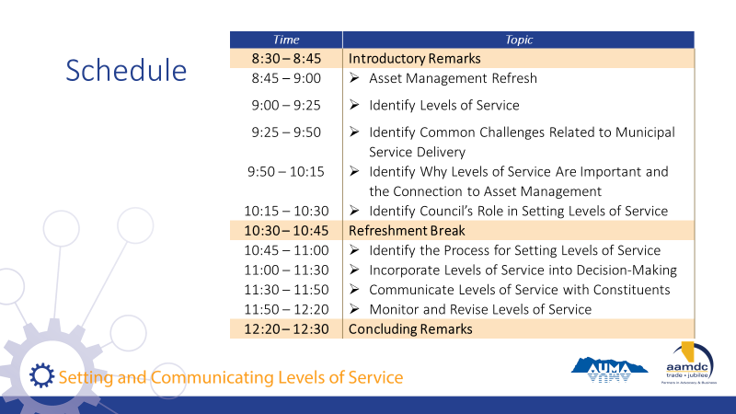 | Review course schedule on slide.  State:  As you can see, we will be covering a lot of content today.

Learning Goal: Asset Management Refresh

15 minutes |
Slides | Script
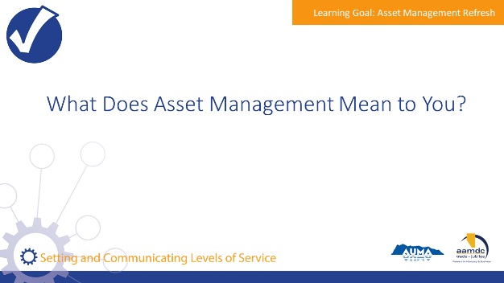 | State:  Let me ask you, when you hear the term asset management, what comes to mind?  Encourage participants to share their thoughts with the large group.
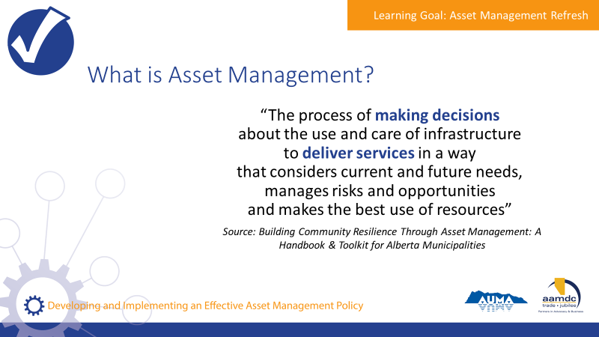 | State:  - Municipalities in Alberta are empowered to provide a range of services to their communities through provincial legislation, specifically the Municipal Government Act (MGA).  - A major component of service provision is taking care of the assets that make those services possible.  - An asset, also known as a tangible capital asset (TCA), is a physical component of a system that enables a service, or services, to be provided.  For example, pipes are the assets that deliver water service to homes, roads and traffic lights are the assets that make transportation possible, and recreation centres are assets that allow recreation services to be provided to the community.  - Municipalities have been managing assets for a long time. However, asset management is more than just managing assets or developing inventories of the assets a municipality owns.  - Here’s one definition of asset management that we think captures the essence of what it really is. We took this from the Alberta Handbook and Toolkit.  Review definition from slide.  State:  - They key terms here are “making decisions” and “deliver services”.  - Asset management is about using systems and processes to balance cost, risk, and LOS to make informed decisions that make sense for your community in the long run.  - Assets don’t exist for the sake of having assets, they exist to deliver services. Service delivery is the starting point for all asset management.
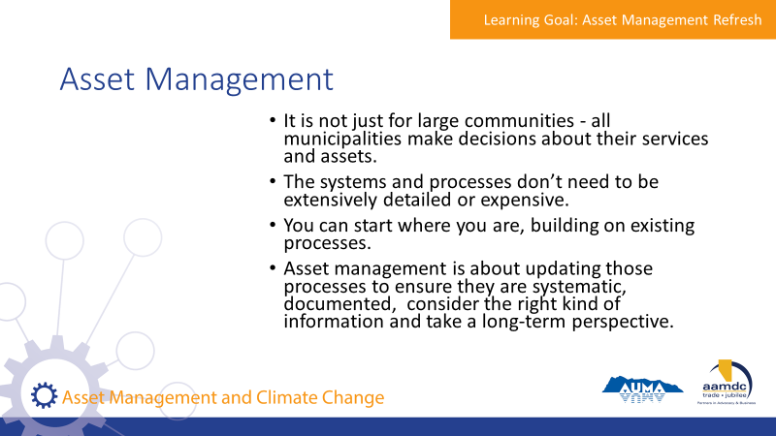 | State:  - It is not just for large communities. All municipalities make decisions about their services and assets.  - The systems and processes don’t need to be extensively detailed or expensive.  - You can start where you are. Your municipality probably already uses processes for things like planning and budgeting.  - Asset management is about updating those processes to ensure they are systematic, documented, consider the right kind of information and take a long-term perspective.
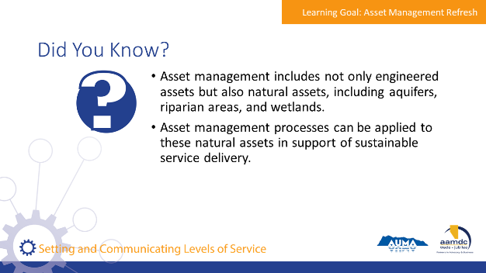 | State:  - Here are a few facts we thought you would find interesting. [Read facts on slide].  - Natural assets are critical to service delivery, and it’s useful to think through how these assets are cared for and invested in, in the same way that infrastructure assets are.  - Does anyone know if their AM programs include consideration of natural assets?
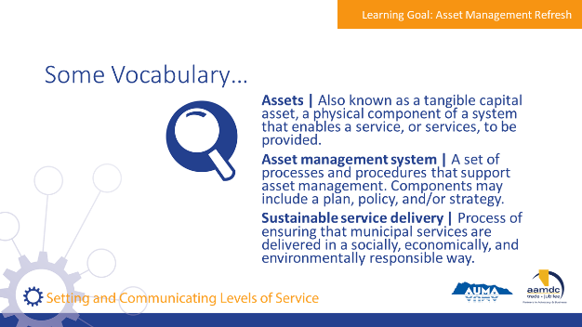 | State:  - There are a couple of terms we will be using as we discuss asset management, so we want to make sure we have a common understanding of them before we get into our discussion of asset management.  Review terms on slide.
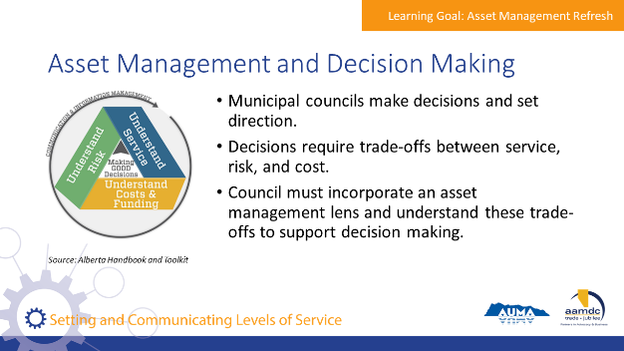 | State:  - Council’s role is to make decisions and set directions.  - Decisions require thinking about trade-offs between service, risk, and cost.  - Council should incorporate an asset management lens on decision making processes and request information from staff to understand these trade offs.
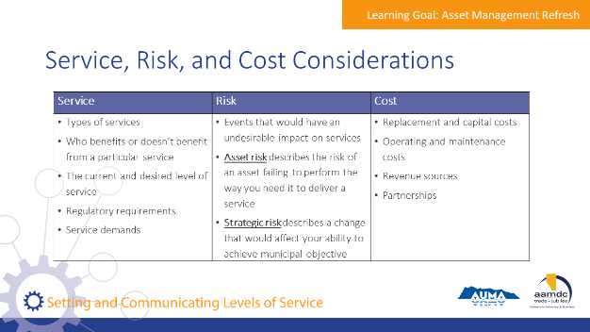 | State:  - This chart shows a summary of what should be considered for service, risk, and cost when evaluating trade-offs  - Levels of service will be covered in more depth in this course, and how levels of service connect to risk and cost.  Review considerations on slide.

Module 1 – Define Levels of Service and the Connection to Asset Management

Learning Goal: Identify Levels of Service

25 minutes |
Slides | Script
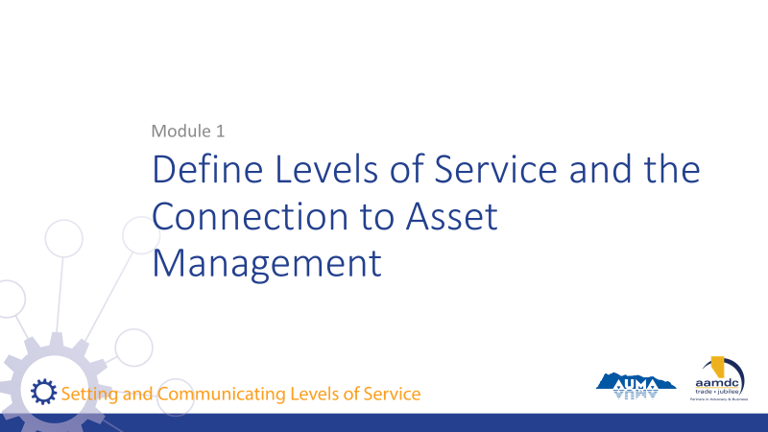 | State:  - This course has been designed with specific learning objectives for each module to state what learners should be able to do after completing a module.  - After Module 1, you should be able to:  - Define what LOS is  - Identify common challenges related to municipal service delivery  - Identify why LOS is important and the connection to asset management  - If you don’t feel like you are mastering these learning objectives, or if you have questions about any of the content, we want to encourage you to let us know. Ask questions during the course at any time or see us during the break.  - Also, you will get out of the course what you put into it. So please participate fully and if there is anything that may get in the way of your full participation, we want to know that as well.
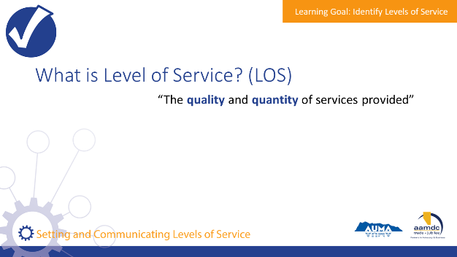 | State:  - LOS refers to the quality and quantity of services provided by municipalities to constituents.  - Although people will have a general idea of the standard of service, LOS are specific, measurable, and documented.
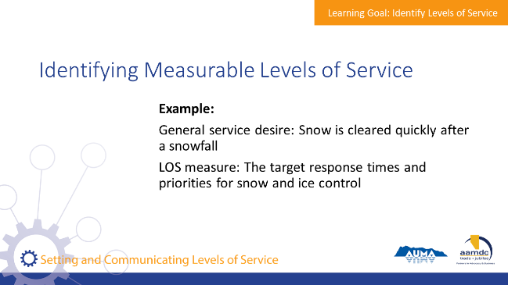 | State:  - To differentiate between having a general service standard desire and a specific/measurable LOS, your workbook includes a number of examples.  - One example asks us to consider a situation where a community experiences a heavy snowfall.  - The general service desire may be that snow is cleared quickly after the storm.  - The customer LOS measure would be based on target response times and set priorities for snow and ice control.
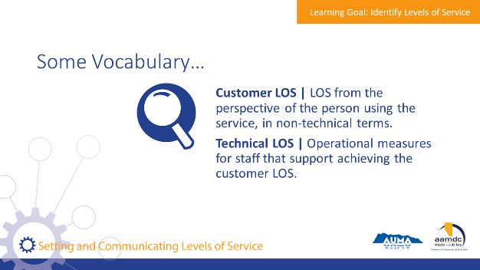 | State:  - There are a couple of ways to consider LOS.  - Council is concerned with customer LOS.  Review terms on slide.
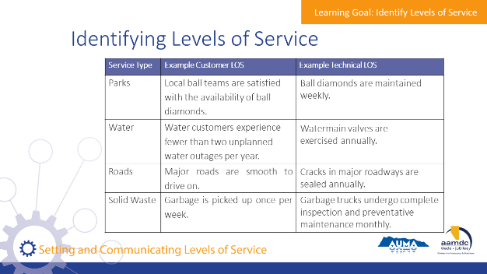 | State:  - To further develop our understanding of customer and technical LOS, let’s consider LOS for parks, water, roads, and solid waste services.  With participants, review customer LOS for each service, then identify technical LOS together as a group, followed by clicking to bring up an example technical LOS answer.  The answers on the slide are just one possible answer, there are many other possible answers.
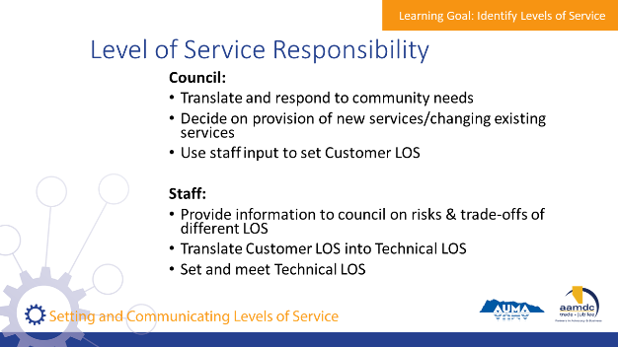 | State:  - Now that we understand the difference between customer and technical LOS, we need to consider how staff and council are responsible for each type of LOS.  - Council is responsible for translating and responding to community needs, then deciding on whether or not to provide new services and or change existing LOS. With input from staff, council sets the Customer LOS.  - Through customer LOS, council sets the performance bar  - Staff provides information to council on risks and trade-offs of different LOS. They then translate the customer LOS set by council to technical LOS, which they are responsible for meeting.  - Staff can work to find efficiencies in meeting the customer LOS. The performance bar has been set, they can be creative in figuring out how best to meet it.
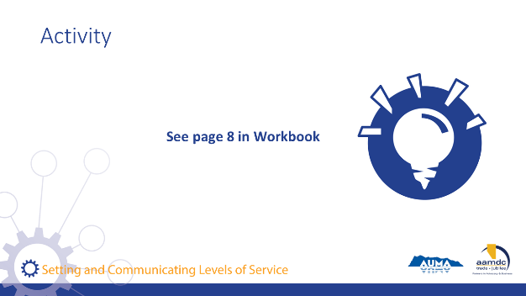 | Activity – Page 8 (10 Minutes)  State:  - Please turn to page 8 in your workbook. You’ll find an exercise that asks you to think of ways that elected officials establish or consider LOS.  As a group, brainstorm answers to each of the questions.  Debrief  Ask groups to share key points for each:  - Council makes decisions regularly that either directly or indirectly establish LOS  - Budgeting: making decisions about capital investments may raise LOS in one area, and postponing other capital projects may reduce LOS in another area. Reducing O&M budgets, or not increasing O&M budgets as the municipality acquires new assets, can also decrease the LOS.  - Planning: making decisions such as how land is used, serviced, and funded will impact LOS throughout the community  - Feedback from constituents: it’s important to take feedback into consideration in a thoughtful way that assesses various options for addressing the feedback and how these options impact other service levels, risks, and costs. Reacting to feedback immediately can result in high variability in the LOS delivered and mis-aligned expectations between the public, staff, and council.

Learning Goal: Identify Common Challenges Related to Municipal Service Delivery

25 minutes |
Slides | Script
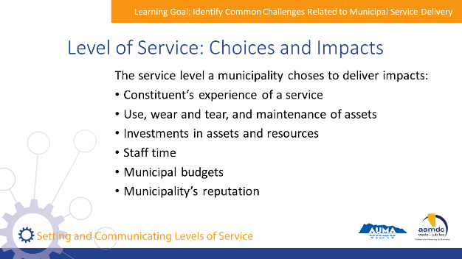 | State:  - Often, services are delivered to a certain standard because that’s the way things have always been done.  - It’s important to acknowledge that a municipality has a choice of the LOS they provide – especially as circumstances in a community change – because LOS impacts many things including:  - Constituent’s experience of a service  - Use, wear and tear, and maintenance of assets  - Investments in assets and resources  - Staff time  - Municipal budgets  - Municipality’s reputation
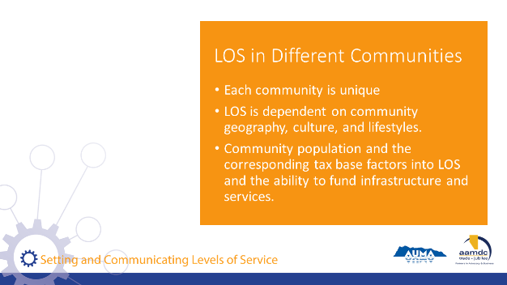 | State:  - Each community is unique.  - LOS depends on things that are inherent to a community, including geography, culture, and lifestyles.  - For example, small communities often cannot provide as many services or as high of LOS as large cities. This could be due to the size of the tax base (fewer tax payers makes it harder to afford expensive services). It could also be due to the cost of installing infrastructure in areas with dispersed populations or that certain communities want services that other communities simply don’t need.
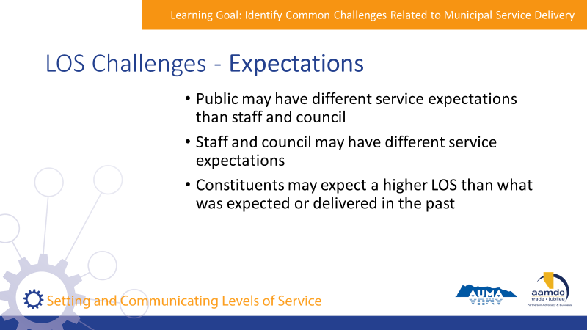 | State:  Expectations can create LOS challenges when:  - The public has different service expectations than staff and council  - Staff and council have different service expectations  - Constituents expect a higher LOS than what was expected or delivered in the past  Facilitator can work through an analogy: what would happen if the customers, staff, and management of a hotel all had different expectations? If customers thought they should expect 5 star service, staff thought they were supposed to provide 3 star service, and management was targeting a budget-focused 2 star approach?
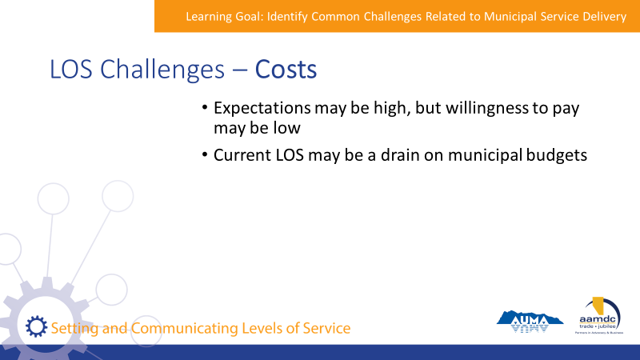 | State:  Costs can create LOS challenges when:  - Expectations may be high, but willingness to pay may be low  - Current LOS may be a drain on municipal budgets (especially when looking at maintaining a service into the future as the municipality is faced with the costs of asset renewal)
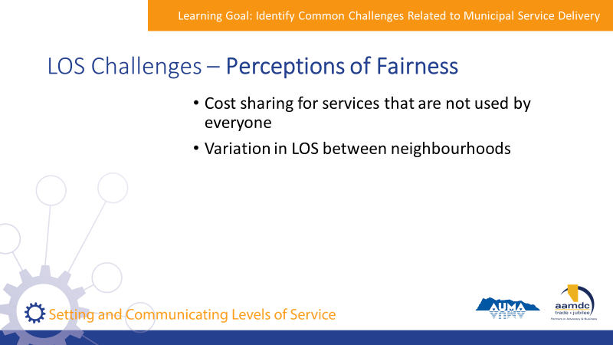 | State:  Perceptions of fairness can create LOS challenges when:  - Service is not used by everyone, some residents may feel disgruntled at the shared cost to provide the LOS  - LOS may vary between neighbourhoods e.g., difference in the quality of sidewalks in older and newer areas
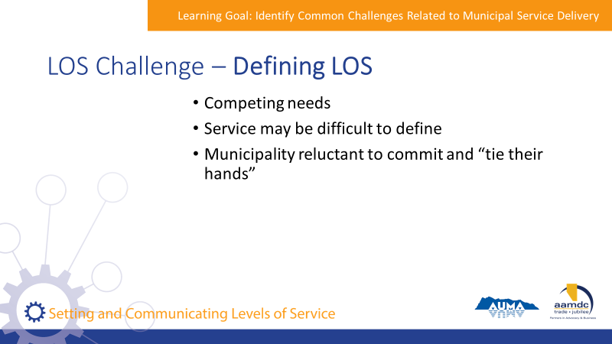 | State:  Defining LOS can be a challenge when:  - There are competing needs  - When a service is difficult to define, e.g., a community wants to introduce new walking trails but isn’t sure how many people would use them  - A municipality doesn’t want to commit to a certain LOS and “tie their hands”  Setting LOS can help address these challenges.
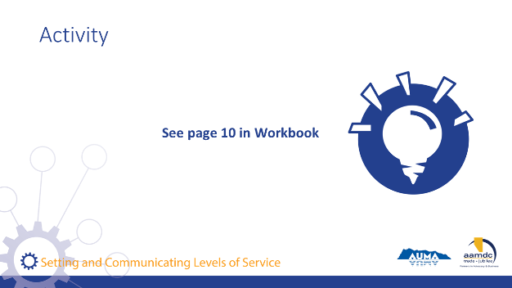 | Activity – Page 10 (15 Minutes)  State:  - Please turn to page 10 in your workbook.  - In your table groups, discuss your answers to each of the questions.  Debrief  Ask for examples/discussion highlights from each table. The goal of this discussion is to generate many different kinds of real examples that provoke the thinking of participants.

Learning Goal: Identify Why Levels of Service Are Important and the Connection to Asset Management

25 minutes |
Slides | Script
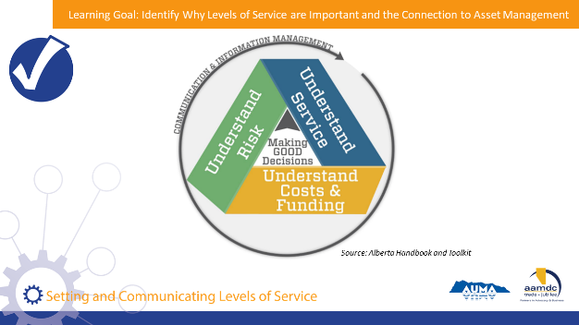 | State:  - To understand the importance of levels of service and the connection to asset management, we’re going to provide a brief overview of the key concepts of asset management.  Explain the graphic on slide.  State:  - Sustainable service delivery is at the centre of asset management.  - Having asset management processes in place will help you to be clear on what services you’re providing, at what level, and how the service needs will change over time.  - Constituents are the recipients of services and will therefore have an important role in determining what services will be delivered and to what level. However, decisions about service delivery should always be made in the context of the cost of delivering services and the associated risks.  - Over the next few slides, we’ll review some of the questions you may think about or ask when considering the service your community provides.
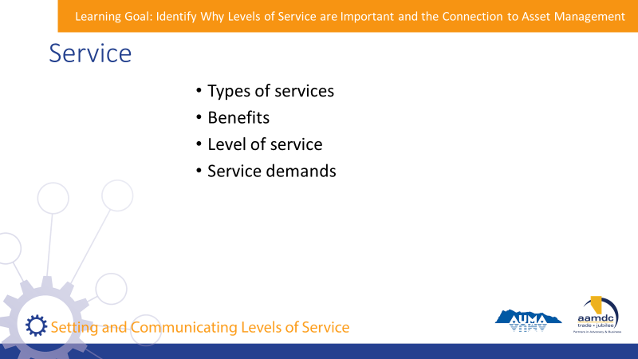 | State:  Questions to think about when considering service:  Types of services  - Does our municipality need to provide this service? Why?  Benefits  - Who benefits from these services?  - Who many not benefit?  Level of service  - What is the current level of service provided?  - What is the desired level of service and timeline for achieving it?  - What are the regulatory requirements (i.e., minimum level of service)?  - How do council and staff understand what level of service is needed or wanted by recipients?  - What is the appropriate level of service to deliver?  Service demands  - How will demands for our services change over time?  - What are the ways that the municipality can influence the demand for a service?  - How do service demands vary in different areas of the municipality?
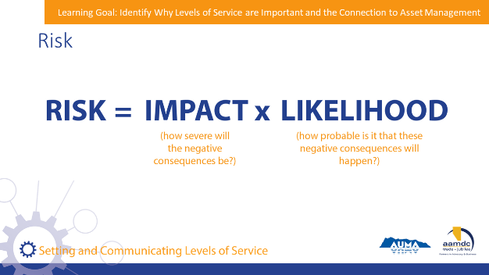 | State:  - Risk can be expressed like this:  - Risk equals the impact (how severe will the negative consequences be) times likelihood (how probable is it that these negative consequences will happen).
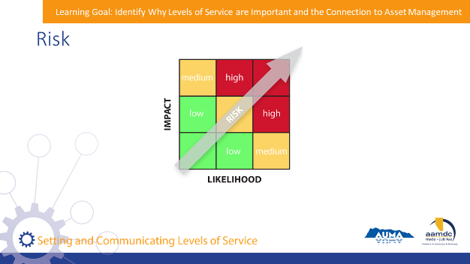 | State:  - This matrix is used to plot the level of risk that might be associated with an action or event.  - Here’s how it works:  Ask participants for a verbal example and show where the risk will fall on the matrix.
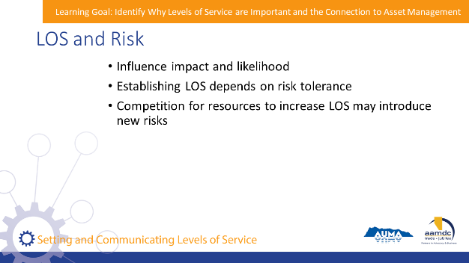 | State:  LOS and risk are connected in several ways:  - LOS influence impact and likelihood. For example, a municipality may decide to increase their LOS by paving gravel roads, but this will also change the types of risks impacting the roads. The costs of repairing a paved road will also be different than the cost of repairing a gravel road, thus the impacts will also change.  - Establishing LOS depends on risk tolerance. For example, potable water standards are high because the risk of failure would be catastrophic. In contrast, a lower LOS may be provided because a municipality cannot afford to manage the risk inherent to maintaining that higher LOS.  - Competition for resources to increase LOS may introduce new risks. For example, a municipality may direct resources to provide a high LOS in a new recreation facility, while maintenance and repair of other facilities is neglected. This would be to the detriment of the LOS provided by those facilities and thus increase the risk of asset failure.
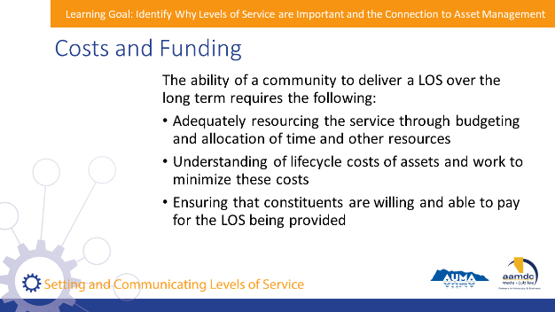 | State:  - We intuitively understand that there is a connection between cost, level of service, and risk but don’t always think about what this means over the long term.  - The ability of a community to deliver a certain LOS sustainably over the long-term requires:  - Adequately resourcing the service through budgeting and allocation of time and other resources  - Understanding lifecycle costs of assets and work to minimize these costs  - Ensuring that constituents are willing and able to pay for the LOS being provided
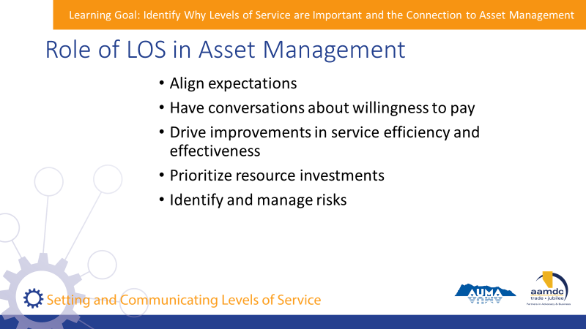 | State:  We understand that assets are managed to deliver services, and LOS sets the bar for what is required of asset management. Clear LOS helps you to:  - Align expectations between the municipality and constituents as well as staff and council  - Have conversations with constituents about willingness to pay  - Drive improvements in service efficiency and effectiveness  - Prioritize resource investments  - Identify and manage risks  LOS is fundamental to asset management. For example, you wouldn’t replace an aging pipe just because it has reached the end of its theoretical useful life – you would replace it because there are risks to the pipe continuing to deliver the desired level of service.
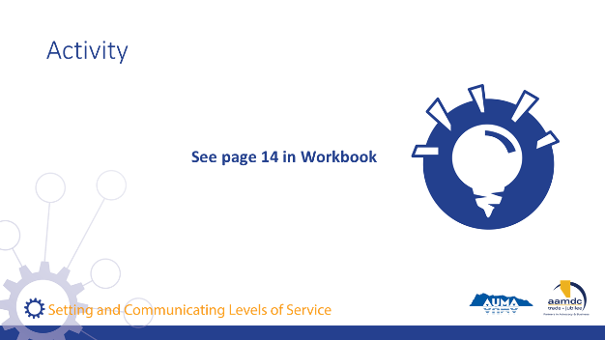 | Activity – Page 14 (20 Minutes)  State:  - Please turn to page 14 in your workbook. In your table groups, review the scenario in your workbook and brainstorm answers to the questions.  Debrief:  - Ask different tables to provide their answers to the questions (depends on how many tables there are).  Key points of discussion to tease out:  - Constituents of the hamlets without piped water will know why they do or don’t qualify for piped water  - If there are disagreements about the rationale for providing levels of service, the municipality can facilitate a discussion about costs and willingness to pay  - Staff and council will be able to respond to constituents in a consistent manner  - Staff will have clear direction on whether they should plan for piped water service in an area or not, and how that also impacts local land use planning  - Staff will know what outcomes are expected, and can find creative ways/efficiencies to deliver the outcomes

Module 2 – Identify How to Set Levels of Service

Learning Goal: Identify Council’s Role in Setting Levels of Service

15 minutes |
Slides | Script
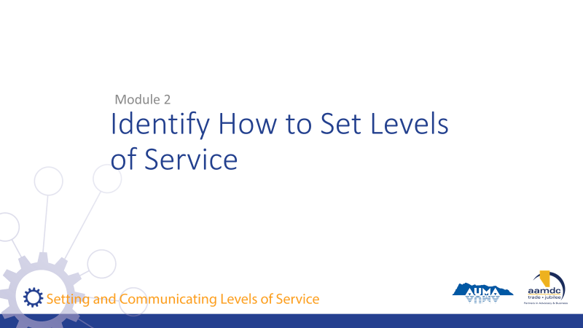 | State:  After Module 2, you should be able to:  - Identify council’s role in setting LOS  - Identify the process for setting LOS
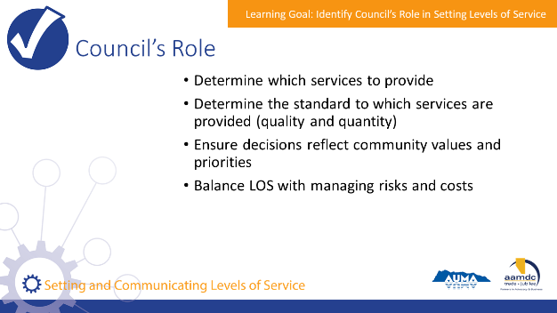 | State:  Council’s role in setting LOS is to:  - Determine which services to provide  - Determine the standard to which services are provided (both quality and quantity)  - Ensure decisions reflect community values and priorities  - Balance LOS with managing risks and costs
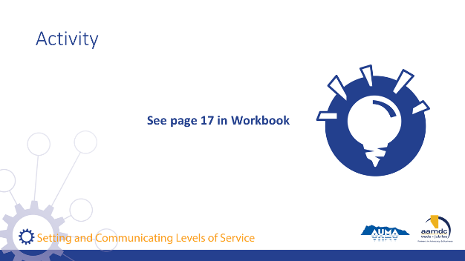 | Activity – Page 17 (10 Minutes)  State:  Please turn to page 17 in your workbook. With your table groups, discuss and answer the questions.  Debrief:  Ask different tables to share their answers. Many of these will build on discussions from earlier exercises.

Break
15 minutes | 10:45 a.m. to 11:00 a.m.

Learning Goal: Identify the Process for Setting Levels of Service

15 minutes |
Slides | Script
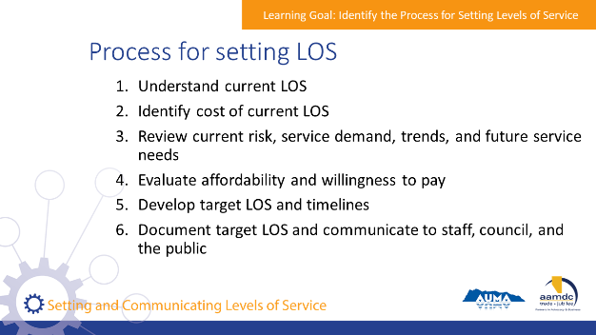 | State:  - To set LOS, staff will lead the following process and inform and consult council when decisions need to be made:  Process: (facilitator to talk through each step in depth, highlighting the role of council along the way)  - Understand current LOS  - Identify cost of current LOS  - Review current risk, service demand, trends, and future service needs  - Evaluate affordability and willingness to pay  - Develop target LOS and timelines  - Document target LOS and communicate to staff, council, and the public
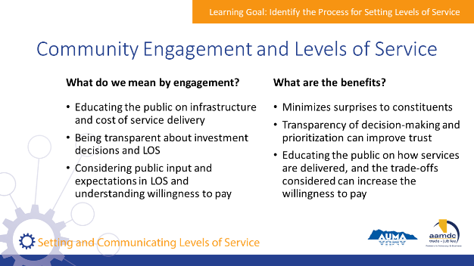 | State:  - Community engagement is an important part of asset management so that council and staff understand what service levels are needed and so that the public understands the reasons behind priorities and investments.  - What do we mean by engagement?  - Educating the public on infrastructure and cost of service delivery  - Being transparent about investment decisions and LOS  - Considering public input and expectations in LOS and understanding willingness to pay  - Benefits of engagement include:  - Minimizing surprises to constituents  - Transparency of decision-making and prioritization can improve trust  - Educating the public on how services are delivered, and the trade-offs considered can increase the willingness to pay  - It should be noted that the public should only be engaged in areas where the municipality is able and willing to adjust LOS.  - There is a separate half-day course dedicated to communication and engagement for asset management.

Module 3 – Effectively Apply and Communicate Levels of Service

Learning Goal: Incorporate Levels of Service into Decision-Making

30 minutes |
Slides | Script
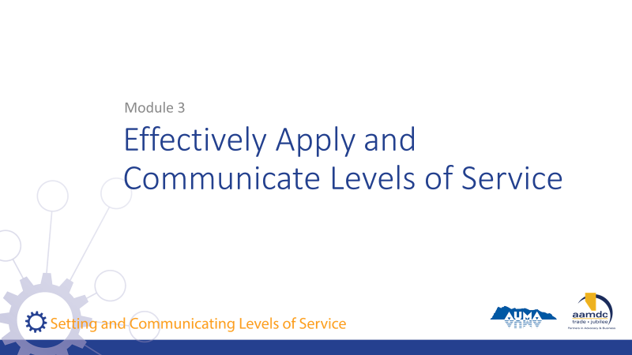 | State:  After Module 3, you should be able to:  - Incorporate LOS into decision making  - Communicate LOS with constituents  - Monitor and revise LOS
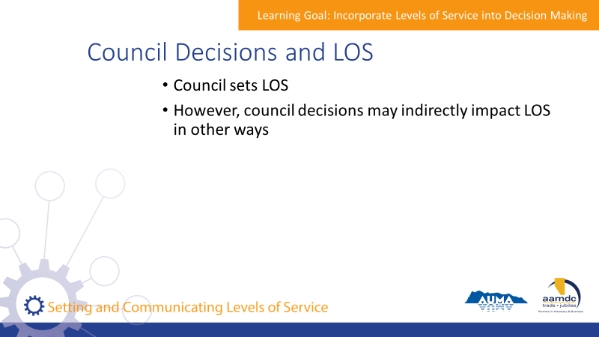 | State:  - We’ve talked about how council is responsible for setting LOS and making decisions about services.  - A municipality may undertake a specific process to define levels of service (as discussed earlier).  - Council can also indirectly impact LOS through day-to-day decisions
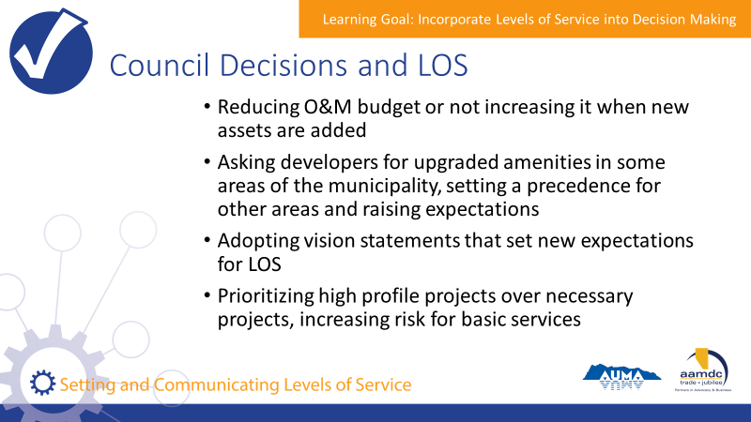 | State:  Some of the ways that LOS can be indirectly impacted:  - Reducing operations and maintenance budget or not increasing it when new assets are added  - Asking developers for upgraded amenities in some areas of the municipality, setting a precedence for other areas and raising expectations  - Adopting vision statements that set different expectations for LOS that cannot be a reality  - Prioritizing high profile projects over necessary projects, increasing risk for basic service provision  The impacts of decisions on levels of service highlights the need for council to consider an asset management lens in day to day decision making, where the trade-offs between service, risk, and cost are identified.
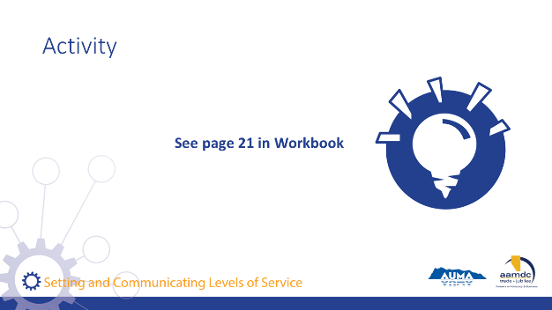 | Activity – Page 21 (15 Minutes)  State:  Please turn to page 21 in your workbook. In pairs, discuss and answer the questions in your workbook.  Debrief:  Ask participants to share some of their questions.  Potential Answers:  How does this decision indirectly impact level of service?  - By reducing the O&M budget, council indirectly reduces the ability of staff to repair and or maintain infrastructure to the current level of service. The same goes for not increasing the O&M budget when new assets are added to the inventory.  - By upgrading amenities in some areas and not others, council may increase expectations for levels of service across the community.  - By adopting a vision statement for service levels that is misaligned with implementation realities, council may indirectly increase the expected level of service from constituents, and put staff in the position of having to address the gap between the service being provided and the expected level of service.  - By prioritizing high profile projects over necessary projects, council impacts level of service by potentially taking resources away from existing infrastructure repairs, creating future risk of failure and declining levels of service.  What are some actions that council could take to understand or manage the indirect impact to levels of service?  - Coordinate with staff when setting O&M budgets to ensure at the very minimum existing levels of service can be maintained.  - Communicate with staff to ensure expected service levels are consistent between council’s vision and the ability of staff to implement the service levels.

Learning Goal: Communicate Levels of Service with Constituents

20 minutes |
Slides | Script
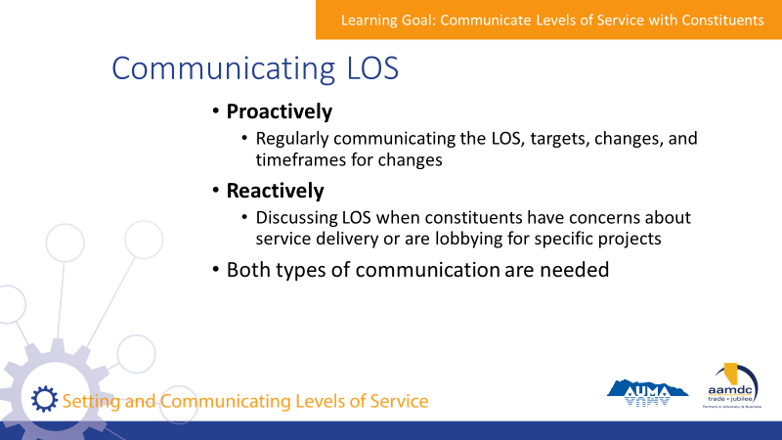 | State:  - Communicating current levels of service, or any future changes, is crucial to ensuring transparent processes and avoiding a shock to residents when services change.  - Council and staff can proactively and regularly communicate the LOS the municipality is providing, what its targets are, if there will be any changes to LOS and what the timeframes are for change.  - Council and staff can reactively communicate by incorporating LOS into discussions when constituents have concerns about service delivery or are lobbying for specific projects.  - Both communication styles help avoid surprises, enable transparency, and ensure that municipal decisions are made with constituent’s interests in mind.
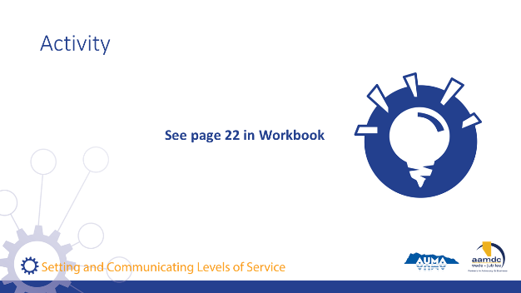 | Activity – Page 22 (10 Minutes)  State:  Please turn to page 22 in your workbook.  With the full group, brainstorm answers to the questions.  Some questions to prompt the group:  - How do you communicate levels of service with your constituents?  - Where do you choose to get input? Which services do you engage with the public to inform levels of service? Which types of services are you less likely to engage the public in? Why?  - How do you engage the public in budget decisions that will impact levels of service?  - What has been most successful?  - What has been the most challenging?  - What do you do when there is not agreement on the level of service or willingness to pay?

Learning Goal: Monitor and Revise Levels of Service

30 minutes |
Slides | Script
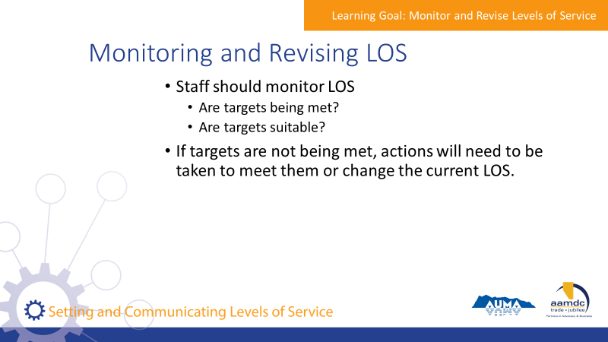 | State:  - Staff should regularly monitor LOS to understand if targets are being met, or if targets are even suitable.  - There are several approaches that can be taken to monitor LOS, identify when targets are being met, and when either current performance or targets need to be refined.
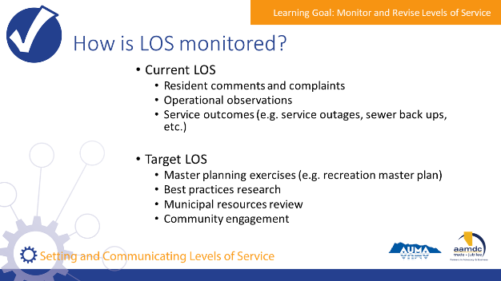 | State:  Current LOS can be monitored through:  - Resident comments and complaints  - Operational observations  - Service outcomes such as service outages or sewer back ups  The suitability of target LOS can be monitored through:  - Master planning exercises such as the development of a recreation master plan  - Best practices research  - Municipal resources review  - Community engagement
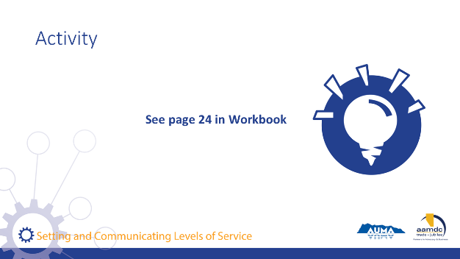 | Activity – Page 24 (10 Minutes)  State:  Please turn to page 24 in your workbook. Please take a few moments to individually reflect on the questions.  Debrief:  Ask for participants to volunteer to share some of their thoughts.

Concluding Remarks

10 minutes |
Slides | Script
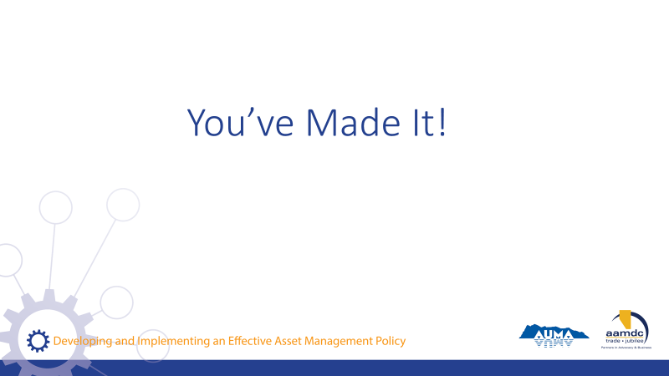 | State:  - Well, you’ve made it!  - Here we are at the end of the course.  - I hope you found today full of learning, good conversation, and shared insight. I want to thank you for joining us.  - Remember, today is just a start.  - Together, we’ve laid the foundation, but we hope that you’ll continue to learn, ask questions, and participate in other opportunities to expand your knowledge of LOS and asset management.  - Throughout the workbook, and at the back, you can find the glossary and a list of resources if you ever need to reference something you learned in this course.
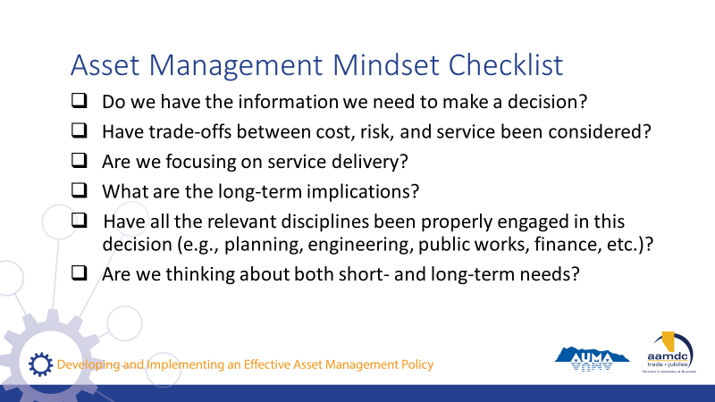 | State:  - If you got anything out of today, we hope that it was an understanding of how an asset management mindset can support you in your role as an elected official and steward of community well-being.  - If you’re ever stuck, start by asking yourself some questions:  Read questions on slide.  State:  - All of these questions apply to the integration of climate change and asset management.
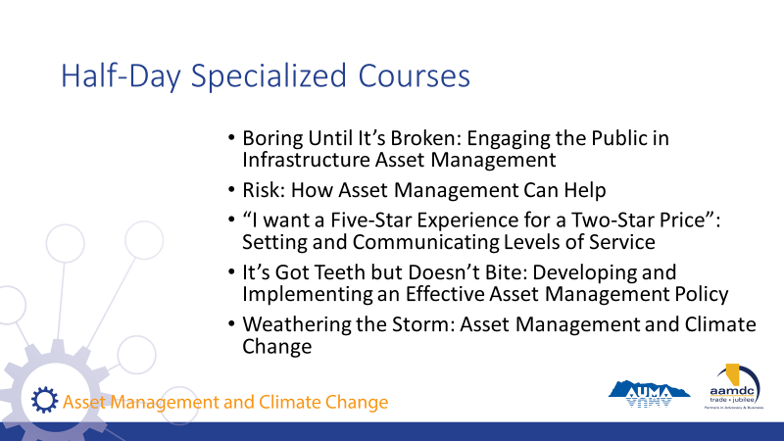 | State:  - AUMA and RMA offer five half-day courses as part of these series on specific topics related to asset management.  Read courses on slide.  If you want to find out more, talk to us after class.
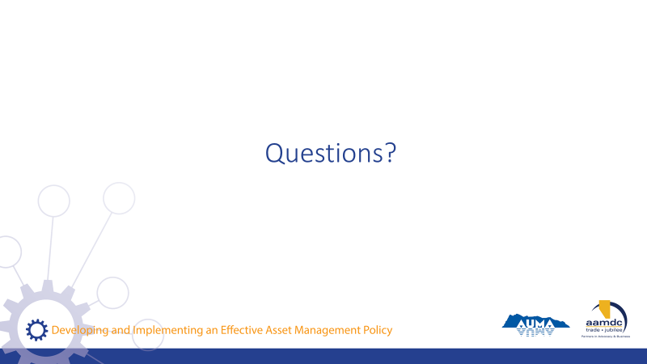 | State:  Before we leave for the day, does anyone have any remaining questions about anything we covered?
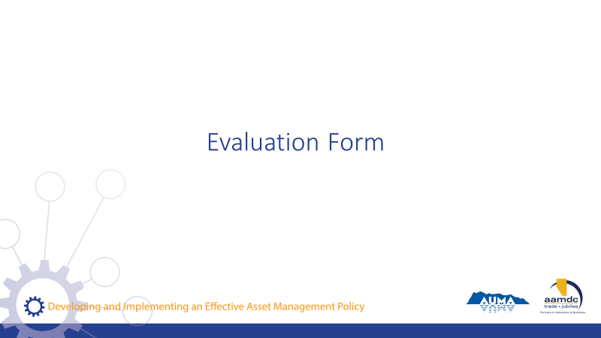 | State:  - Before you leave today, we would really value getting your input on this course.  - Your input will help us to understand how the course helped you (what worked for you) and where we can be making improvements.  - Thanks for taking about 10 minutes to provide your feedback. Once completed, you can leave your forms on (pick a central location for all forms so they remain anonymous).

NOTES

